
Question Bank

Subject Code | 19EC406 | Subject Name | DIGITAL COMMUNICATION | Common To
(PART A – 2 Marks)
Q. No | Questions | CO | Knowledge Level (Blooms) | Difficulty Level (1-5)
QA101* | What is the use of a source encoder with an example? Compresses the data into minimum number of bits. Eg: Lossy and Lossless compression, Arithmetic, Huffman, Shannon, Shannon–fano coding. | CO1 | K2 | 2
QA102 | State the Nyquist theorem of sampling.  It is defined as twice the maximum frequency component present in the analog signal. Mathematically it can be represented as: $f_{s}=2f_{max}$ | CO1 | K3 | 3
QA103 | What is aliasing in the context of signal processing?  When a high-frequency signal is represented at lower frequency. Means it occurs when the sampling rate is insufficient and fails to capture the signal properly. | CO1 | K3 | 4
QA104* | What is the use of a channel encoder with an example?  Channel encoder is used to control the combat noise in the channel; some redundancy is deliberately introduced in the message. Eg: Block, Cyclic, Convolution, Turbo code. | CO1 | K2 | 2
QA105 | What is quantization in digital signal processing? Mention its type.  Within the finite amplitude range of the signal, we find an infinite number of amplitude levels. There are three types of Quantization - Uniform Quantization, Non-uniform Quantization and Vector quantization. | CO1 | K3 | 4
QA106* | Mention different method used in Uniform and Non-uniform quantization method.  There are two types of uniform quantization. They are Mid-Rise type and Mid-Tread type.There are two types of non-uniform quantization. They are A-law and μ-law. | CO1 | K2 | 2
QA107* | Draw the tree diagram, code word and code word length of given samples {0.5, 0.2, 0.2, 0.1} using Huffman coding method.  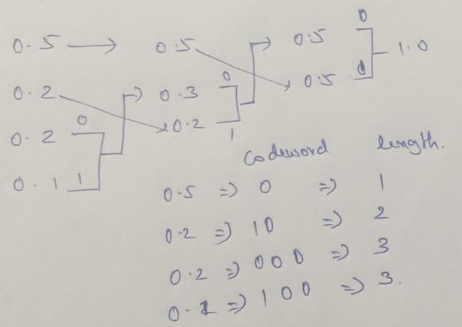 | CO1 | K2 | 3
QA108* | Draw the tree diagram, code word and code word length of given samples {0.5, 0.2, 0.2, 0.1} using Shannon-Fano coding method.  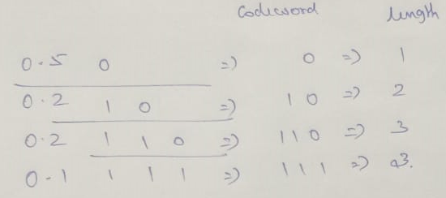 | CO1 | K2 | 3
QA201* | How is noise controlled in Delta Modulation?  If step size is variable, the noise is controlled in DM. But step size fixed and has slope overload and granular error. | CO2 | K2 | 3
QA202 | Draw the Polar NRZ and Unipolar RZ waveform for the digital data 1101001  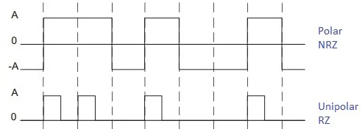 | CO2 | K3 | 2
QA203 | What is the use of compander in PCM?  The combination of a compressor and an expander is called a compander. The compressor is in input side and expander is in output part of the quantization. | CO2 | K2 | 2
QA204 | Define AMI code.  Line code uses three amplitude level, positive and negative pulses of equal amplitude are used alternately for symbol 1, with each having a half-symbol width; no pulse is always used for symbol 0. | CO2 | K2 | 1
QA205* | What is the advantage of DPCM over PCM? Name the line coding methods used in DPCM.  Removing redundancy before encoding, which is the basic idea behind Differential Pulse Code Modulation. The encoding methods are Unipolar NRZ, Bipolar RZ, Manchester encoding. | CO2 | K3 | 2
QA206* | Draw the Unipolar RZ and Bipolar RZ waveform for the digital data 1101001  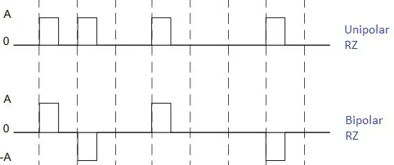 | CO2 | K3 | 2
QA207 | State Shannon's Capacity Theorem.  Shannon's Capacity Theorem, also known as the Shannon-Hartley Theorem, describes the maximum data rate that can be transmitted over a communication channel with a specified bandwidth in the presence of noise. $c\text{ = B}{\text{log}}_{\text{2}}{\text{(1+}\frac{\text{S}}{\text{N}}\text{)}}$ | CO2 | K3 | 2
QA208 | What is a drawback of Manchester coding in terms of bandwidth?  A drawback of Manchester coding is that it requires double the bandwidth compared to NRZ coding, due to the increased number of transitions | CO2 | K3 | 2
QA301 | Draw the BFSK signal for the binary sequence 101101. | CO3 | K3 | 3
QA302 | What is the difference between QAM and QPSK?  The in-phase and quadrature components are permitted to be independent called M-ary quadrature amplitude modulation.  The in-phase and quadrature components are permitted to be dependent called QPSK. | CO3 | K3 | 3
QA303 | Why synchronization is essential?  Ensure error free and efficient transmission of data. | CO3 | K3 | 3
QA303* | What is the use of phase recovery circuit in digital modulation system?  The oscillator supplying the locally generated carrier signal in the receiver is synchronized to the oscillator supplying the carrier wave used to originally modulate the incoming data stream in the transmitter. | CO3 | K3 | 3
QA305 | What is signal constellation diagram?  The constellation diagram is useful for understanding the effect of interference on the signal. | CO3 | K3 | 3
QA306 | Why is QAM considered bandwidth-efficient?  QAM is considered bandwidth-efficient because it can transmit multiple bits per symbol by using a combination of different amplitudes and phases, allowing higher data rates within the same bandwidth. | CO3 | K3 | 3
QA307 | How does DPSK perform in terms of BER in a noisy channel?  DPSK typically has a higher BER compared to coherent PSK techniques because it relies on the difference between successive phases, making it more susceptible to phase noise. | CO3 | K3 | 3
QA308 | How does FSK provide robustness against noise?  FSK provides robustness against noise because it uses different frequencies to represent different data bits, making it less sensitive to amplitude variations and noise. | CO3 | K3 | 3
QA401 | State the channel-coding theorem.  A discrete memoryless channel has capacity C and a source generate information at a rate less than C, then there exists a coding technique such that the output of the source may be transmitted over the channel with aa arbitrarily low probability of symbol error | CO4 | K2 | 2
QA402 | Calculate the hamming distance between 101001 and 110001  Hamming distance of the codeword is 3. | CO4 | K2 | 3
QA403* | Define the term burst error.  When several consecutive bits are flipped mistakenly in digital transmission, it creates a burst error. This error causes a sequence of consecutive incorrect values. | CO4 | K3 | 4
QA404 | Mention a few properties of cyclic codes.  Linearity property: the sum of any two code word in the code is also a code word.  Cyclic property: any cyclic shift of a code word in the code is also a code word. | CO4 | K2 | 3
QA405 | Define constraint length in a convolutional code.  Constraint length of a convolutional code, expressed in terms of message bits, is defined as the number of shift over which a single message bit can influence the encoder output. | CO4 | K2 | 3
QA406 | Write the syndrome properties for linear block codes.  Syndrome Property 1: the syndrome only on the error pattern, and not on the transmitted code word.  $$s=rH^{T}=cH^{T}+eH^{T}=eH^{T}$$  Syndrome Property 2: all error patterns, that differ by a code word have the same syndrome.  $$e_{i}H^{T}= eH^{T}+ c_{i}H^{T}=eH^{T}$$ | CO4 | K1 | 3
QA407 | Differentiate systematic and non-systematic code.  A systematic code embeds the original data within the encoded output. Example: Telecommunications, data storage, and satellite communications  A non-systematic code does not, making the original data harder to extract. Example: Cyclic codes and turbo codes. | CO4 | K2 | 3
QA408* | What does the word "hamming distance" mean?  Hamming distance $d_{min}$ of a linear block code is the smallest hamming weight of the nonzero code vector in the code. | CO4 | K2 | 3
QA501 | Describe the basic principle of Direct Sequence Spread Spectrum (DSSS).  DSSS spreads the signal over a wider bandwidth than the original signal by multiplying it with a pseudorandom noise (PN) code, which increases the bandwidth and makes the signal more resistant to interference. | CO5 | K2 | 2
QA502 | What is the role of the pseudorandom noise (PN) code in DSSS?  The PN code in DSSS is used to spread the signal across a wider bandwidth, ensuring that the signal can be reconstructed correctly at the receiver by using the same PN code for de-spreading. | CO5 | K3 | 3
QA503 | Compare FDMA and TDMA in terms of bandwidth usage.  FDMA divides the bandwidth into separate frequency channels, with each user having exclusive use of a frequency band, leading to potentially inefficient use of spectrum. TDMA, on the other hand, allows multiple users to share the same frequency by dividing it into time slots, which can lead to more efficient use of the available bandwidth. | CO5 | K3 | 4
QA504 | Describe the concept of spatial multiplexing in MIMO systems.  Spatial multiplexing in MIMO systems involves transmitting multiple data streams simultaneously over different transmit antennas, allowing for higher data rates by effectively using the spatial dimension. | CO5 | K2 | 2
QA505* | State and mention the type of frequency hopping.  To force the jammer to cover a wider spectrum by randomly hopping the data modulated carrier from one frequency to the next. In effect, the spectrum transmitted signal is spread sequentially rather than instantaneously, the term sequentially refers to the pseudo random ordered sequence of frequency hops. Slow and Fast Frequency hopping are its type. | CO5 | K3 | 4
QA506* | Define the term slow frequency hopping.  Slow frequency hopping, in which the symbol rate $R_{s}$ of the MFSK signal is an integer multiple of the hop rate $R_{h}$. That is several symbols are transmitted on each frequency hop. | CO5 | K2 | 2
QA507 | What is diversity gain in MIMO systems?  Diversity gain is achieved in MIMO systems by using multiple antennas to transmit and receive signals, which helps in mitigating the effects of fading and improves signal reliability. | CO5 | K2 | 3
QA508* | What is the use of adaptive antenna in SDMA?  Adaptive antennas used at the base station promise to mitigate some of the problem on the reverse link. | CO5 | K2 | 3
(PART B – 13 Marks)
Q. No | Questions | CO | Knowledge Level (Blooms) | Difficulty Level (1-5)
QB101(a) | Derive the expression for sampling theorem and discuss limitation. How to overcome the aliasing effect.  Sampling process is usually described in time domain  Sampling process, analog signal is converted into a corresponding sequence of samples that are usually spaced uniformly in time.  Sampling period is Ts,  sampling rate is $f_{s}=\frac{1}{T_{s}}$  Ideal or Instantaneous or Impulse Sampling: sampling signal is a periodic impulse train. The area of each impulse in the sampled signal is equal to the instantaneous value of the input signal.  $g_{δ}\left(t\right)=\sum_{-α}^{α}{g\left(nT_{s}\right)δ(t-nT_{s})}$ --------------- (1)  Where $g_{δ}\left(t\right)$as ideal sampled signal.  Where $δ(t-nT_{s})$ delta function at time t= $nT_{s}$  Fourier transform pairs, $g_{δ}\left(t\right)=f_{s}\sum_{-α}^{α}{G(f-{nf}_{s})}$----------- (2)  Fourier transform of $δ(t-nT_{s})$ = $e^{-j2πft}$ = $e^{-j2πfnT_{s}}$  Equ (1) can be rewritten as discrete time FT  $G_{δ}\left(f\right)=\sum_{-α}^{α}{g\left(nT_{s}\right)e^{-j2πfnT_{s}}}$ ---------- (3)  $G_{δ}\left(f\right)=\sum_{-α}^{α}{g\left(nT_{s}\right)e^{-j(\frac{πnf}{W})}}$ ---------- (4)  Equ (2) can be rewritten as  ${G_{δ}\left(f\right)= f}_{s}\sum_{-α}^{α}{G(f-nf_{s})}=f_{s} G\left(f\right)+f_{s}\sum_{\begin{aligned}-α \\ n≠0\end{aligned}}^{α}{G(f-nf_{s})}$ ------- (5)  Conditions G(f) = 0 for |$f_{s}$| ≥ W; $f_{s}$= 2W  Equ (5) can be rewritten as $G_{δ}\left(f\right)=f_{s}G\left(f\right)$;  $G\left(f\right)=\frac{1}{f_{s}}G_{δ}\left(f\right)$ -------- (6)  Sub (4) in (6); = $\frac{1}{2W}$ $\sum_{-α}^{α}{g\left(\frac{n}{2W}\right)e^{-j(\frac{πnf}{W})}}$ ---(7)  The sample of a signal g(t) are specified for all n, the Fourier transform G(f) of the signal is uniquely determined by using discrete time Fourier transform of (7).  Reconstructing original signal apply inverse Fourier transform;  $g\left(t\right)=\int_{-α}^{α}{G(f) e^{j2πft}df}$ ------------ (8)  Sub (6) in (7),  = $\frac{1}{2W} \int_{-α}^{α}{\sum_{-α}^{α}{g\left(\frac{n}{2W}\right)e^{-j(\frac{πnf}{W})} e^{j2πft}df}}$  = $\frac{1}{2W} \int_{-W}^{W}{\sum_{-α}^{α}{g\left(\frac{n}{2W}\right)e^{j2πf(t - \frac{n}{2W})}df}}$  = $\sum_{-α}^{α}{g\left(\frac{n}{2W}\right)}\frac{1}{2W}\int_{-W}^{W}{e^{j2πf(t - \frac{n}{2W})}df}$  = $\sum_{-α}^{α}{g\left(\frac{n}{2W}\right)}$ $\left(\frac{sin⁡(2πwt-nπ)}{2πWt-nπ}\right)$  g(t)= $\sum_{-α}^{α}{g\left(\frac{n}{2W}\right)}$ sinc (2wt-n); –α < t < α  The above equation is interpolation formula for reconstructing the original signal g(t).  The sampling signal is strictly band limited signals,  - The band limited signal of finite energy, which has no frequency components higher than WHz, is completely described by specifying the value of the signal at instants of time separated by time 1/2W seconds.  - The band limited signal of finite energy, which has no frequency components higher than WHz, may be completely recovered from a knowledge of its sample taken at the rate of 2W samples per second.  It is the minimum sampling rate required to accurately capture an analog signal in digital form without information loss. It is also known as Nyquist Frequency or Nyquist Limit.  It is defined as twice the maximum frequency component present in the analog signal. Mathematically it can be represented as:  $$f_{s}=2f_{max}$$  Nyquist interval, reciprocal of the Nyquist rate, which is the smallest sampling rate required to accurately capture an analog signal in digital form without information loss.  $$T=\frac{1}{Nyquist rate}=\frac{1}{f_{s}}$$  A signal can be exactly reproduced if it is sampled at the rate $f_{s}$ which is greater than twice the maximum frequency.  If​ $f_{s} <2f_{max}$, then it is the case of under sampling.  If $f_{s}=2f_{max}$, then it is the case of sampling at Nyquist Rate and it is perfect sampling.  If $f_{s}>2f_{max}$​, then it is the case of oversampling.  Undersampling: rate is less than the Nyquist rate, making it impossible to extract the original signal from the sampled signal. Because the spectra overlap, some frequency components of the original signal will acquire a new frequency; this process is known as frequency aliasing.  Oversampling: is when more samples are taken that are necessary to capture the signal's frequency. It can be done to measure more accurately, enhancing SNR, providing more detailed information for further processing  Aliasing: When a high-frequency signal is represented at lower frequency. Means it occurs when the sampling rate is insufficient and fails to capture the signal properly. When the signals are sampled at lower frequency than the Nyquist frequency, high frequency components fold back in the low frequency range. This may lead to distorted signal representation.  Avoid Aliasing: Sampling at Nyquist Rate, Using Anti-Aliasing Filter is used in signal processing and digital data collection systems to prevent or eliminate aliasing effects.  Filtering High-Frequency Components: The anti-aliasing filter is used to remove high-frequency components in analog signals that exceed the Nyquist frequency, which is half the sampling rate of the ADC. If these high-frequency components are not filtered, they will cause aliasing which results in incorrect information.  Preventing Aliasing: The anti-aliasing filter ensures that only the desired frequency are represented in the digital signal by attenuating the high-frequency components.  Improved Signal Quality: It improves signal quality and allows for more accurate data gathering. It helps to retain the original signal's integrity and decreases the possibility of errors in later digital processing.  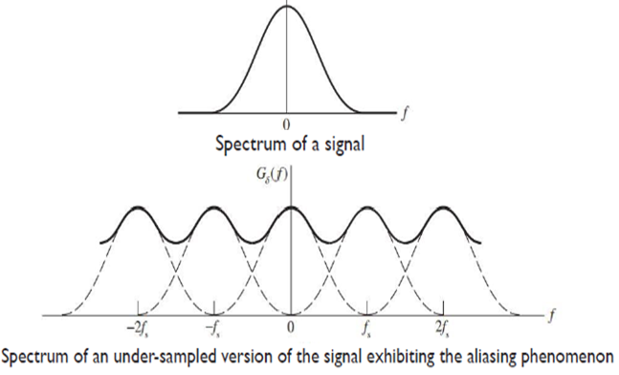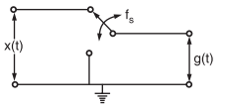  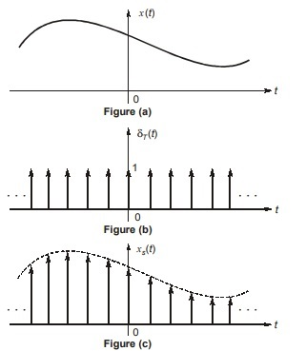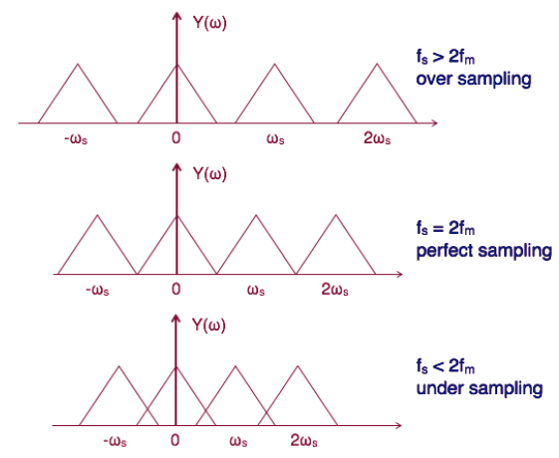 | CO1 | K2 | 2
Or
QB101(b) | Explain the building block diagram of digital communication system.  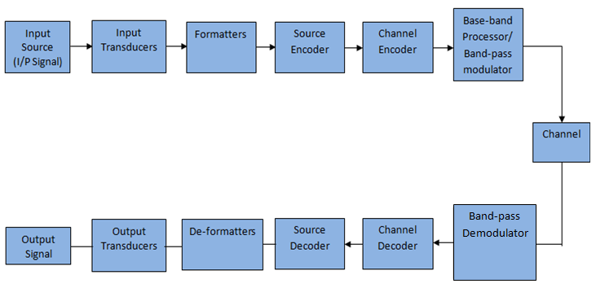  Transmitter  Information source: analog in nature (Voice, Video, Text and Images) I/P  Transducer: convert analog signal into analog electrical signal (computer data are in discrete form)  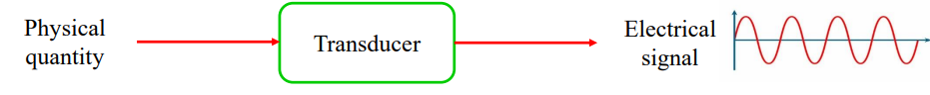  Formatter: electrical signal into a sequence of digital signals.  Source encoder: compresses the data into minimum number of bits. Eg: Lossy and Lossless compression, Arithmetic, Huffman, Shannon, Shannon–fano coding.  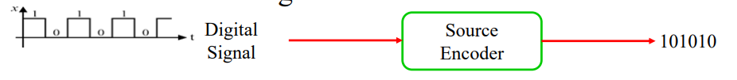  Channel encoder: combat noise in the channel, some redundancy is deliberately introduced in the message. Eg: Block, Cyclic, Convolution, Turbo code….  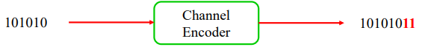  Baseband Processor: proper detection in the receiver and to combat noise and interference, line coding is used. Eg: Manchester, P-NRZ, PRZ, B-NRZ, B-RZ….  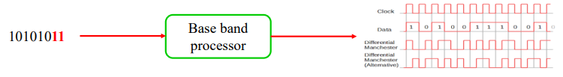  Modulator: is to map the digital signal to high frequency analog signal. Eg: PCM, DM, DPCM, ASK, PSK, FSK, QAM….  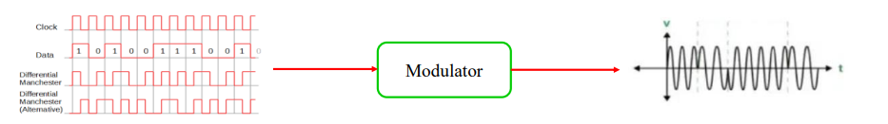  Channel: physical medium which connects the transmitter with that of the receiver Noise: corrupted information (Electronics devices: thermal, white and shot, Man-made: automobile and electromagnetic interference and other electronics equipment; natural sources: atmospheric and electrical lighting)  Receiver  De-modulator: channel corrupted transmitted waveform and maps them back to estimate of transmitted data sequence.  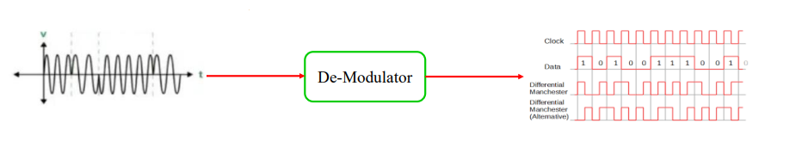  Baseband: channel corrupted transmitted waveform and maps them back to estimate of transmitted data sequence. Line coded pulse waveform to transmitted data sequence.  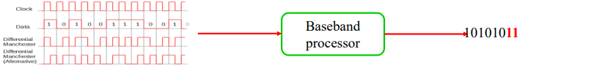  Channel decoder: reconstruct the original information sequence.  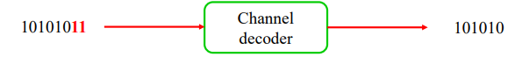  Source decoder: estimate the digital signal from the information sequence.  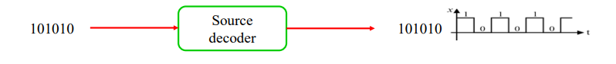  De-formatter: convert back the digital data to either discrete or analog form.  O/P Transducer: convert estimate of digital signal to analog nonelectrical signal.  Performance measure: demodulator and decoder is the frequency of BER. BER depends on Channel coding characteristic, type of analog signal used in transmission at modulator, transmitter power, channel characteristics and the method of demodulation and decoding. | CO1 | K3 | 4
QB102(a) | Derive the expression for quantization and discuss Uniform quantization.  Quantization within the finite amplitude range of the signal, we find an infinite number of amplitude levels.  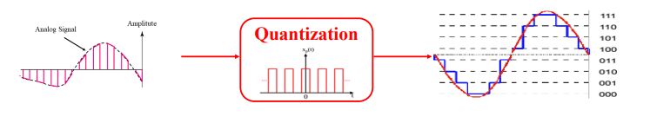  Amplitude quantization is defined as the process of transforming the sample amplitude $m\left(nT_{s}\right)$, of a message signal m(t) at a time t=$nT_{s}$ into a discrete amplitude taken from a finite set of possible amplitude.  The signal amplitude m is specified by the index k if it lies inside partition cell. The quantization process is memoryless and instantaneous. The quantizer inputs are called decision levels or decision threshold. The spacing between two adjacent representation level is called quantum or step-size. There are three types of Quantization - Uniform Quantization, Non-uniform Quantization and Vector quantization.  Vector quantization: is used in speech coding technique. Uniform Quantization: in which the quantization levels are uniformly spaced. Non-uniform Quantization: in which the quantization levels are unequal and mostly the relation between them is logarithmic. There are two types of uniform quantization. They are Mid-Rise type and Mid-Tread type. The following figures represent the two types of uniform quantization.  The Mid-Rise type is so called because the origin lies in the middle of a raising part of the stair-case like graph. The quantization levels in this type are even in number. The Mid-tread type is so called because the origin lies in the middle of a tread of the stair-case like graph. The quantization levels in this type are odd in number. Both the mid-rise and mid-tread type of uniform Quantizer are symmetric about the origin. Quantization introduces an error defined as the difference between the input signal m and the output signal v. The error is called quantization error. Quantization error Q of sample value q, Q = M - V or q = m – v  Input m having zero mean, quantizer assumed to be symmetric, quantization error Q, will also have zero mean. M is continuous amplitude in range ($-m_{max}$, $+m_{max}$) and L is total level of representation, the step size of the quantizer is  $$∆=\frac{2m_{max}}{L}$$  The probability density function of the quantization error Q as  $$f_{Q}\left(q\right)=\left\{\begin{aligned}\frac{1}{∆}, -\frac{∆}{2}<q ≤\frac{∆}{2} \\ 0, otherwise \end{aligned}\right.$$  The mean of the quantization error being zero, variance is the same as the mean square value,  $$σ_{Q}^{2}=E\left[Q^{2}\right]= \int_{-\frac{∆}{2}}^{\frac{∆}{2}}{q^{2}f_{Q}\left(q\right) dq}= \frac{1}{∆} \int_{-\frac{∆}{2}}^{\frac{∆}{2}}{q^{2} dq}= \frac{∆^{2}}{12}$$  L – ary number k, R denotes the number of bits per sample used in the construction of the binary code.  $$L=2^{R}, R=\log_{2}{L}$$  Step size is $∆ = \frac{2m_{max}}{2^{R}},$the variance rewritten as  $$σ_{Q}^{2}=\frac{1}{3}m_{max}^{2}2^{-2R}$$  P denotes average power of the message signal, output signal-to-noise ratio of a uniform quantizer is  $$SNR_{o}= \frac{P}{σ_{Q}^{2}}=\left(\frac{3P}{m_{max}^{2}}\right) 2^{2R}$$  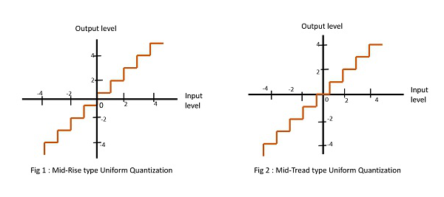 | CO1 | K2 | 2
Or
QB102(b) | Explain the key elements of a digital communication system, including the roles of the transmitter, channel, and receiver. How do these elements ensure reliable data transmission?    Transmitter  Information source: analog in nature (Voice, Video, Text and Images) I/P  Transducer: convert analog signal into analog electrical signal (computer data are in discrete form)    Formatter: electrical signal into a sequence of digital signals.  Source encoder: compresses the data into minimum number of bits. Eg: Lossy and Lossless compression, Arithmetic, Huffman, Shannon, Shannon–fano coding.    Channel encoder: combat noise in the channel, some redundancy is deliberately introduced in the message. Eg: Block, Cyclic, Convolution, Turbo code….    Baseband Processor: proper detection in the receiver and to combat noise and interference, line coding is used. Eg: Manchester, P-NRZ, PRZ, B-NRZ, B-RZ….    Modulator: is to map the digital signal to high frequency analog signal. Eg: PCM, DM, DPCM,  ASK, PSK, FSK, QAM….    Channel: physical medium which connects the transmitter with that of the receiver Noise: corrupted information (Electronics devices: thermal, white and shot, Man-made: automobile and electromagnetic interference and other electronics equipment; natural sources: atmospheric and electrical lighting)  Receiver  De-modulator: channel corrupted transmitted waveform and maps them back to estimate of transmitted data sequence.    Baseband: channel corrupted transmitted waveform and maps them back to estimate of transmitted data sequence. Line coded pulse waveform to transmitted data sequence.    Channel decoder: reconstruct the original information sequence.    Source decoder: estimate the digital signal from the information sequence.    De-formatter: convert back the digital data to either discrete or analog form.  O/P Transducer: convert estimate of digital signal to analog nonelectrical signal.  Performance measure: demodulator and decoder is the frequency of BER. BER depends on Channel coding characteristic, type of analog signal used in transmission at modulator, transmitter power, channel characteristics and the method of demodulation and decoding. | CO1 | K3 | 4
QB103(a)* | Draw the tree diagram, calculate efficiency, redundancy and variance of given samples {0.4, 0.19, 0.16, 0.15, 0.15} using Huffman coding method.  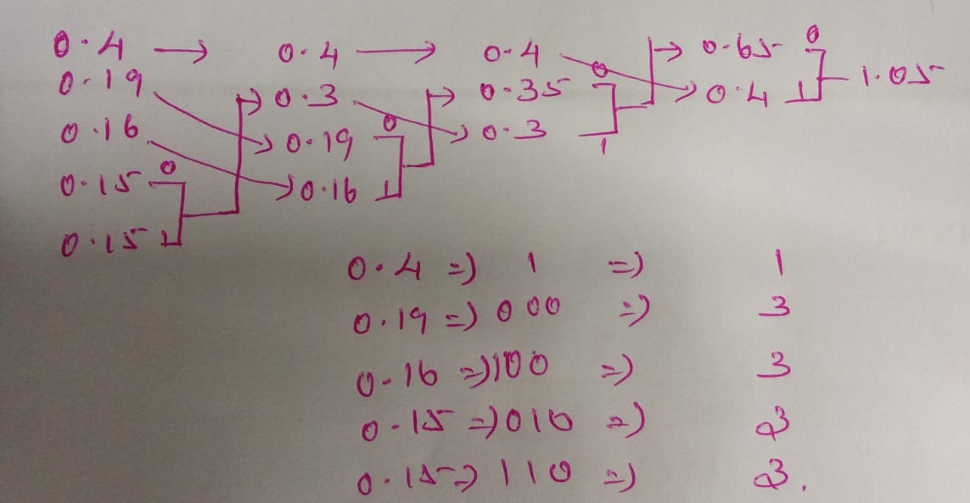  - Average code word length, L= $\sum_{k=0}^{k-1}{P_{k}l_{k}}$ = 2.35  - Entropy, $H\left(s\right)=\sum_{k=0}^{k-1}{P_{k}\log_{2}{\frac{\text{1 }}{P_{k}}}}$ = 2.22 $\left[\log_{2 }x{= \frac{\log_{10 }x}{\log_{10 }2}}\right]$  - Variance, $σ^{2}=\sum_{k=0}^{k-1}{P_{k}{\left(l_{k}-L\right)}^{2} }$= 1  - Efficiency, $η=\frac{\text{H(s) }}{L}$ = 94.8%  - Redundancy, r = 1 – η = 0.052 | CO1 | K2 | 2
Or
QB103(b)* | Draw the tree diagram, calculate efficiency, redundancy and variance of given samples {0.3, 0.25, 0.2, 0.12, 0.08, 0.05} using Shannon-Fano coding method.  0.3 00 2  0.25 01 2  0.2 10 2  0.12 110 3  0.08 1110 4  0.05 1111 4  - Average code word length, L= $\sum_{k=0}^{k-1}{P_{k}l_{k}}$ = 2.38  - Entropy, $H\left(s\right)=\sum_{k=0}^{k-1}{P_{k}\log_{2}{\frac{\text{1 }}{P_{k}}}}$ $\left[\log_{2 }x{= \frac{\log_{10 }x}{\log_{10 }2}}\right]$ = 2.36  - Variance, $σ^{2}=\sum_{k=0}^{k-1}{P_{k}{\left(l_{k}-L\right)}^{2} }$ = 0.496  - Efficiency, $η=\frac{\text{H(s) }}{L}$ = 0.992  - Redundancy, r = 1 – η = 0.008 | CO1 | K2 | 3
QB104(a)* | Draw the tree diagram, calculate efficiency, redundancy and variance of given samples {0.125, 0.0625, 0.25, 0.0625, 0.125, 0.125, 0.25} using Huffman coding method.  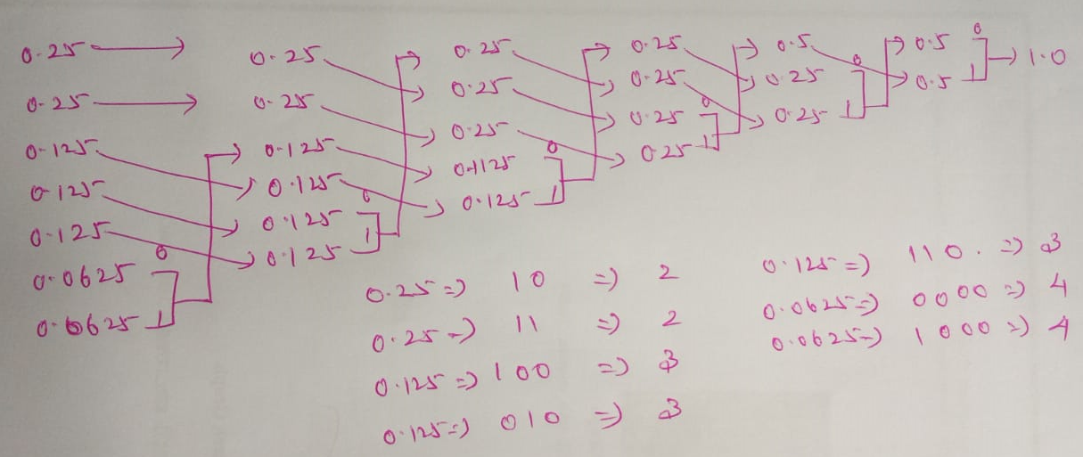  - Average code word length, L= $\sum_{k=0}^{k-1}{P_{k}l_{k}}$ = 2.625  - Entropy, $H\left(s\right)=\sum_{k=0}^{k-1}{P_{k}\log_{2}{\frac{\text{1 }}{P_{k}}}}$ = 2.625 $\left[\log_{2 }x{= \frac{\log_{10 }x}{\log_{10 }2}}\right]$  - Variance, $σ^{2}=\sum_{k=0}^{k-1}{P_{k}{\left(l_{k}-L\right)}^{2} }$= 0.484  - Efficiency, $η=\frac{\text{H(s) }}{L}$ = 1  - Redundancy, r = 1 – η = 0. | CO1 | K2 | 3
Or
QB104(b)* | Draw the tree diagram, calculate efficiency, redundancy and variance of given samples {0.5, 0.2, 0.2, 0.1} using Shannon-Fano coding method. (8)  0.5 0 1  0.2 10 2  0.2 110 3  0.1 111 3  - Average code word length, L= $\sum_{k=0}^{k-1}{P_{k}l_{k}}$ = 1.8  - Entropy, $H\left(s\right)=\sum_{k=0}^{k-1}{P_{k}\log_{2}{\frac{\text{1 }}{P_{k}}}}$ $\left[\log_{2 }x{= \frac{\log_{10 }x}{\log_{10 }2}}\right]$ = 1.761  - Variance, $σ^{2}=\sum_{k=0}^{k-1}{P_{k}{\left(l_{k}-L\right)}^{2} }$= 0.76  - Efficiency, $η=\frac{\text{H(s) }}{L}$ = 0.978  - Redundancy, r = 1 – η = 0.022  Write the Shannon capacity theorem. Calculate the channel capacity for given bandwidth is 3KHz and signal to noise radio is 10dB. (5)  Solution  Channel capacity, 𝑐 = 𝐵 log2(1 + 𝑆𝑁𝑅)  = 3𝐾 ∗ log2(1 + 10) = 3𝐾 ∗ log2 11 = 10.378K b/s | CO2 | K2 | 3
QB201(A) | With neat diagram, explain the working principles of PCM.  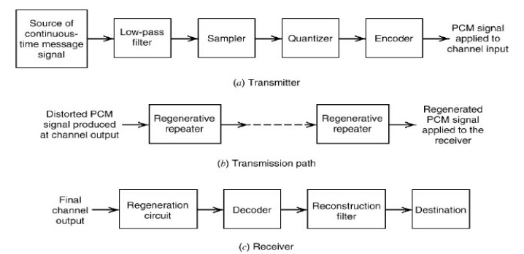  PCM, a message signal is represented by a sequence of coded pulse, which is accomplished by representing the signal in discrete form in both time and amplitude. A signal is sampled at a rate slightly higher than the Nyquist rate as usually done in PCM.  PCM system are sampling, quantizing and encoding, the low pass filter prior to sampling is included to prevent aliasing of the message signal.  The quantization and encoding operations are usually performed in the same circuits, which is called an analog-to digital converter. The basic operation in the receiver in the receiver are regeneration of impaired signals, decoding, and reconstruction of the train of quantized sample.  The regeneration also occurs at intermediate points along the transmission path as necessary. Sampling: incoming message signal is sampled with a train of narrow rectangular pulses so as to closely approximately the instantaneous sampling process.  Perfect reconstruction of the message signal at the receiver, the sampling are must be grater than twice the highest frequency components W of the message signal in accordance with the sampling theorem.  Low pass anti-aliasing filter is used at the front end of the sampler to exclude frequency greater than W before sampling. The sampling permits the reduction of the continuously varying message signal to a limited number of discrete values per seconds.  Quantization: new representation of the signal that is discrete in both time and amplitude. It is preferable to use a variable separation between the representation levels.  The range of voltage covered by voice signals, from the peaks of loud talk to the weak passages of weak talk, is on the order of 1000 to 1. A nonuniform quantizer with the feature that the step-size increase as the separation from origin of the input-output amplitude characteristics is increased.  The large end steps of the quantizer can take care of possible excursions of the voice signal into the large amplitude ranges that occur relatively infrequently.  The weak passages, which need more protection, are favored at the expense of the loud passages. A nonuniform quantizer is equivalent to passing the baseband signal through a compressor and then applying the compressed signal to a uniform quantizer.  The compression law that is used in practice is the A-law (Europe) and μlaw (North America). A-law and μ-law, the combination of a compressor and an expander is called a compander. The dynamic range capability of the compander improve with increasing A and μ-law, respectively.  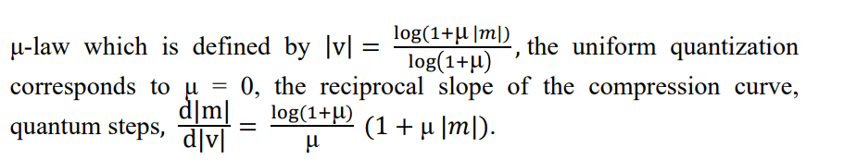  Where m and v are normalized input and output voltage, μ-law is strictly linear and not strictly logarithmic.  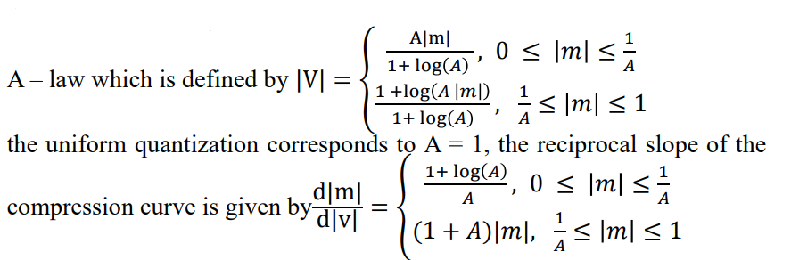  Restore the signal to their correct relative level, use a device in the receiver which a characteristics complementary to the compressor. Such a device is called an expander.  The compression and expander laws are exactly inverse. The effect of quantization, the expander output is equal to the compressor input.  The combination of compressor and expander is called compander. SNR for low -level signals increase at the expense of the high -level signal.  The typical values used in A -law = 87 . 6 and μ -law = 255.  Encoding: Combining process of sampling and quantization, the specification of a baseband signal becomes limited to a discrete set of values, but not in the form best suited to transmission over a telephone line or radio path.  An encoding process to translate the discrete set of values to a more appropriate form of signal. Any plan for representing each of this discrete set of values as a particular arrangement of discrete events is called code.  The discrete events in a code is called code element or symbol. Symbols used in a code to represent a single value of the discrete set is called a code word or character.  Each symbol may be either of two distinct values or kind is called binary code. Two symbols of a binary code are denoted as 0 and 1.  Maximum advantage over the effects of noise in transmission medium is obtained by using a binary code, because a binary symbol withstand a relatively high level of noise and is easy to regenerate.  Regenerative repeater: Reconstructing PCM signal by means of a chain of regenerative repeaters located at sufficient close spacing along the transmission route. Three basic functions are performed by a regenerative repeater: equalizing, timing and decision making.  Amplifier & Equalizer shapes the received pulses, to compensate for the effects of amplitude and phase distortions produced by the nonideal transmission characteristics of the channels. Timing circuit provide a periodic pulse of train, derived from the received pulses, for sampling and the equalized pulse at the instants of time where the SNR is a maximum. Code word consists of R bits, bit is an acronym for binary digits; thus R denoted the number of bits per sample.  PCM systems lies in the ability to control the effect of distortion and noise produced by transmitting a PCM signal through a channel. Each sample so extracted is compared to predetermined threshold in the decision making device, a decision is then made whether the received symbol is a 1 or a 0 on the basis of whether the threshold is exceed or not. If the threshold is exceeded, a clean new pulse representing symbol 1 is transmitted to next repeater.  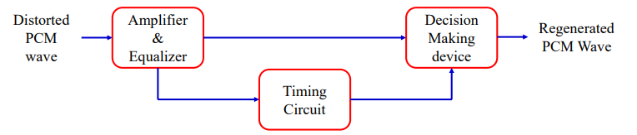  Otherwise, another new pulse representing symbol 0 is transmitted. In this way, the accumulation of distortion and noise in a repeater is completely removed.  Ideally, except for delay, the regenerated signal is exactly the same as the signal originally transmitted.  Reason for regenerative signal: The unavoidable presence of channel noise and interference cause the repeater to make wrong decisions occasionally, introducing bit errors into the regenerated signal.  Spacing between received pulses deviated from its assigned value, a jitter is introduced into the regenerated pulse position, thereby causing distortion.  Decoding: the first operation in the receiver is to regenerate, the received pulse one last time. Clean pulse are then regrouped into code words and decoded into a quantized signal.  Recover the message signal by passing the decoder output through a low-pass reconstruction filter whose cutoff frequency is equal to the message bandwidth W.  The transmission path is error free, the recovered signal includes no noise with the exception of the initial distortion introduced by the quantization process. | CO2 | K3 | 2
Or
QB201(B) | Discuss in details about Delta modulation and explain its noises effects.  Delta modulation, an incoming message signal is over sampled to purposely increase the correlation Between adjacent samples of the signal.  A staircase approximation to the over sampled version of the message signal. The difference between input and the approximation is quantized into two level, namely +∆ -∆, corresponding to positive and negative difference.  The approximation is falls below the signal at any sampling epoch, it is increased by ∆.  The approximation is falls above the signal at any sampling epoch,it is diminished by∆.Signal does not changes too rapidly from sample to sample.  Convenience of presentation m[n]=m(nTs) , where n=0,±1,±2,...  Ts is sampling period m(nTs) sample of signal m(t) at time t=nTs.  Delta modulation in the following set of discrete-time relations  e[n]=m[n]−m𝑞[𝑛−1]  e𝑞=Δ𝑠𝑔𝑛(𝑒[𝑛])  m𝑞=mq𝑛−1+𝑒𝑞[𝑛]  Where 𝑒𝑞[𝑛] quantized version of 𝑒[𝑛], 𝑒[𝑛]is an error signal the difference between the present input m[𝑛]of the input signal and the latest approximation 𝑚𝑞[𝑛−1] and sig(.) is the signum function.The quantizer output 𝑚𝑞[𝑛] is code to produce the DM signal.  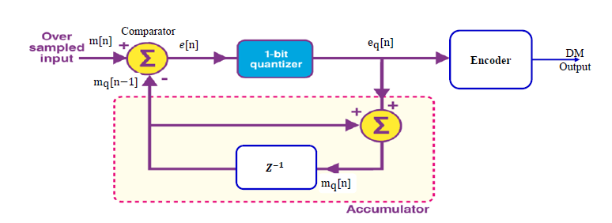  The principle of DM is simplicity. Applying the sampled version of the incoming message signal to a modulator that involves a comparator, quantizer and accumulator. Z−1 inside the accumulator represented a unit delay, that is equal to one sampling period. The comparator compute the difference between its two inputs.  The quantizer consists of a hard limiter with an input- output relation that is scaled version of the signum function. The quantizer output is then applied to an accumulator, producing the result.  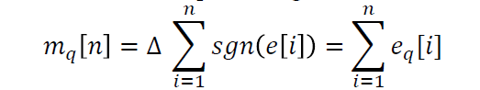  At the sampling instant nTs , the accumulator increment the approximation by a ∆ step in a positive or negative direction, depending on the algebraic sign of the error sample e[n].  The input sample [𝑛] is greater than the most recent approximation 𝑚[𝑛], a positive increment +∆ is applied to the approximation. The input sample 𝑚[𝑛] is smaller, a negative  increment-∆ is applied to the approximation. The accumulator does the best it can to track the input samples by one step at a time.  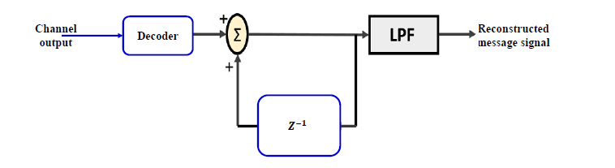  The staircase approximation [𝑛] is reconstructed by passing the sequence of positive and negative pulses, produced at the decoder output, through an accumulator in a manner similar to that used in the transmitter. The out-of-band quantization noise in the high frequency staircase waveform 𝑚𝑞[𝑛]is rejected by passing it through a low pass filter, with a bandwidth equal to the original message bandwidth.  Noise in delta Modulation.  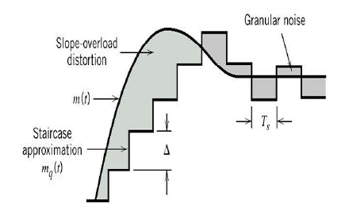  DM is subject to two noise types of quantization error: slope over load distortion and granular noise. The digital equivalent of integration in the sense that it represent the accumulation of positive and negative increments of magnitude of ∆.  The quantization error by 𝑞[𝑛],  𝑚𝑞[𝑛]=𝑚[𝑛]+𝑞[𝑛]  The input of the quantizer is  𝑒[𝑛]=𝑚[𝑛]−𝑚[𝑛−1]−𝑞[𝑛−1]  The quantization error 𝑞[𝑛−1], the quantizer input is first backward difference of the input signal, which may be viewed as a digital approximation to the derivative of the input signal,  as the inverse of the digital integration process.  The maximum slope of the original input sample 𝑚(𝑡) it is clear that in order for the sequence of the samples {𝑚𝑞𝑛} to increase as fast as the input sequence of samples {𝑚𝑛} in a region of maximum slope of𝑚𝑡,  Δ/𝑇𝑠≥max|𝑑𝑚(𝑡)/𝑑𝑡|  The step size Δ is too small for the staircase approximation (𝑡) to follow a steep segment of the input waveform m(t), with the result that 𝑚𝑞(𝑡) falls behind m(t). This condition is called slope over load, the resulting quantization error is called slope- over load distortion.  The maximum slope of the staircase approximation 𝑚𝑞[𝑡] is fixed by the step size Δ, increases and decreases in 𝑚𝑞{𝑡} tend to occur a long straight lines. A delta modulator using fixed step size is often referred to as a linear delta modulation.  Granular noise occurs when a step size Δ is too large relative to the local slope characteristics of the input waveform m(t), thereby causing the staircase approximation 𝑚𝑞(𝑡) to hunt around a relatively flat segment of the input waveform.  A large step size to accommodate a wide dynamic range, where as a small step size is required for the accurate representation of relatively low level signals.  The optimum step size that minimize the mean square value of the quantization error in a linear delta modulation.  The step size is made to vary in accordance with the input signal; called adaptive delta modulator. | CO2 | K2 | 2
QB202(A) | With suitable diagram, explain the working principles of DPCM and derive the expression for processing gain.  Removing redundancy before encoding, which is the basic idea behind Differential Pulse Code Modulation. A baseband signal m(t) is sampled at the rate 𝑓𝑠 = 1 /𝑇𝑠 to produce the sequence {m[n]} whose samples are Ts seconds apart. The fact that it is possible to predict future values of the signal m(t) provides motivation for the differential quantization.  The input signal to the quantizer is  𝑒 [ 𝑛] = 𝑚{𝑛} − 𝑚′ [𝑛]  Which is difference between the unquantized input sample m[n] and a prediction of it denoted by 𝑚′ [𝑛]. This predicted value is produced by using linear prediction filter, consists of a quantized version of the input sample m[n]. The difference signal e{n} is the prediction error. The amount by which the prediction filter fails to predict the input exactly. Encoding the quantizer output, a variant of PCM known as DPCM.  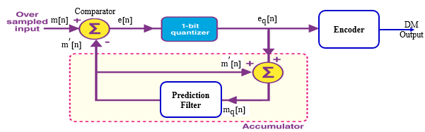  The quantizer output may be expresses as  𝑒q[𝑛] = 𝑒[𝑛] + 𝑞[𝑛]  q[n] is the quantizer error, the quantizer output eq[n] is added to the predicted value m` [n] to produce the prediction filter input,  𝑚𝑞 [𝑛] = 𝑚′ [𝑛] + 𝑞[𝑛]  𝑚𝑞 [𝑛] = 𝑚′[𝑛] + 𝑒 [𝑛] + 𝑞[𝑛]  The sum of 𝑚′ [𝑛] + 𝑒 [𝑛] is equal to the input sample m [𝑛].  𝑚𝑞 [𝑛] = 𝑚 [𝑛] + 𝑞 [𝑛]  A quantized version of the input sample m [𝑛] . Irrespective of the properties of the prediction filter, the quantized sample 𝑚𝑞 [𝑛] at the prediction filter input differs from the original input sample [𝑛] by the quantization error 𝑞 [𝑛] .  If the prediction is good, the variance of the prediction error 𝑒 𝑛 will be smaller than the variance of [𝑛] .  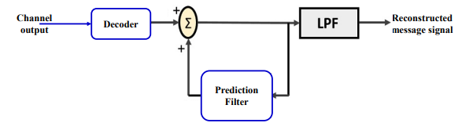  Receiver consists of decoder to reconstruct the quantized error signal. The quantized version of the original input is reconstructed from the decoder output using prediction filter used in the transmitter.  The absence of channel noise, the encoded signal at the receiver input is identical to the encoded signal at the transmitter output. Receiver output is equal to 𝑚𝑞 [𝑛] which differs from the original input 𝑚 [𝑛] only by quantization error 𝑞 [𝑛] incurred as a result of quantizing the prediction error 𝑒 [𝑛].  In a noise free environment, the prediction filter in the transmitter and receiver operates on the same sequence of samples 𝑚𝑞 [𝑛] .  The difference between DM an DPCM is basically similar, except two important differences,  1. one-bit(two-level) quantizer in the delta modulation.  2. The replacement of the prediction filter by a single delay element. DM is the 1-bit version of DPCM.  Standard PCM system, the transmitter of both the DPCM and DM involve the use of feedback.  DPCM, like DM is subject to slope-overload distortion whenever the input signal changes too rapidly for the prediction filter to track it. PCM and DPCM suffer from quantization noise.  Processing Gain  Output signal-to-noise of the DPCM system is  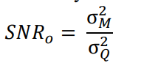  σ𝑀 2 is the variance of the original input sample m[𝑛], assumed to be of zero mean. σ𝑄 2 is the variance of the quantization error q[n]. σ𝐸 2 is the variance of prediction error.  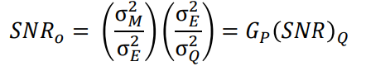  The (𝑆𝑁𝑅) 𝑄 is the signal-to-quantization noise ratio, and 𝐺𝑃 is the processing gain  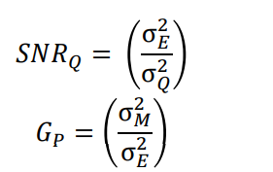  𝐺𝑃 is maximized by minimizing the variance σ𝐸 2 of the prediction error e[n]. Our objective should be to design the prediction filter so as to minimize σ𝐸 2. | CO2 | K2 | 1
Or
QB202(B) | - With a neat diagram, explain time division multiplexing. (8)  - Find differential encoding for the given data 11000011 and sketch the Manchester encoding waveform for the resultant data. (5)  Sampling theorem provides the basic for transmitting the information contained in a band limited message signal m(t) as a sequence of m(t) taken uniformly data rate that is usually slightly higher than Nyquist rate. The important features of sampling process is a conservation of time.  The message samples engage the communication channel for only a fraction of the sampling interval on a periodic basic. The time interval between adjacent sample is cleared for the use by other independent message source on a time shared basic.  A time division multiplexing system which enable the joint utilization of a common communication channel by a plurality of independent message sources without mutual interference among them. The input message signal is first restricted in bandwidth by a low-pass anti-aliasing filter to remove the frequencies that are nonessential to an adequate signal representation. Commutator, which is usually implemented using electronics switching circuitry.  Commutator is twofold:  1. to take narrow sample of each of the N input message at a rate 𝑓𝑠 , that is slightly higher than 2W, where W is the cutoff frequency of the anti-aliasing filter.  2. sequentially interleaves these N samples inside the sampling interval 𝑇𝑠 .  The multiplexed signal is applied to a pulse modulator, the purpose of which is to transform the multiplexed signal into a form suitable for transmission over the common channel.  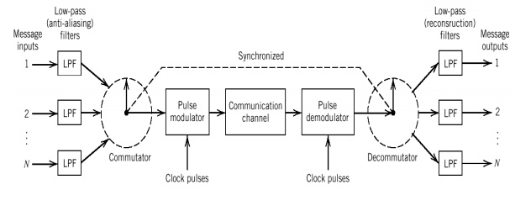  TDM introduces a bandwidth expansion factor N. N sample derived from N independent message sources into a time slot equal to one sampling interval.  The received signal is applied to a pulse demodulator, which perform the reverse operation of the pulse modulator.  Narrow samples produced at the pulse demodulator output are distributed to the appropriate low-pass reconstruction filters by means of a decommutator, which operates in synchronism with the commutator in the transmitter.  2. Find differential encoding for the given data 11000011 and sketch the Manchester encoding waveform for the resultant data.  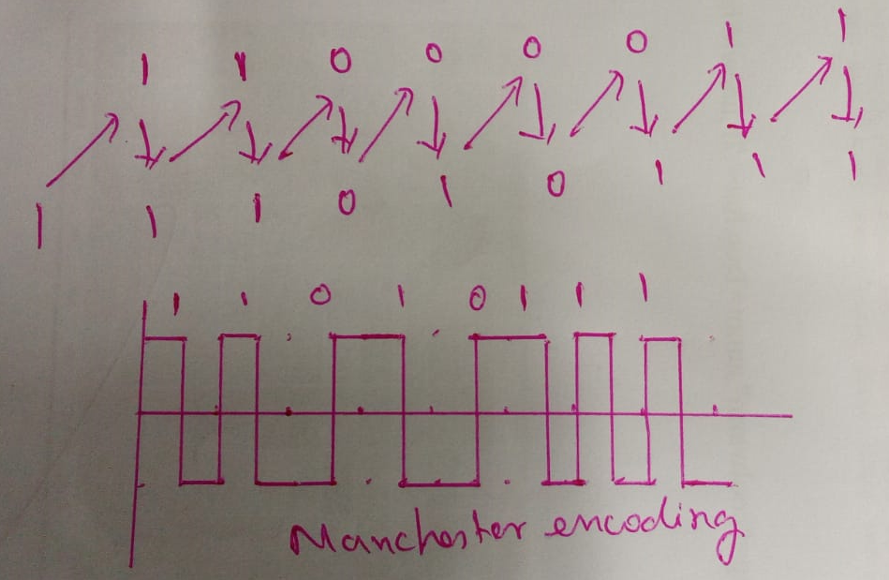 | CO2 | K3 | 2
QB203(A) | Sketch the waveform for a given binary data 11000110. 1, Unipolar NRZ, 2. Bipolar RZ, 3. Unipolar RZ, 4. Polar NRZ and 5. Manchester encoding.  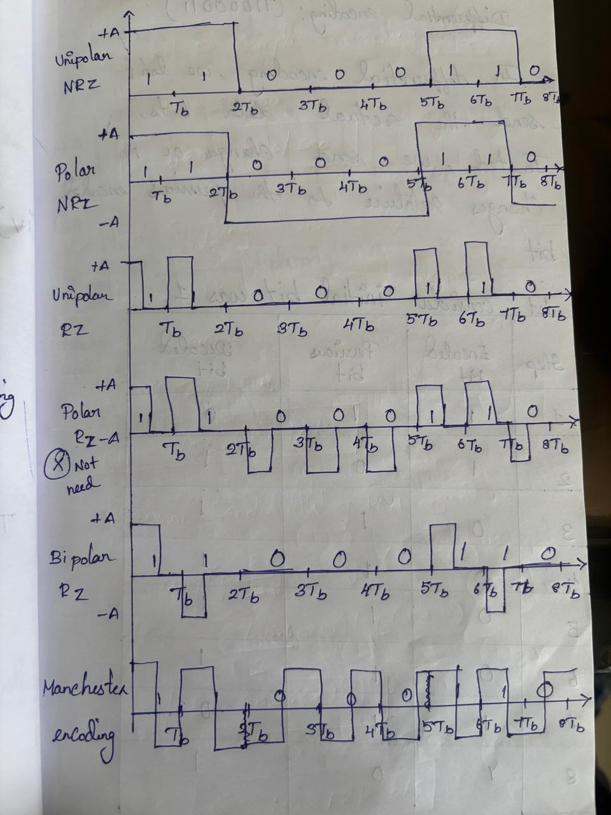 | CO2 | K3 | 2
Or
QB203(B) | With neat diagram, explain the working principles of PCM.    PCM, a message signal is represented by a sequence of coded pulse, which is accomplished by representing the signal in discrete form in both time and amplitude. A signal is sampled at a rate slightly higher than the Nyquist rate as usually done in PCM.  PCM system are sampling, quantizing and encoding, the low pass filter prior to sampling is included to prevent aliasing of the message signal.  The quantization and encoding operations are usually performed in the same circuits, which is called an analog-to digital converter. The basic operation in the receiver in the receiver are regeneration of impaired signals, decoding, and reconstruction of the train of quantized sample.  The regeneration also occurs at intermediate points along the transmission path as necessary. Sampling: incoming message signal is sampled with a train of narrow rectangular pulses so as to closely approximately the instantaneous sampling process.  Perfect reconstruction of the message signal at the receiver, the sampling are must be grater than twice the highest frequency components W of the message signal in accordance with the sampling theorem.  Low pass anti-aliasing filter is used at the front end of the sampler to exclude frequency greater than W before sampling. The sampling permits the reduction of the continuously varying message signal to a limited number of discrete values per seconds.  Quantization: new representation of the signal that is discrete in both time and amplitude. It is preferable to use a variable separation between the representation levels.  The range of voltage covered by voice signals, from the peaks of loud talk to the weak passages of weak talk, is on the order of 1000 to 1. A nonuniform quantizer with the feature that the step-size increase as the separation from origin of the input-output amplitude characteristics is increased.  The large end steps of the quantizer can take care of possible excursions of the voice signal into the large amplitude ranges that occur relatively infrequently.  The weak passages, which need more protection, are favored at the expense of the loud passages. A nonuniform quantizer is equivalent to passing the baseband signal through a compressor and then applying the compressed signal to a uniform quantizer.  The compression law that is used in practice is the A-law (Europe) and μlaw (North America). A-law and μ-law, the combination of a compressor and an expander is called a compander. The dynamic range capability of the compander improve with increasing A and μ-law, respectively.    Where m and v are normalized input and output voltage, μ-law is strictly linear and not strictly logarithmic.    Restore the signal to their correct relative level, use a device in the receiver which a characteristics complementary to the compressor. Such a device is called an expander.  The compression and expander laws are exactly inverse. The effect of quantization, the expander output is equal to the compressor input.  The combination of compressor and expander is called compander. SNR for low -level signals increase at the expense of the high -level signal.  The typical values used in A -law = 87 . 6 and μ -law = 255.  Encoding: Combining process of sampling and quantization, the specification of a baseband signal becomes limited to a discrete set of values, but not in the form best suited to transmission over a telephone line or radio path.  An encoding process to translate the discrete set of values to a more appropriate form of signal. Any plan for representing each of this discrete set of values as a particular arrangement of discrete events is called code.  The discrete events in a code is called code element or symbol. Symbols used in a code to represent a single value of the discrete set is called a code word or character.  Each symbol may be either of two distinct values or kind is called binary code. Two symbols of a binary code are denoted as 0 and 1.  Maximum advantage over the effects of noise in transmission medium is obtained by using a binary code, because a binary symbol withstand a relatively high level of noise and is easy to regenerate.  Regenerative repeater: Reconstructing PCM signal by means of a chain of regenerative repeaters located at sufficient close spacing along the transmission route. Three basic functions are performed by a regenerative repeater: equalizing, timing and decision making.  Amplifier & Equalizer shapes the received pulses, to compensate for the effects of amplitude and phase distortions produced by the nonideal transmission characteristics of the channels. Timing circuit provide a periodic pulse of train, derived from the received pulses, for sampling and the equalized pulse at the instants of time where the SNR is a maximum. Code word consists of R bits, bit is an acronym for binary digits; thus R denoted the number of bits per sample.  PCM systems lies in the ability to control the effect of distortion and noise produced by transmitting a PCM signal through a channel. Each sample so extracted is compared to predetermined threshold in the decision making device, a decision is then made whether the received symbol is a 1 or a 0 on the basis of whether the threshold is exceed or not. If the threshold is exceeded, a clean new pulse representing symbol 1 is transmitted to next repeater.    Otherwise, another new pulse representing symbol 0 is transmitted. In this way, the accumulation of distortion and noise in a repeater is completely removed.  Ideally, except for delay, the regenerated signal is exactly the same as the signal originally transmitted.  Reason for regenerative signal: The unavoidable presence of channel noise and interference cause the repeater to make wrong decisions occasionally, introducing bit errors into the regenerated signal.  Spacing between received pulses deviated from its assigned value, a jitter is introduced into the regenerated pulse position, thereby causing distortion.  Decoding: the first operation in the receiver is to regenerate, the received pulse one last time. Clean pulse are then regrouped into code words and decoded into a quantized signal.  Recover the message signal by passing the decoder output through a low-pass reconstruction filter whose cutoff frequency is equal to the message bandwidth W.  The transmission path is error free, the recovered signal includes no noise with the exception of the initial distortion introduced by the quantization process. | CO2 | K3 | 2
QB204(A) | Discuss in details about Delta modulation and explain its noises effects.  Delta modulation, an incoming message signal is over sampled to purposely increase the correlation Between adjacent samples of the signal.  A staircase approximation to the over sampled version of the message signal. The difference between input and the approximation is quantized into two level, namely +∆ -∆, corresponding to positive and negative difference.  The approximation is falls below the signal at any sampling epoch, it is increased by ∆.  The approximation is falls above the signal at any sampling epoch,it is diminished by∆.Signal does not changes too rapidly from sample to sample.  Convenience of presentation m[n]=m(nTs) , where n=0,±1,±2,...  Ts is sampling period m(nTs) sample of signal m(t) at time t=nTs.  Delta modulation in the following set of discrete-time relations  e[n]=m[n]−m𝑞[𝑛−1]  e𝑞=Δ𝑠𝑔𝑛(𝑒[𝑛])  m𝑞=mq𝑛−1+𝑒𝑞[𝑛]  Where 𝑒𝑞[𝑛] quantized version of 𝑒[𝑛], 𝑒[𝑛]is an error signal the difference between the present input m[𝑛]of the input signal and the latest approximation 𝑚𝑞[𝑛−1] and sig(.) is the signum function.The quantizer output 𝑚𝑞[𝑛] is code to produce the DM signal.    The principle of DM is simplicity. Applying the sampled version of the incoming message signal to a modulator that involves a comparator, quantizer and accumulator. Z−1 inside the accumulator represented a unit delay, that is equal to one sampling period. The comparator compute the difference between its two inputs.  The quantizer consists of a hard limiter with an input- output relation that is scaled version of the signum function. The quantizer output is then applied to an accumulator, producing the result.    At the sampling instant nTs , the accumulator increment the approximation by a ∆ step in a positive or negative direction, depending on the algebraic sign of the error sample e[n].  The input sample [𝑛] is greater than the most recent approximation 𝑚[𝑛], a positive increment +∆ is applied to the approximation. The input sample 𝑚[𝑛] is smaller, a negative  increment-∆ is applied to the approximation. The accumulator does the best it can to track the input samples by one step at a time.    The staircase approximation [𝑛] is reconstructed by passing the sequence of positive and negative pulses, produced at the decoder output, through an accumulator in a manner similar to that used in the transmitter. The out-of-band quantization noise in the high frequency staircase waveform 𝑚𝑞[𝑛]is rejected by passing it through a low pass filter, with a bandwidth equal to the original message bandwidth.  Noise in delta Modulation.    DM is subject to two noise types of quantization error: slope over load distortion and granular noise. The digital equivalent of integration in the sense that it represent the accumulation of positive and negative increments of magnitude of ∆.  The quantization error by 𝑞[𝑛],  𝑚𝑞[𝑛]=𝑚[𝑛]+𝑞[𝑛]  The input of the quantizer is  𝑒[𝑛]=𝑚[𝑛]−𝑚[𝑛−1]−𝑞[𝑛−1]  The quantization error 𝑞[𝑛−1], the quantizer input is first backward difference of the input signal, which may be viewed as a digital approximation to the derivative of the input signal,  as the inverse of the digital integration process.  The maximum slope of the original input sample 𝑚(𝑡) it is clear that in order for the sequence of the samples {𝑚𝑞𝑛} to increase as fast as the input sequence of samples {𝑚𝑛} in a region of maximum slope of𝑚𝑡,  Δ/𝑇𝑠≥max|𝑑𝑚(𝑡)/𝑑𝑡|  The step size Δ is too small for the staircase approximation (𝑡) to follow a steep segment of the input waveform m(t), with the result that 𝑚𝑞(𝑡) falls behind m(t). This condition is called slope over load, the resulting quantization error is called slope- over load distortion.  The maximum slope of the staircase approximation 𝑚𝑞[𝑡] is fixed by the step size Δ, increases and decreases in 𝑚𝑞{𝑡} tend to occur a long straight lines. A delta modulator using fixed step size is often referred to as a linear delta modulation.  Granular noise occurs when a step size Δ is too large relative to the local slope characteristics of the input waveform m(t), thereby causing the staircase approximation 𝑚𝑞(𝑡) to hunt around a relatively flat segment of the input waveform.  A large step size to accommodate a wide dynamic range, where as a small step size is required for the accurate representation of relatively low level signals.  The optimum step size that minimize the mean square value of the quantization error in a linear delta modulation.  The step size is made to vary in accordance with the input signal; called adaptive delta modulator. | CO2 | K3 | 2
Or
QB204(B) | With suitable diagram explain the working principles of DPCM and derive the expression for processing gain.  Removing redundancy before encoding, which is the basic idea behind Differential Pulse Code Modulation. A baseband signal m(t) is sampled at the rate 𝑓𝑠 = 1 /𝑇𝑠 to produce the sequence {m[n]} whose samples are Ts seconds apart. The fact that it is possible to predict future values of the signal m(t) provides motivation for the differential quantization.  The input signal to the quantizer is  𝑒 [ 𝑛] = 𝑚{𝑛} − 𝑚′ [𝑛]  Which is difference between the unquantized input sample m[n] and a prediction of it denoted by 𝑚′ [𝑛]. This predicted value is produced by using linear prediction filter, consists of a quantized version of the input sample m[n]. The difference signal e{n} is the prediction error. The amount by which the prediction filter fails to predict the input exactly. Encoding the quantizer output, a variant of PCM known as DPCM.    The quantizer output may be expresses as  𝑒q[𝑛] = 𝑒[𝑛] + 𝑞[𝑛]  q[n] is the quantizer error, the quantizer output eq[n] is added to the predicted value m` [n] to produce the prediction filter input,  𝑚𝑞 [𝑛] = 𝑚′ [𝑛] + 𝑞[𝑛]  𝑚𝑞 [𝑛] = 𝑚′[𝑛] + 𝑒 [𝑛] + 𝑞[𝑛]  The sum of 𝑚′ [𝑛] + 𝑒 [𝑛] is equal to the input sample m [𝑛].  𝑚𝑞 [𝑛] = 𝑚 [𝑛] + 𝑞 [𝑛]  A quantized version of the input sample m [𝑛] . Irrespective of the properties of the prediction filter, the quantized sample 𝑚𝑞 [𝑛] at the prediction filter input differs from the original input sample [𝑛] by the quantization error 𝑞 [𝑛] .  If the prediction is good, the variance of the prediction error 𝑒 𝑛 will be smaller than the variance of [𝑛] .    Receiver consists of decoder to reconstruct the quantized error signal. The quantized version of the original input is reconstructed from the decoder output using prediction filter used in the transmitter.  The absence of channel noise, the encoded signal at the receiver input is identical to the encoded signal at the transmitter output. Receiver output is equal to 𝑚𝑞 [𝑛] which differs from the original input 𝑚 [𝑛] only by quantization error 𝑞 [𝑛] incurred as a result of quantizing the prediction error 𝑒 [𝑛].  In a noise free environment, the prediction filter in the transmitter and receiver operates on the same sequence of samples 𝑚𝑞 [𝑛] .  The difference between DM an DPCM is basically similar, except two important differences,  1. one-bit(two-level) quantizer in the delta modulation.  2. The replacement of the prediction filter by a single delay element. DM is the 1-bit version of DPCM.  Standard PCM system, the transmitter of both the DPCM and DM involve the use of feedback.  DPCM, like DM is subject to slope-overload distortion whenever the input signal changes too rapidly for the prediction filter to track it. PCM and DPCM suffer from quantization noise.  Processing Gain  Output signal-to-noise of the DPCM system is    σ𝑀 2 is the variance of the original input sample m[𝑛], assumed to be of zero mean. σ𝑄 2 is the variance of the quantization error q[n]. σ𝐸 2 is the variance of prediction error.    The (𝑆𝑁𝑅) 𝑄 is the signal-to-quantization noise ratio, and 𝐺𝑃 is the processing gain    𝐺𝑃 is maximized by minimizing the variance σ𝐸 2 of the prediction error e[n]. Our objective should be to design the prediction filter so as to minimize σ𝐸 2. | CO3 | K3 | 3
QB301(A) | Elaborate on the operational principles of the transmitter and receiver in PSK, and derive the expression for the BER.  A coherent binary PSK system, the pair of the signals $s_{1}\left(t\right)$ and $s_{2}\left(t\right)$ used to represent binary symbol 0 and 1, respectively, is defined by  $$s_{1}\left(t\right)= \sqrt{\frac{2E_{b}}{T_{b}}} cos⁡(2{\text{π}f}_{c}t)$$  $$s_{2}\left(t\right)= \sqrt{\frac{2E_{b}}{T_{b}}}\cos\left(2{\text{π}f}_{c}t+\text{π}\right)=-\sqrt{\frac{2E_{b}}{T_{b}}}\cos\left(2{\text{π}f}_{c}t\right)$$  Where $0 ≤t ≤T_{b}$ and $E_{b}$ is the transmitted signal energy per bit, carrier frequency $f_{c}$is chosen equal to $\frac{n_{c}}{T_{b}}$ for some fixed integer $n_{c}$. A pair of sinusoidal waves that differ only in a relatively phase-shift of 180 degrees, are referred to as antipodal signals.  The binary PSK, there is only one basic function of unit energy,  $$ф_{1}\left(t\right)=\sqrt{\frac{2}{T_{b}}}\cos\left(2{\text{π}f}_{c}t\right) 0≤t<T_{b}$$  The transmitted signals $s_{1}(t)$ and $s_{2}(t)$ in terms of $ф_{1}\left(t\right)$ as follows  $$s_{1}\left(t\right)= \sqrt{E_{b}}{ ф}_{1}\left(t\right) 0≤t<T_{b}$$  $$s_{2}\left(t\right)=-\sqrt{E_{b}}{ ф}_{1}\left(t\right) 0≤t<T_{b}$$  PSK system is characterized by having a signal space that is one-dimensional, with a signal constellation consisting of two message points.  The coordinates of the message points are  $$s_{11}=\int_{0}^{T_{b}}{s_{1}\left(t\right)ф_{1}\left(t\right) dt}= \sqrt{E_{b}}$$  $$s_{21}=\int_{0}^{T_{b}}{s_{2}\left(t\right)ф_{1}\left(t\right) dt}=-\sqrt{E_{b}}$$  $s_{1}\left(t\right)$ is located at $s_{11}= \sqrt{E_{b}}$  $s_{2}\left(t\right)$ is located at $s_{21}=-\sqrt{E_{b}}$  Error probability of Binary PSK : A rule for making in favor of symbol 1 or 0. Set of point closet to message point 1 at $\sqrt{E_{b}}$ and message point 2 at $-\sqrt{E_{b}}$.  By constructing the midpoint of the line joining these two message points, and marking off the appropriate decision regions. The decision regions are marked $Z_{1}$ and $Z_{2}.$  The decision rule is now simply to decide that signal $s_{1}\left(t\right)$ (bin symbol 1) was transmitted if the received signal point falls in region $Z_{1}$, and decide that signal $s_{2}\left(t\right)$ (bin symbol 0) was transmitted if the received signal point falls in region $Z_{2}$.  Two kinds of erroneous, signal $s_{2}\left(t\right)$ is transmitted, but the noise is such that the received signal point falls inside region $Z_{1}$ and so the receiver decides in favor to the signal $s_{1}\left(t\right)$.  Signal $s_{1}\left(t\right)$ is transmitted, but the noise is such that the received signal point falls inside region $Z_{2}$ and so the receiver decides in favor to the signal $s_{2}\left(t\right)$.  The probability of making an error of the first kind, the decision region associated with symbol 1 or signal $s_{1}\left(t\right)$ is described by  $$Z_{1}:0<x_{1}< ∞$$  The observable elements $x_{1}$ is related to the received signal $x(t)$ by  $$x_{1}= \int_{0}^{T}{x\left(t\right)ф_{1}\left(t\right)dt}$$  The conditional probability density function of random variable $X_{1}$, is given that symbol 0 was transmitted, is defined by  ${f_{x}}_{1}\left(x_{1} | 0\right)=\frac{1}{\sqrt{\text{π}N_{0}}}exp\left[-\frac{1}{N_{0}}{\left(x_{1}-s_{21}\right)}^{2}\right]=\frac{1}{\sqrt{\text{π}N_{0}}}exp\left[-\frac{1}{N_{0}}{\left(x_{1}+\sqrt{E_{b}}\right)}^{2}\right]$  The conditional probability of the receiver deciding in favor of symbol 1, given that symbol 0 was transmitted  $$p_{10}=\int_{0}^{∞}{{f_{x}}_{1}\left(x_{1} | 0\right)dx_{1}}=\frac{1}{\sqrt{\text{π}N_{0}}}\int_{0}^{∞}{exp\left[-\frac{1}{N_{0}}{\left(x_{1}+\sqrt{E_{b}}\right)}^{2}\right]dx_{1}}$$  Replace $z=-\frac{1}{\sqrt{N_{0}}}\left(x_{1}+\sqrt{E_{b}}\right)$  $$p_{10}=\frac{1}{\sqrt{N_{0}}}\int_{\sqrt{E_{b}/N_{0}}}^{∞}{exp⁡(-z^{2})dz}=\frac{1}{2} erfc⁡\left(\sqrt{\frac{E_{b}}{N_{0}}}\right)$$  The conditional probability of the receiver deciding in favor of symbol 0, given that symbol 1 was transmitted.  Averaging the conditional error probability $p_{10}$ and $p_{01}$, the average probability of symbol error, equivalently, the bit error rate for coherent binary PSK is $P_{e}= \frac{1}{2} erfc⁡\left(\sqrt{\frac{E_{b}}{N_{0}}}\right)$  The input binary sequence in polar form with symbol 1 and 0 represented by constant amplitude level of $\sqrt{E_{b}}$ and -$\sqrt{E_{b}}$.  Signal transmission is performed by a Polar NRZ level encoder.  Binary wave and a sinusoidal carrier $ф_{1}\left(t\right)$, whose frequency $f_{c}=\frac{n_{c}}{T_{b}}$for some fixed integer $n_{c}$, are applied to a product modulator. The carrier and timing pulse used to generate the  binary wave are usually extracted from a common master clock. PSK modulated wave is obtained at the modulator output.  Detect the original binary sequence of 1 and 0, the noisy PSK signal $x(t)$ to a correlator, which is also supplied with locally generated coherent reference signal $ф_{1}\left(t\right)$.  The correlator output is $x_{1}$, is compared with a threshold of zero volts. If $x_{1}$> 0, the receiver decides in favor of symbol 1,  If $x_{1}$< 0, the receiver decides in favor of symbol 0,  If $x_{1}$exactly 0, the receiver makes a random guess in favor of 1 or 0.  The complex envelop of a binary PSK wave consists of an in-phase component only. The symbol 1 or 0 at the modulator input during the signaling interval 0 ≤ t ≤ $T_{b}$, in-phase component equals $g(t)$ or $-g(t)$. Where $g(t)$ is the symbol shaping function defined by  $$g\left(t\right)=\left\{\begin{aligned}\sqrt{\frac{2E_{b}}{T_{b}}}\text{, 0 ≤ t ≤ }T_{b} \\ &0, otherwise \end{aligned}\right.$$  The input binary wave is random, with symbol 1 and 0 equally likely. The symbol transmitted during the different time slots being statistically independent.  The power spectral density of a random binary wave so described is equal to the energy spectral density of the symbol shaping function divided by the symbol duration.  The energy spectral density of a Fourier transformable signal $g(t)$ is defined as the squared magnitude of the signals Fourier transform.  The baseband power spectral density of a binary PSK signal equals  $$S_{B}\left(f\right)= \frac{2E_{b}\sin^{2}{({\text{π}T}_{b}f)}}{{\left({\text{π}T}_{b}f\right)}^{2}}=2E_{b}sinc^{2}(T_{b}f)$$  This power spectrum falls off as the inverse square of frequency.  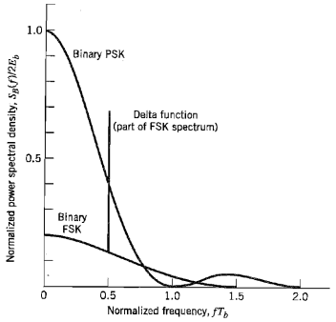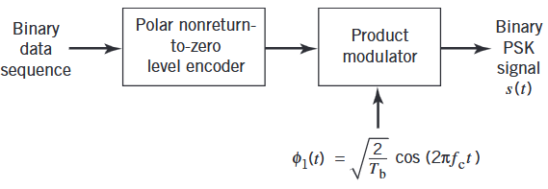  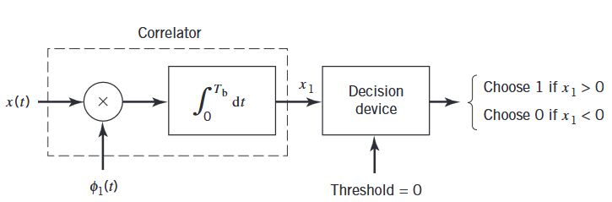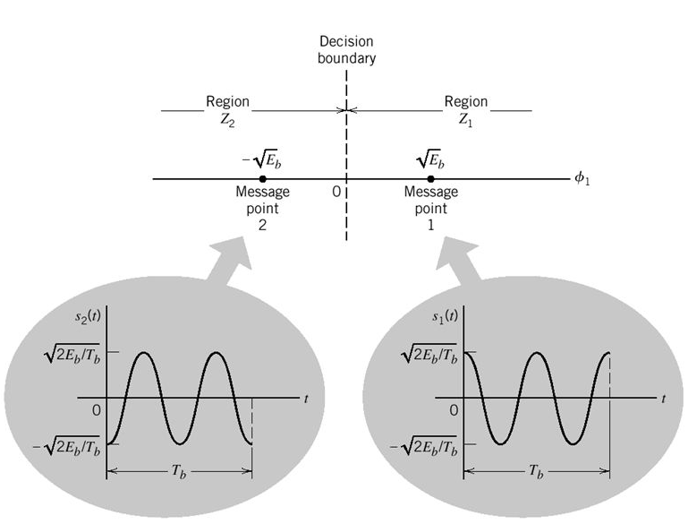  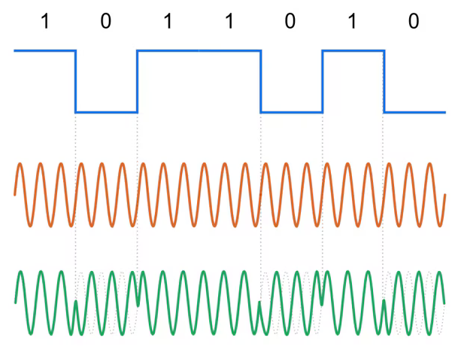 | CO4 | K4 | 3
Or
QB301(B) | With a suitable diagram, explain the working principle of the transmitter and receiver in DPSK, and derive the expression for the BER.  DPSK as the noncoherent version PSK. Eliminate the need for a coherent reference signal at the receiver by combining two basic operations at the transmitter:  - Differential encoding of the input binary wave.  - PSK – hence the Differential PSK .  Send symbol 0, phase advance the current signal waveform by 180 degree, send symbol 1 phase advance the current signal waveform unchanged. The receiver equipped with a storage capability, so that it can measure the relative phase difference between the waveform received during two successive bit interval. The phase difference between waveform received in two successive bit interval will be independent of θ.  DPSK signal equals $\sqrt{\frac{E_{b}}{{2T}_{b}}}cos\text{ (2}\text{π}f_{c}\text{t), 0 ≤ t }\text{≤ } T_{b}$, Where $E_{b}$ is the signal energy per bit, $T_{b}$ is the bit duration.  $s_{1}\left(t\right)$ denote the transmitted DPSK signal for $\text{0 ≤ t ≤ } 2T_{b}$for the case when symbol 1 at the transmitter input fro the second part of this interval, namely, $T_{b}\text{ ≤ t ≤ } 2T_{b}$.  $$s_{1}\left(t\right)=\left\{\begin{aligned}\sqrt{\frac{E_{b}}{2T_{b}}}cos\text{ (2}\text{π}f_{c}\text{t), 0 ≤ t ≤ } T_{b} \\ \sqrt{\frac{E_{b}}{2T_{b}}}cos\text{ (2}\text{π}f_{c}\text{t),}{ T}_{b}\text{≤ t ≤ } {2T}_{b}\end{aligned}\right.$$  $s_{2}\left(t\right)$ denote the transmitted DPSK signal for $\text{0 ≤ t ≤ } 2T_{b}$for the case when symbol 0 at the transmitter input for $T_{b}\text{≤ t ≤ } 2T_{b}$. The transmission of 0 advances the carrier phase by 180 degree, so we define $s_{2}\left(t\right)$ as  $$s_{1}\left(t\right)=\left\{\begin{aligned}\sqrt{\frac{E_{b}}{2T_{b}}}cos\text{ (2}\text{π}f_{c}\text{t), 0 ≤ t ≤ } T_{b} \\ \sqrt{\frac{E_{b}}{2T_{b}}}cos\text{ (2}\text{π}f_{c}\text{t +}\text{π}\text{),}{ T}_{b}\text{≤ t ≤ } {2T}_{b}\end{aligned}\right.$$  DPSK is a special case of noncoherent modulation with $T= 2T_{b}$ and $E = 2E_{b}$. The bit error rate for DPSK is given by  $$P_{e}=\frac{1}{2}\exp\left(-\frac{E_{b}}{N_{0}}\right)$$  Generation and Detection of DPSK  The differential encoding process at the transmitter input starts with an arbitrary first bit, serving as reference. $d_{k}$denote the differentially encoded sequence with added reference bit. The generation of this sequence  - Incoming symbol $b_{k}$ is 1, leave the symbol $d_{k}$ unchanged with respect to the previous bit.  - Incoming symbol $b_{k}$ is 0, leave the symbol $d_{k}$ unchanged with respect to the previous bit.  The differentially encoded sequence ${\{d}_{k}\}$ generated is used to phase shift a carrier with phase angle 0 and $\text{π}$ radians represent symbol 1 and 0. $d_{k}$ is the complement of the modulo-2 sum of $b_{k}$ and $d_{k-1}$.  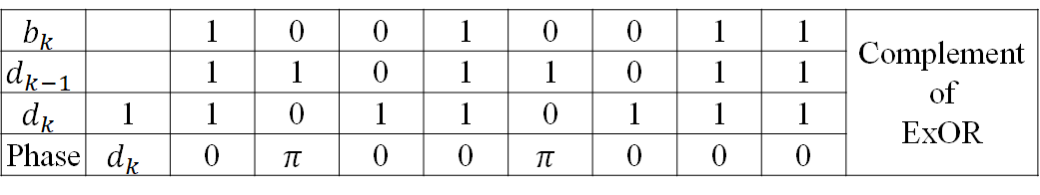  A logic network and a one-bit delay element interconnected to convert the raw binary sequence ${\{d}_{k}\}$ into a differentially encoded sequence${\{d}_{k}\}$. This sequence is amplitude-level encoded and then used to modulate a carrier wave of frequency $f_{c}$, thereby producing the desired DPSK signal.  Detection of DPSK, the carrier phase is unknown, in light of the receiver being equipped with an in-phase and a quadrature channel. A signal space diagram where the received signal point are $(A\cos{\text{θ}} , A\sin{\text{θ}})$ and $\left(-A\cos{\text{θ}} , -A\sin{\text{θ}}\right)$ with $\text{θ}$denoting the unknown phase and $A$denoting the amplitude.  The receiver measure the coordinates $\left(x_{I_{0}}, x_{Q_{0}}\right)$ at time $t=T_{b}$ and $(x_{I_{1}}, x_{Q_{1}})$ at time $t={2T}_{b}$. These two point map same signal point or different ones.  The two vector $x_{0}$ and $x_{1}$, with end point $\left(x_{I_{0}}, x_{Q_{0}}\right)$ and $(x_{I_{1}}, x_{Q_{1}})$ are pointed roughly in the same direction if their inner product is positive, hypothesis text as follow  $$x_{I_{1}}x_{I_{0}}+x_{Q_{0}}x_{Q_{1}}\text{≶}0$$  $$x_{I_{1}}x_{Q_{1}}+x_{I_{0}}x_{Q_{0}}=\frac{1}{4}\left[{\left(x_{I_{0}}{+ x}_{I_{1}}\right)}^{2}-{\left(x_{I_{0}}{- x}_{I_{1}}\right)}^{2}+{\left(x_{Q_{0}}+x_{Q_{0}}\right)}^{2}-{\left(x_{Q_{0}}-x_{Q_{0}}\right)}^{2}\right]$$  $${\left(x_{I_{0}}{+ x}_{I_{1}}\right)}^{2}+{\left(x_{Q_{0}}+x_{Q_{0}}\right)}^{2}-{\left(x_{I_{0}}{- x}_{I_{1}}\right)}^{2}-{\left(x_{Q_{0}}-x_{Q_{0}}\right)}^{2}\text{≶}\text{ 0}$$  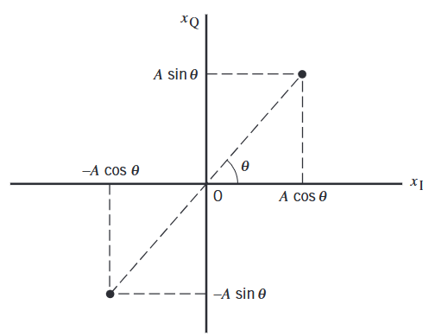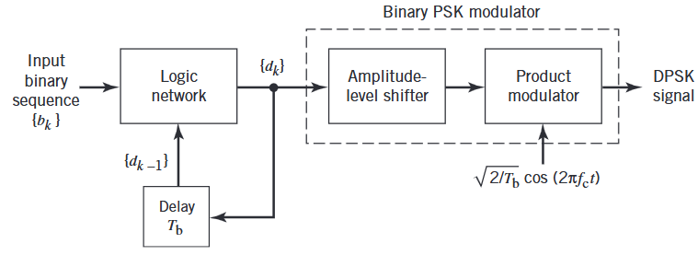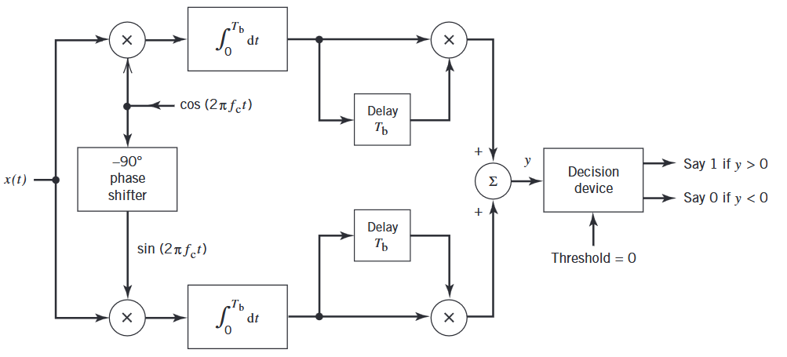 | CO3 | K3 | 3
QB302(A) | Explain the working principle of transmitter and receiver ASK and derive the expression for BER.  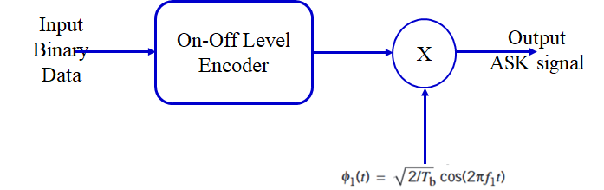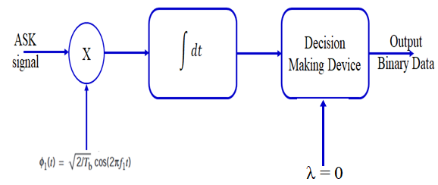  Amplitude Shift Keying (ASK) is a digital modulation technique . It transmits the digital information by varying the amplitude of a carrier signal. In ASK, a high-amplitude carrier signal is used to represent a binary '1,' and a low-amplitude carrier signal represents a binary '0.'  It involves the superimposition of a carrier signal and a digital message signal. The carrier signal is often a high-frequency sinusoidal waveform, which serves as the carrier for the digital information. The binary message signal, consisting of '1's and '0's, is used to control the amplitude of the carrier signal. The resultant signal formed after the superimposition of message and carrier is transmitted over the communication channel.  Carrier signal is chosen to be of very high frequency as compared to the message signal. It is usually a sinusoidal waveform.  Message signal consists of a binary stream of data. In ASK the high amplitude is represented by '1' and low amplitude is represented by '0'.  Modulated signal is generated as the resultant of the product of message signal and carrier signal(Modulation).  At receiver end, the modulated signal is demodulated to get the message binary stream (Demodulation). At receiver various mechanisms are used to recover the original message.  In ASK modulation, a carrier wave (usually a sinusoidal wave) is modified in accordance with the digital message signal. The amplitude of the carrier signal is changed between two predefined values i.e. 0 and 1 to represent binary data.  The carrier wave is represented by continuous signal. The carrier's amplitude changes between two levels, particularly '0' and '1'. When the input data is '0', the amplitude might be lower, and when the input data is '1', the amplitude could be higher. The changes in amplitude effects the carrier signal in accordance with the digital signal. This modulation technique is simple but can be susceptible to noise and interference, which can affect the accuracy of the received data.  Demodulation in Amplitude Shift Keying (ASK) involves extracting the original digital message signal from the modulated carrier wave. The process reverses the modulation applied to the carrier signal. The demodulation of ASK can be performed through various methods, such as envelope detection or coherent detection.  There are mainly two types of Demodulation which is performed namely envelope detection and coherent detection technique: Envelope detection, Coherent detection.  Envelop detection is a relatively simpler method as compared to coherent detection which is used for demodulating ASK signals. It primarily focuses on extracting the envelope of the modulated signal to recover the original digital data.  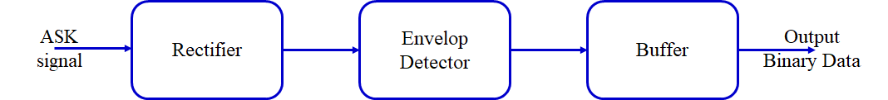  The steps involved in this technique is as follows  The modulated ASK signal, which contains the carrier signal and the digital data, is received by the demodulator. This is called receiving of signal.  The received signal is then passed through a diode. The diode rectifies the signal, allowing only the positive portion of the waveform (the envelope) to pass through it. This process is called Diode Rectification.  Following the rectification process, a low-pass filter is applied to the rectified signal. This filter helps remove or discard the high-frequency carrier signal, leaving the varying amplitude that represents the original digital data. This process is called Low-Pass Filtering of the modulated signal.  Once the signal has been filtered by passing it through the LPF, a threshold detection mechanism is used to interpret the amplitude changes. Comparing the amplitudes to a predefined threshold helps to determine the transmitted digital data. If the amplitude is above the threshold, it might be interpreted as one bit '1', and if it's below the threshold, it might be interpreted as the other bit '0'. This is called Threshold Detection. The message signal is recovered from the modulated signal  Coherent detection: This is another method which is used for demodulation of ASK signal. It involves phase synchronization with the carrier wave. The steps involved in this technique is as follows;  The received signal is mixed with a local oscillator, aligning its phase and frequency with the original carrier signal. This process is called Reception. Filtering isolates the part of the mixed signal that corresponds to the data signal. The demodulator sets an amplitude threshold to distinguish between the '1' and '0' states. The amplitude of the received signal is compared against the threshold to determine the transmitted data. In this way the original message signal is recovered.  The probability of error in ASK is $P_{e}= \frac{1}{2} erfc⁡\left(\sqrt{\frac{E_{b}}{{4N}_{0}}}\right)$  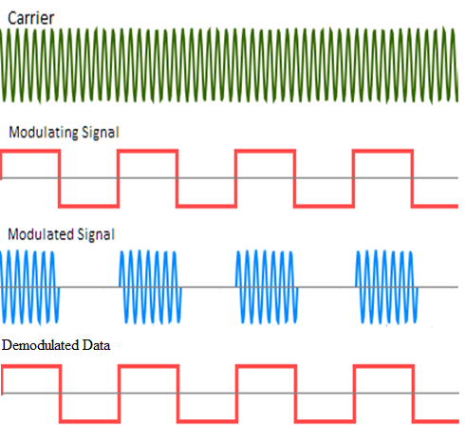 | CO3 | K3 | 3
Or
QB302(B) | Discuss in detail about QAM and derive the expression for BER.  The in-phase and quadrature components are permitted to be independent called M-ary quadrature amplitude modulation.  Two orthogonal passband basic functions,  $$ф_{1}\left(t\right)=\sqrt{\frac{2}{T}}cos\text{ (2}\text{π}f_{c}\text{t), 0 ≤ t ≤ } T$$  $$ф_{2}\left(t\right)=\sqrt{\frac{2}{T}}\text{sin (2}\text{π}f_{c}\text{t), 0 ≤ t ≤ } T$$  Let the $i^{th}$ message point $s_{i}$ in the ($ф_{1},ф_{2}$) plane be denoted by ($a_{i}\frac{d_{min}}{2}$, $b_{i}\frac{d_{min}}{2}$), where $d_{min}$ is the minimum distance between any two message point sin the constellation.  $a_{i}$, $b_{i}$ are integer, and i=1, 2, …….M. $\frac{d_{min}}{2}=\sqrt{E_{0}}$, $E_{0}$ is the energy of the signal with the lowest amplitude.  $$s_{k}\left(t\right)=\sqrt{\frac{2E_{0}}{T}}a_{k} cos\text{ (2}\text{π}f_{c}\text{t) -}\sqrt{\frac{2E_{0}}{T}}b_{k} \text{sin (2}\text{π}f_{c}\text{t), 0 ≤ t ≤ } T, k=0,±1,…$$  The signal $s_{k}(t)$ consists of two phase-quadrature carriers with one being modulated a set of discrete amplitude, hence the name quadrature amplitude modulation. The number of possible M, distinguish two distinct QAM constellations: square constellation for which of bits per symbol is even, cross constellation for which the number of bits per symbol is odd.  Even number of bits per symbol, where $L$ is a positive integer.  $$L=\sqrt{M}$$  Signal constellation diagram, the encoding of the message points in this figure is as follow  - Two of the four bits, namely, the left most two bits, specify the quadrant in the ($ф_{1},ф_{2}$) plane in which a message point lies. Starting from the first quadrant and proceeding counter clockwise, the four quadrants are represented by the dibits 11, 10, 00, 01.  - Remaining two bits are used to present one of the four possible symbols lying within each quadrant of the ($ф_{1},ф_{2}$) plane. The encoding of the four quadrants and also the encoding of the symbols in each quadrant follows the Gary coding rule.  QAM square constellation, the ordered pairs of coordinates naturally form a square matrix,  $$(a_{i}, b_{i})=\left[\begin{aligned}(-3,3) \\ (-3,1) \\ (-3,-1) \\ (-3,-3)\end{aligned} \begin{aligned}(-1,3) \\ (-1,1) \\ (-1,-1) \\ (-1,-3)\end{aligned} \begin{aligned}(1,3) \\ (1,1) \\ (1,-1) \\ (1,-3)\end{aligned} \begin{aligned}(3,3) \\ (3,1) \\ (3,-1) \\ (3,-3)\end{aligned}\right]$$  The probability of symbol error for M-ary QAM, The probability of correct detection for M-ary QAM $P_{c}={\left(1-P_{e}^{'}\right)}^{2}$. Where $P_{e}^{'}$ is the probability of symbol error for corresponding $L$-ary, $L=\sqrt{M}$.  Probability of symbol error $P_{e}^{'}$ is defined by  $$P_{e}^{'}= \left(1-\frac{1}{\sqrt{M}}\right)erfc⁡\left(\sqrt{\frac{E_{0}}{N_{0}}}\right)$$  Probability of symbol error for M-ary QAM is  $$P_{e}=1-P_{c}=1 -{\left(1-P_{e}^{'}\right)}^{2}=2P_{e}^{'}$$  $$P_{e}=2\left(1-\frac{1}{\sqrt{M}}\right)erfc⁡\left(\sqrt{\frac{E_{0}}{N_{0}}}\right)$$  Transmitted energy in M-ary QAM is variable in that its instantaneous value depends on the particular symbol transmitted. $P_{e}$ in terms of the average value of the transmitted energy rather than $E_{0}$. Assuming $L$ amplitude levels of the in-phase or quadrature component are equally likely,  $$E_{av }=2\left[\frac{2E_{0}}{L} \sum_{i=1 }^{\frac{L}{2}}{{\left(2i-1\right)}^{2}}\right]$$  The multiplying factor of 2 outside the square brackets accounts for the equal contribution made by the in-phase and quadrature components.  The limit of summation and the multiplying factor of 2 inside the square brackets take account of the symmetric nature of the pertinent amplitude levels around zero.  $$E_{av}=\frac{2\left(L^{2}-1\right)E_{0}}{3}=\frac{2\left(M-1\right)E_{0}}{3}$$  $$P_{e}=2\left(1-\frac{1}{\sqrt{M}}\right)erfc⁡\left(\sqrt{\frac{{3E}_{av}}{{2(M-1)N}_{0}}}\right)$$  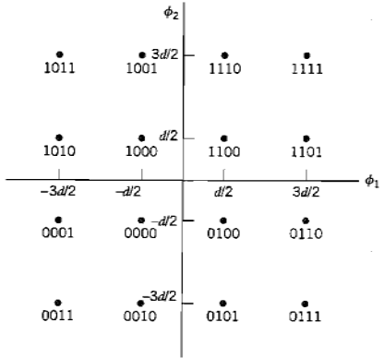 | CO3 | K3 | 3
QB303(A) | List out the difference between coherent and non-coherent modulation techniques. (6)  Coherent DetectionCoherent detection, also known as synchronous detection, relies on the receiver having a reference signal that is synchronized in frequency and phase with the carrier signal used in the transmitter. This method is highly accurate but requires precise synchronization.  Key Points:1. Phase Synchronization: The receiver needs to have a local oscillator that is phase-locked to the transmitter'scarrier signal.  2. Frequency Synchronization: The local oscillator must also be frequency-locked to the carrier signal.  3. High Accuracy: Because of synchronization, coherent detection can accurately detect phase and frequencychanges in the signal, making it suitable for high data rate communications.  4. Signal Types: Commonly used for signals like Amplitude Modulation (AM), Frequency Modulation (FM), PhaseModulation (PM), Phase Shift Keying (PSK), and Quadrature Amplitude Modulation (QAM).  Example:• Phase Shift Keying (PSK): In PSK, coherent detection allows the receiver to correctly demodulate the phasechanges of the incoming signal by comparing it with the phase of the locally generated reference signal.  Non-Coherent DetectionNon-coherent detection, also known as asynchronous detection, does not require the receiver to have a reference signal that is synchronized in phase with the carrier signal. This method is less accurate but simpler to implement and does not need precise synchronization  Key Points:1. No Phase Synchronization: The receiver does not need to synchronize its phase with the transmitter’s carriersignal.  2. Lower Accuracy: Without phase synchronization, non-coherent detection is generally less accurate than coherentdetection.  3. Simpler Implementation: Easier and cheaper to implement because it does not require complex synchronizationcircuits.  4. Signal Types: Often used for signals like Frequency Shift Keying (FSK) and Amplitude Shift Keying (ASK).Example:  • Frequency Shift Keying (FSK): In FSK, non-coherent detection can demodulate the signal by detecting the frequency differences between the different states without needing a phase reference.  With a suitable diagram, explain the working principles of passband modulation. (7)  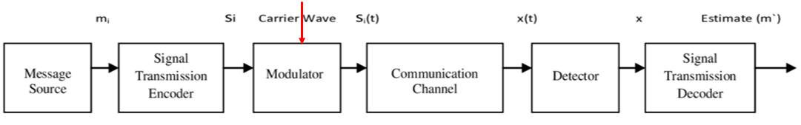  A message source that emits one symbol every $T$ seconds, with the symbols belonging to an alphabet of $M$ symbols, which we denoted by $m_{1}, m_{2},……..m_{M}$. a priori probabilities. $P\left(m_{1}\right), pP\left(m_{2}\right),…..P\left(m_{M}\right)$ specify the message source output. When the $M$ symbols of the alphabet are equally likely, $p_{i}=P\left(m_{i}\right)=\frac{1}{M}$ for all i.  $M$ ary output of the message source is presented to a signal transmission encoder, producing a corresponding vector $s_{i}$ made up of $N$ real elements, one such set for each of the $M$ symbols of the source alphabet; the dimension $N$ is less tha or equal to $M.$  The vector $s_{i}$ as input, the modulator then constructs a distinct signal $s_{i}(t)$ of duration $T$ seconds as the representation of the symbol $m_{i}$ generated by the message source. The signal $s_{i}(t)$ is necessarily an energy signal,  $\int_{0}^{T}{s_{i}^{2}\left(t\right)dt, i=1,2, 3…M.}$  $s_{i}(t)$ is real valued, signal is transmitted every $T$ seconds. Signal chosen for transmission depends in some fashion on the incoming message and possibly on the signals transmitted in preceding time slots. A sinusoidal carrier, the feature that is used by the modulator to distinguish one signal from another is a step change in the amplitude, frequency, or phase of the carrier.  The bandpass communication channel, coupling the transmitter to the receiver, is assumed to have two characteristics  - The channel is linear, with a bandwidth that is wide enough to accommodate the transmission of the modulated signal $s_{i}\left(t\right)$ with negligible or no distortion.  - The channel noise $w\left(t\right)$ is the sample function of a white gaussian noise process of zero mean and power spectral density $\frac{N_{0}}{2}$.  The receiver, which consists of a detector followed by a signal transmission decoder, performs two functions  - It receives the operations performed in the transmitter.  - It minimizes the effect of channel noise on the estimate $m^{'}$ computed for the transmitted symbol $m_{i}$.  Linear Modulation: Amplitude of the transmitted signal varies linearly with message, Eg: PSK, QPSK etc.  Non- Linear Modulation: Amplitude of the transmitted signal does not varies linearly with message signal, Eg: FSK, MSK etc. | CO3 | K3 | 3
Or
QB303(B) | With a suitable diagram, explain the working principle of transmitter and receiver QPSK and derive the expression for BER.  Goal of digital communication system is, low probability error, efficient utilization of channel bandwidth. Bandwidth conserving modulation scheme is Quadriphase shift keying.  QPSK, as with binary PSK, information carried by the transmitted signal is contained in the phase. The phase of the carrier takes on one of four equally spaced values, such as $\text{π}\text{/4}$, $3\text{π}\text{/4}$, $5\text{π}\text{/4}$ and $7\text{π}\text{/4}$. The transmitted signal is  $$g\left(t\right)=\left\{\begin{aligned}\sqrt{\frac{2E}{T}}cos\left[2\text{π}f_{c}t+\frac{\left(2i-1\right)\text{π}}{4}\right]\text{, 0 ≤ t ≤ } T \\ &0, otherwise \end{aligned}\right.$$  $i=1,2, 3. 4, E$is the transmitted signal energy per symbol, $T$ is the symbol duration. Carrier frequency $f_{c}$ equals $\frac{n_{c}}{T}$ for some fixed integer $n_{c}$. The value of the phase corresponds to a unique dibit.  The foregoing set of phase values to represent the Gray-encoded set of dibits: 10, 00, 01 and 11. Where only a single bit is changed from one dibit to the next.  Signal space of QPSK  The transmitted signal ${ s}_{i}(t)$ for the interval $0 ≤ t ≤ T$  $$s_{i}\left(t\right)=\sqrt{\frac{2E}{T}}cos\left[\frac{\left(2i-1\right)\text{π}}{4}\right]\cos\left(2\text{π}f_{c}t\right)-\sqrt{\frac{2E}{T}}sin\left[\frac{\left(2i-1\right)\text{π}}{4}\right] sin⁡(2\text{π}f_{c}t)$$  Where $i=1,2, 3. 4$. There are two orthonormal basic functions $ф_{1}\left(t\right)$ and $ф_{2}\left(t\right)$ are defined by a pair of quadrature carrier:  $$ф_{1}\left(t\right)= \sqrt{\frac{2}{T}}\cos\left(2{\text{π}f}_{c}t\right) 0≤t≤T$$  $$ф_{2}\left(t\right)= \sqrt{\frac{2}{T}} sin\left(2{\text{π}f}_{c}t\right) 0≤t≤T$$  There are four message points,  $$s_{i}= \left[\begin{aligned}\sqrt{E}cos⁡\left(\frac{\left(2i-1\right)\text{π}}{4}\right) \\ -\sqrt{E}sin⁡\left(\frac{\left(2i-1\right)\text{π}}{4}\right)\end{aligned}\right]$$  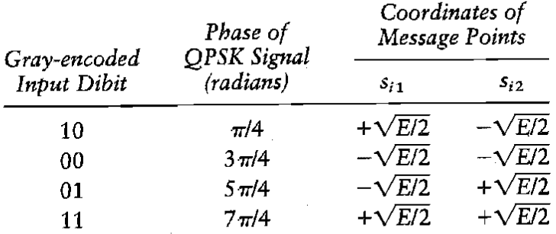  The elements of $s_{i1}$ and $s_{i2}$are given in the table. A QPSK signal has a two-dimensional signal constellation and four message points. Whose phase angle increase in a counterclockwise direction. The QPSK signal has minimum average energy.  The incoming binary data sequence is first transferred into polar form by nonreturn to zero level encoder. Symbol 1 and 0 are represented by $\sqrt{E_{b}}$ and ${-\sqrt{E}}_{b}$. The binary wave is next divided by means of a Demultiplexer into two separate binary waves consisting of odd-even numbered input bits.  Two binary waves are denoted by $a_{1}(t)$ and $a_{2}(t)$, the amplitude of $a_{1}\left(t\right)$ and $a_{2}(t)$ equal $s_{i1}$ and $s_{i2}$, depending on the particular dibit that is transmitted. The two binary waves are modulated a pair of quadrature carrier or orthonormal basic functions: equal to $\sqrt{\frac{2}{T}} cos\left(2{\text{π}f}_{c}t\right)$ and $\sqrt{\frac{2}{T}} sin\left(2{\text{π}f}_{c}t\right)$. The result is a pair of binary PSK signals, the two binary PSK signals are added to produce the desired QPSK signal.  The receiver consists of a pair of correlators with a common inputs, with a locally generated pair of coherent reference signals $ф_{1}\left(t\right)$ and $ф_{2}\left(t\right)$. The correlators outputs $x_{1}\left(t\right)$ and $x_{2}\left(t\right)$ produced in response to the received signal $x\left(t\right)$, are each compared with a threshold of zero. If $x_{1} >0$, a decision is made in favor of symbol 1 for the in-phase channel output, If $x_{1}<0$, a decision is made in favor of symbol 0. If $x_{2}<0$, a decision is made in favor of symbol 0, If $x_{2}>0$, a decision is made in favor of symbol 1. the in-phase and quadrature channel outputs are combined in a multiplexer to reproduce the original binary sequence at the transmitter input with minimum probability of symbol error.  Error probability of Binary QPSK: A coherent QPSK system, the received signal $x(t)$ is defined by $x\left(t\right)=s_{i}\left(t\right)+w\left(t\right), \left\{\begin{aligned}0 ≤t ≤T \\ i=1,2,3,4\end{aligned}\right.$  $w\left(t\right)$ is the sample WGN process of zero mean and power spectral density $\frac{N_{0}}{2}$ , the vector $x$ has two elements, $x_{1}$and $x_{2}$ defined by  $$x_{1}=\int_{0}^{T}{{x(t)ф}_{1}\left(t\right) dt}=\sqrt{E} cos\left[\frac{\left(2i-1\right)\text{π}}{4}\right]+w_{1}=∓\sqrt{\frac{E}{2}}+w_{1}$$  $$x_{2}=\int_{0}^{T}{{x(t)ф}_{2}\left(t\right) dt}=- \sqrt{E} sin\left[\frac{\left(2i-1\right)\text{π}}{4}\right]+w_{2}=\text{±}\sqrt{\frac{E}{2}}+w_{2}$$  Decision rule is now simply to decide that $s_{1}\left(t\right)$ was transmitted if the received signal points associated with the observation vector $x$ falls inside region $Z_{1}$ decide that $s_{2}(t)$ was transmitted if the received signal point falls inside region $Z_{2}$, and so on. An erroneous decision will be made if for example signal $s_{4}(t)$ is transmitted but the noise $w(t)$ is such that the received signal points falls outside region $Z_{4}$.  Coherent QPSK system is in fact equivalent to two coherent PSK systems working in parallel and using two carriers that are in phase quadrature.  The in-phase channel output $x_{1}$and the quadrature channel output $x_{2}$ may be viewed as the individual outputs of the two coherent binary PSK system. Signal energy per bit is $\frac{E}{2}$, noise spectral density $\frac{N_{0}}{2}$.  The average probability of bit error in each channel of the coherent binary PSK system is  $$P^{'}= \frac{1}{2}\operatorname{erfc}\left(\sqrt{\frac{E/2}{N_{0}}}\right)=\frac{1}{2}\operatorname{erfc}\left(\sqrt{\frac{E}{{2N}_{0}}}\right)$$  The bit errors in the in-phase and quadrature channels of the coherent QPSK system are statistically independent. The in-phase channel makes a decision on one of the two bits constituting a symbol (dibit) of the QPSK signal, and the quadrature channel takes care of the other bit.  The average probability of a correct decision resulting from the coherent action of the two channels working together is  $$P_{c}= {\left(1-P^{'}\right)}^{2}={\left[1-\frac{1}{2}\operatorname{erfc}\left(\sqrt{\frac{E}{{2N}_{0}}}\right)\right]}^{2}=1 -\operatorname{erfc}\left(\sqrt{\frac{E}{{2N}_{0}}}\right)+\frac{1}{4}{erfc}^{2}\left(\sqrt{\frac{E}{{2N}_{0}}}\right)$$  The average probability of a symbol error for coherent QPSK  $$P_{e}=1-P_{c}=\operatorname{erfc}\left(\sqrt{\frac{E}{{2N}_{0}}}\right)-\frac{1}{4}{erfc}^{2}\left(\sqrt{\frac{E}{{2N}_{0}}}\right) ≈\operatorname{erfc}\left(\sqrt{\frac{E}{{2N}_{0}}}\right)$$  Anther way same equation is derived from signal space diagram  $$p_{e}≤ \frac{1}{2} \sum_{\begin{aligned}k=1 \\ k≠i\end{aligned}}^{4}{\operatorname{erfc}\left(\frac{d_{ik}}{2\sqrt{N_{0} }}\right)} for all i$$  QPSK system, there are two bits per symbol, the transmitted signal energy per symbol is twice the signal energy per bit, $E =2E_{b}$  The average probability of symbol error in terms of the ratio $\frac{E_{b}}{N_{0}}$ ,  $$P_{e}=\operatorname{erfc}\left(\sqrt{\frac{E_{b}}{N_{0}}}\right)$$  Gray encoding used for the incoming symbols, the bit error rate of QPSK is exactly  $$BER=\frac{1}{2}\operatorname{erfc}\left(\sqrt{\frac{E_{b}}{N_{0}}}\right)$$  Coherent QPSK and PSK have same average probability of bit error, but used only the half the channel bandwidth.  QPSK uses channel bandwidth better than PSK.  Power Spectra of QPSK signals.  The binary wave at the modulator input is random, with symbol 1 and 0 being equally likely, the in-phase and quadrature components of a QPSK signal  1. The dibits sent during the signaling interval $-T_{b}≤t ≤T_{b}$ the in-phase component equals $g\left(t\right) or-g(t)$, and similarly for the quadrature component.  The $g\left(t\right)$ denotes the symbol shaping function, defined by  $$g\left(t\right)=\left\{\begin{aligned}\sqrt{\frac{E}{T}}\text{, 0 ≤ t ≤ }T \\ &0, otherwise \end{aligned}\right.$$  A common power spectral density, $E sinc^{2}(Tf)$.  2. The baseband power spectral density of the QPSK signal equals the sum of the individual power spectral densities of the in-phase and quadrature components,  $$S_{B}\left(f\right)=2Esinc^{2}\left(Tf\right)=4E_{b} sinc^{2}(2T_{b}f)$$  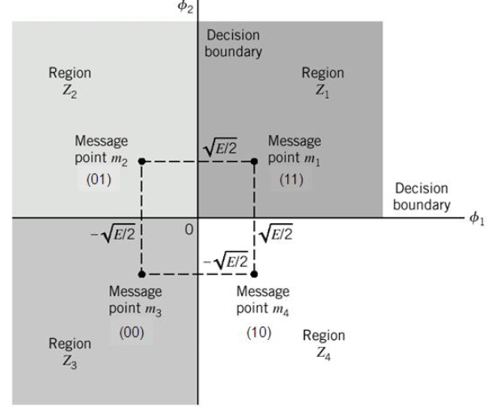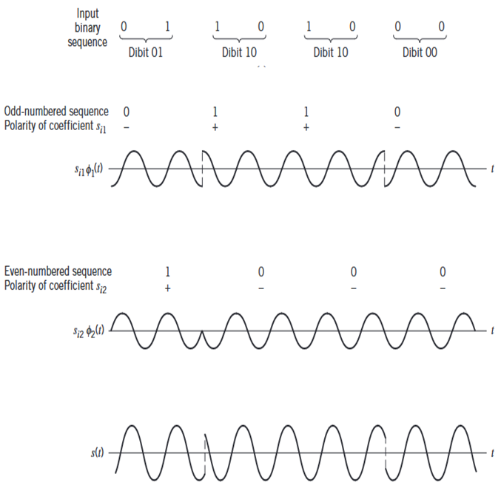  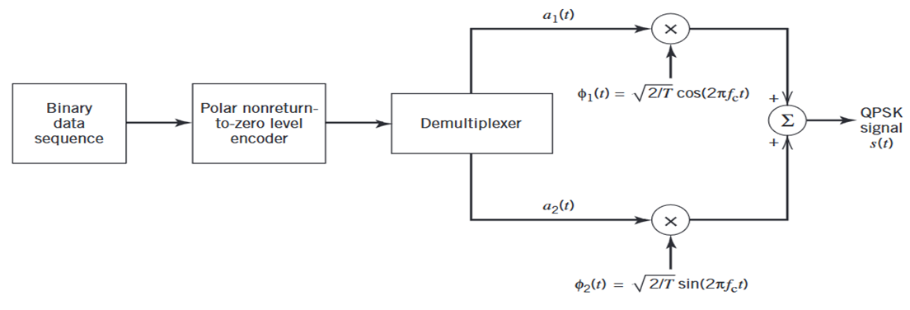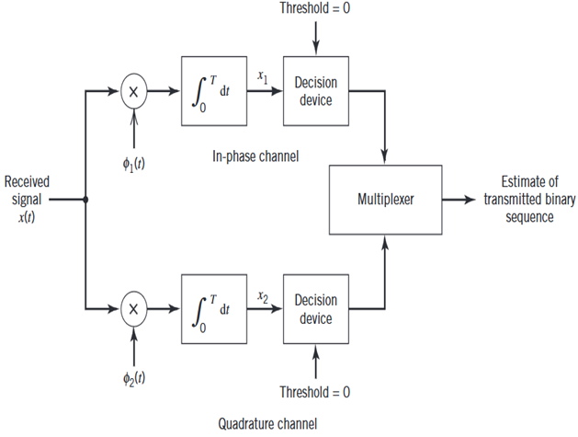 | CO3 | K3 | 3
QB304(A) | Highlight the major difference between a QPSK signal and a BPSK. (6)  Quadrature Phase Shift Keying (QPSK) and Binary Phase Shift Keying (BPSK) are both digital modulation schemes used in communication systems. Here are the key differences between them:  1. Number of Symbols:  - BPSK: Uses two symbols (0 and 1). Each symbol represents one bit of information.  - QPSK: Uses four symbols (00, 01, 10, 11). Each symbol represents two bits of information.  2. Modulation Order:  - BPSK: Binary modulation (2 levels).  - QPSK: Quadrature modulation (4 levels).  3. Bit Rate:  - BPSK: The bit rate is equal to the symbol rate since one symbol represents one bit.  - QPSK: The bit rate is twice the symbol rate because each symbol carries two bits.  4. Bandwidth Efficiency:  - BPSK: Less bandwidth efficient because it transmits one bit per symbol.  - QPSK: More bandwidth efficient, effectively doubling the bits transmitted per symbol compared to BPSK.  5. Phase States:  - BPSK: Has two phase states (0° and 180°).  - QPSK: Has four phase states (0°, 90°, 180°, and 270°).  6. Error Performance:  - BPSK: Generally has better performance in terms of error rates in low signal-to-noise ratio (SNR) conditions due to its simpler structure.  - QPSK: More susceptible to noise compared to BPSK at the same SNR due to the closer proximity of its phase states.  7. Complexity:  - BPSK: Simpler to implement as it only requires a phase shift of 180°.  - QPSK: More complex due to the need to distinguish between four different phase states.  8. Applications:  - BPSK: Used in simpler communication systems, satellite communications, and where power efficiency is critical.  - QPSK: Commonly used in applications requiring higher data rates, such as wireless communication systems, Wi-Fi, and digital TV broadcasting.  Draw the block diagram of the QPSK transmitter and coherent QPSK receiver and explain their operation. (7)    Goal of digital communication system is, low probability error, efficient utilization of channel bandwidth. Bandwidth conserving modulation scheme is Quadriphase shift keying.  QPSK, as with binary PSK, information carried by the transmitted signal is contained in the phase. The phase of the carrier takes on one of four equally spaced values, such as $\text{π}\text{/4}$, $3\text{π}\text{/4}$, $5\text{π}\text{/4}$ and $7\text{π}\text{/4}$. The transmitted signal is  $$g\left(t\right)=\left\{\begin{aligned}\sqrt{\frac{2E}{T}}cos\left[2\text{π}f_{c}t+\frac{\left(2i-1\right)\text{π}}{4}\right]\text{, 0 ≤ t ≤ } T \\ &0, otherwise \end{aligned}\right.$$  $i=1,2, 3. 4, E$is the transmitted signal energy per symbol, $T$ is the symbol duration. Carrier frequency $f_{c}$ equals $\frac{n_{c}}{T}$ for some fixed integer $n_{c}$. The value of the phase corresponds to a unique dibit.  The foregoing set of phase values to represent the Gray-encoded set of dibits: 10, 00, 01 and 11. Where only a single bit is changed from one dibit to the next.  Signal space of QPSK  The transmitted signal ${ s}_{i}(t)$ for the interval $0 ≤ t ≤ T$  $$s_{i}\left(t\right)=\sqrt{\frac{2E}{T}}cos\left[\frac{\left(2i-1\right)\text{π}}{4}\right]\cos\left(2\text{π}f_{c}t\right)-\sqrt{\frac{2E}{T}}sin\left[\frac{\left(2i-1\right)\text{π}}{4}\right] sin⁡(2\text{π}f_{c}t)$$  Where $i=1,2, 3. 4$. There are two orthonormal basic functions $ф_{1}\left(t\right)$ and $ф_{2}\left(t\right)$ are defined by a pair of quadrature carrier:  $$ф_{1}\left(t\right)= \sqrt{\frac{2}{T}}\cos\left(2{\text{π}f}_{c}t\right) 0≤t≤T$$  $$ф_{2}\left(t\right)= \sqrt{\frac{2}{T}} sin\left(2{\text{π}f}_{c}t\right) 0≤t≤T$$  There are four message points,  $$s_{i}= \left[\begin{aligned}\sqrt{E}cos⁡\left(\frac{\left(2i-1\right)\text{π}}{4}\right) \\ -\sqrt{E}sin⁡\left(\frac{\left(2i-1\right)\text{π}}{4}\right)\end{aligned}\right]$$    The elements of $s_{i1}$ and $s_{i2}$are given in the table. A QPSK signal has a two-dimensional signal constellation and four message points. Whose phase angle increase in a counterclockwise direction. The QPSK signal has minimum average energy.  The incoming binary data sequence is first transferred into polar form by nonreturn to zero level encoder. Symbol 1 and 0 are represented by $\sqrt{E_{b}}$ and ${-\sqrt{E}}_{b}$. The binary wave is next divided by means of a Demultiplexer into two separate binary waves consisting of odd-even numbered input bits.  Two binary waves are denoted by $a_{1}(t)$ and $a_{2}(t)$, the amplitude of $a_{1}\left(t\right)$ and $a_{2}(t)$ equal $s_{i1}$ and $s_{i2}$, depending on the particular dibit that is transmitted. The two binary waves are modulated a pair of quadrature carrier or orthonormal basic functions: equal to $\sqrt{\frac{2}{T}} cos\left(2{\text{π}f}_{c}t\right)$ and $\sqrt{\frac{2}{T}} sin\left(2{\text{π}f}_{c}t\right)$. The result is a pair of binary PSK signals, the two binary PSK signals are added to produce the desired QPSK signal.  The receiver consists of a pair of correlators with a common inputs, with a locally generated pair of coherent reference signals $ф_{1}\left(t\right)$ and $ф_{2}\left(t\right)$. The correlators outputs $x_{1}\left(t\right)$ and $x_{2}\left(t\right)$ produced in response to the received signal $x\left(t\right)$, are each compared with a threshold of zero. If $x_{1} >0$, a decision is made in favor of symbol 1 for the in-phase channel output, If $x_{1}<0$, a decision is made in favor of symbol 0. If $x_{2}<0$, a decision is made in favor of symbol 0, If $x_{2}>0$, a decision is made in favor of symbol 1. the in-phase and quadrature channel outputs are combined in a multiplexer to reproduce the original binary sequence at the transmitter input with minimum probability of symbol error. | CO3 | K3 | 4
QB304(B) | With a suitable diagram, explain the working principle of the transmitter and receiver non-coherent FSK and derive the expression for BER.  Generation and Detection  The incoming binary data sequence is first applied to an on-off level encoder, at the output of which symbol 1 is represented by a constant amplitude of $\sqrt{E_{b}}$ volts and symbol 0 is represented by zero volts. By suing inverter in the lower channel,  Symbol 1 at the input, the oscillator with frequency $f_{1}$ in the upper channel is switched on while the oscillator with frequency $f_{2}$ in the lower channel is switched off, with the result that frequency $f_{1}$ is transmitted.  Symbol 0 at the input, the oscillator in the upper channel is switched off and the oscillator on the lower channel is switched on, with result that frequency $f_{2}$ is transmitted.  The two frequency $f_{1}$ and $f_{2}$ are chosen to equal different integer multiples of the bit rate $\frac{1}{T_{b}}$.  The oscillator are synchronized, so that their outputs satisfy the requirements of the two orthonormal basic function $ф_{1}$ and $ф_{2}$.  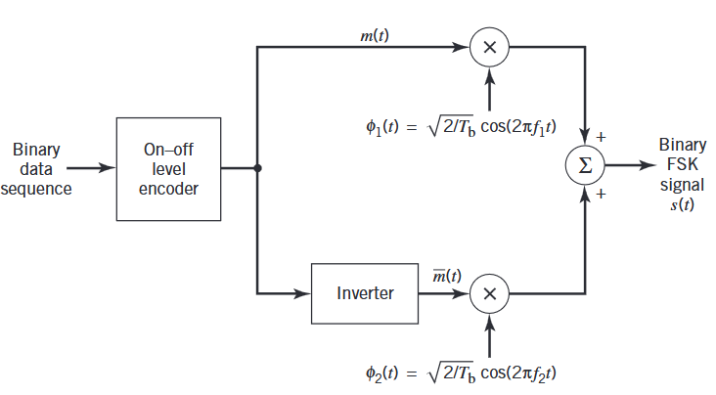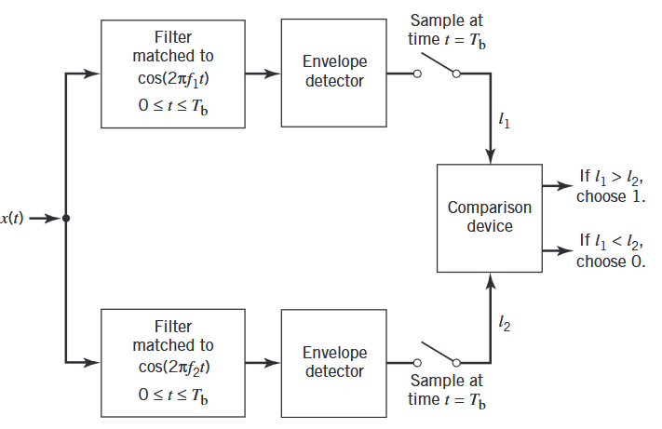  The carrier frequency $f_{i}$ equals one of two possible values, $f_{1}$ and $f_{2}$; to ensure that the signals representing these two frequencies are orthogonal, $f_{i}=\frac{n_{i}}{T_{b}}$ where $n_{i}$ is an integer. The transmitted signal is defined by,  $$s_{i}\left(t\right)=\left\{\begin{aligned}\sqrt{\frac{2E_{b}}{T_{b}}}cos\text{ (2}\text{π}f_{i}\text{t), 0 ≤ t ≤ } T_{b} \\ &0, otherwise \end{aligned}\right.$$  The transmission of frequency $f_{1}$ represent symbol 1, and the transmission frequency of $f_{2}$ represent symbol 0.  The receiver consists of a pair of matched filters followed by envelop detector. The filter in the upper path of the receiver is matched to $cos\text{ (2}\text{π}f_{1}\text{t)}$, and the filter in the lower path is matched to $cos\text{ (2}\text{π}f_{2}\text{t)}$, and in both cases values are compared.  The envelop samples of the upper and lower paths are $l_{1}$ and $l_{2}$, respectively. If $l_{1}>l_{2}$, the receiver decides in favor of symbol 1, and $l_{1}<l_{2}$, it decides in favor of symbol 0. If $l_{1}=l_{2}$, the receiver simply makes a guess in favor of symbol 0 or 1.  The bit error rate for Noncoherent binary FSK is  $$P_{e}=\frac{1}{2}\exp\left(-\frac{E_{b}}{{2N}_{0}}\right)$$  Noncoherent orthogonal modulation with ${T= T}_{b}$ and ${E=E}_{b}$. Where $E_{b}$ is the signal energy per bit, $T_{b}$ is the bit duration. | CO3 | K3 | 3
QB401(A) | Consider a (6,3) linear block code whose parity check matrix is given by  101 100  H = 110 010  011 001  Find (i) Generator matrix (ii) All the code vectors (iii) Minimum distance between codes (iv) Error detection and correction capability.  Solution  The Parity Matrix is:  1 1 0  0 1 1  1 0 1  The Generator Matrix, G = [P | I_{k}]  The Generator Matrix is:  1 1 0 1 0 0  0 1 1 0 1 0  1 0 1 0 0 1  **********  Codeword, c = m G = m [P | I_{k}]  Message Bits Codeword Hamming Weight  0 0 0 0 0 0 0 0 0 0  0 0 1 1 0 1 0 0 1 3  0 1 0 0 1 1 0 1 0 3  0 1 1 1 1 0 0 1 1 4  1 0 0 1 1 0 1 0 0 3  1 0 1 0 1 1 1 0 1 4  1 1 0 1 0 1 1 1 0 4  1 1 1 0 0 0 1 1 1 3  **********  Minimum Hamming distance : 3  **********  Parity Check Matrix, H = [P^{T} | I_{n-k}]  Parity Check Matrix  1 0 0 1 0 1  0 1 0 1 1 0  0 0 1 0 1 1  **********  Parity Check Matrix Transpose, H^{T}  0 0 0  1 0 0  0 1 0  0 0 1  1 1 0  0 1 1  1 0 1  Enter the received codeword, r: 1 0 0 1 1 1  **********  The error position is : r H^{T}  Syndrome of given received codeword is, s: 1 0 0  **********  Syndrome Matrix  0 0 0 0 0 0 0 0 0  1 0 0 1 0 0 0 0 0  0 1 0 0 1 0 0 0 0  0 0 1 0 0 1 0 0 0  1 1 0 0 0 0 1 0 0  0 1 1 0 0 0 0 1 0  1 0 1 0 0 0 0 0 1  The error position is, s : 1 0 0 0 0 0  The correct codeword is : s + r = 0 0 0 1 1 1 | CO3 | K3 | 2
Or
QB401(B) | With a suitable equation, explain the linear block code and its property.  A code is said to be linear if any two code words in the code can be added in modulo-2 arithmetic to produce a third code word in the code. (𝑛, 𝑘) linear block code, in which 𝑘 bits of the bits are always identical to the message sequence to be transmitted.  𝑛 − 𝑘 bits in the remaining portion are computed from the message bits in accordance with a prescribed encoding rule that determines the mathematical structure of the code. These bits are referred to be generated parity check bits or simply parity bits.  Block codes in which the message bits are transmitted in unaltered form are called systematic codes. Applications: error detection and error correction 𝑚₀, 𝑚₁, 𝑚₂,····· 𝑚_{𝑘−1} constitute a block of 𝑘 arbitrary message bits, 2^{𝑘} distinct message blocks. Linear block encoder, producing an 𝑛 bit code word whose elements are denoted by 𝑐₀, 𝑐₁,····, 𝑐_{𝑛−1}.  𝑏₀, 𝑏₁,····, 𝑏_{𝑛−𝑘−1} denoted the (𝑛, 𝑘) parity bits in the code word. A code word is divided into two parts, one which is occupied by the message bits and the other by the parity bits.  𝑚₀, 𝑚₁, ···, 𝑚_{𝑘−1}  𝑏₀, 𝑏₁, ···, 𝑏_{𝑛−𝑘−1}  The (𝑛 − 𝑘) left most bits of a code word are identical to the corresponding parity bits, and the 𝑘 right most bits of the code word are identical to the corresponding message bits.  𝑐 = =  ^{b}𝑖  ^{𝑚}𝑖+𝑘−𝑛  𝑖 = 0,1, … … . . , 𝑛 − 𝑘 − 1  𝑖 = 𝑛 − , 𝑛 − 𝑘 + 1, … … … . . , 𝑛 − 1  (𝑛 − 𝑘) parity bits are linear sums of the 𝑘 message bits, 𝑏_{𝑖} = 𝑝_{0𝑖}𝑚₀ + 𝑝_{1𝑖}𝑚₁ + ···· +𝑝_{𝑘−1,𝑖}𝑚_{𝑘−1}  Where coefficient are defined as follows  𝑝_{𝑖𝑗} = 1, 𝑖𝑓 𝑏_{𝑖} 𝑑𝑒𝑝𝑒𝑛𝑑𝑠 𝑜𝑛 𝑚_{𝑖}  0, 𝑜𝑡ℎ𝑒𝑟𝑤𝑖𝑠𝑒  The equation can be rewritten in a compact form using matrix notation. 1 𝑏𝑦 𝑘 𝑎𝑠 𝑚 message vector or information vector, 1 𝑏𝑦 𝑛 − 𝑘 𝑎𝑠 𝑏 as parity vector,1 𝑏𝑦 𝑛 𝑎𝑠 𝑐 as code vector.  𝑚 = 𝑚₀, 𝑚₁, … . . , 𝑚_{𝑘−1}  𝑏 = 𝑏₀, 𝑏₁, … . . , 𝑏_{𝑛−𝑘−1}  𝑐 = 𝑐₀, 𝑐₁, … . . , 𝑐_{𝑛−1}  All three vectors are row vectors. Rewrite the set of simultaneous equations defining the parity bits in the compact matrix from,  𝑏 = 𝑚𝑃  Where 𝑃 is the 𝑘 𝑏𝑦 (𝑛 − 𝑘) coefficient matrix defined by  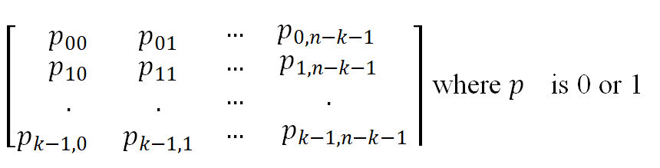  𝑐 may be expressed as a partitioned row vector in terms of the vector 𝑐 = [𝑏 ∶ 𝑚] = 𝑚[𝑃∶ 𝐼_{𝑘}]  The value of 𝑏 is substitute from previous equation, 𝐼_{𝑘} is the 𝑘 𝑏𝑦 𝑘 matrix.  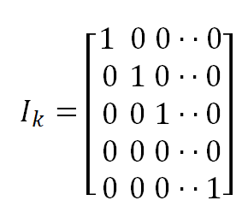  Define the 𝑘 𝑏𝑦 𝑛 generator matrix 𝐺 = [𝑃 ∶ 𝐼_{𝑘}] is said to be in the canonical form in that its 𝑘 rows are linearly independent. The generator matrix G, as 𝑐 = 𝑚𝐺  The set of code words, referred to simply s the code, generated using above equation. The message vector 𝑚 range through the set of all 2^{𝑘} binary 𝑘-tuples. The sum of any two code word is another code word. This basic property of linear block code is closure. The sum of 𝑐_{𝑖} and 𝑐_{𝑗} as  𝑐_{𝑖} + 𝑐_{𝑗} = 𝑚_{𝑖}𝐺 + 𝑚_{𝑗}𝐺 = 𝑚_{𝑖} + 𝑚_{𝑗} 𝐺  The modulo -2 sum of and represents a new message vector. The modulo -2 sum of 𝑐_{𝑖} and 𝑐_{𝑗} represents a new code vector. The relationship between the message bits and parity-check bits of a linear block code, 𝐻 denote an (𝑛 − 𝑘) by 𝑛 matrix defined as 𝐻 = [𝐼_{𝑛−𝑘} ∶ 𝑃^{𝑇}] where 𝑃^{𝑇} is an (𝑛 − 𝑘)by 𝑘 matrix,  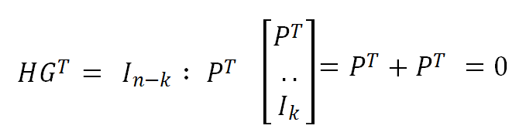  Multiply both the side by 𝐻^{T} in 𝑐 = 𝑚𝐺, 𝑐𝐻^{𝑇} = 𝑚𝐺𝐻^{𝑇} = 0, 𝐻 is called parity check matrix of the code, and set of equation is called parity check equations. The form of block diagrams.  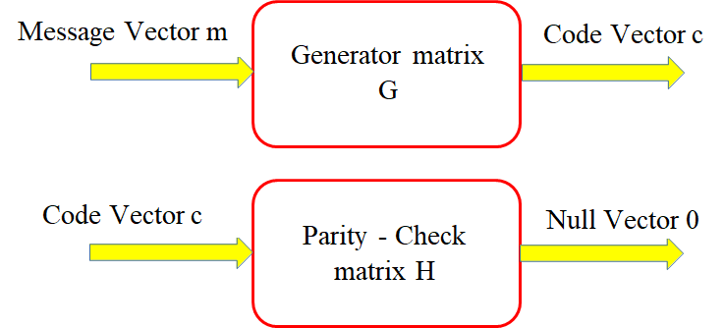  Generator matrix 𝐺 is used in the encoding operation at the transmitter. Parity-check matrix 𝐻 is used in the decoding operation at the receiver. Let 𝑟 denote the 1-by–n received vector that results from sending the code vector c over a noisy channel. The vector 𝑒 is called error vector. The vector 𝑟 as the 𝑟 = 𝑐 + 𝑒  𝑒𝑖 = 1, 𝑖𝑓 𝑎𝑛 𝑒𝑟𝑟𝑜𝑟 ℎ𝑎𝑠 𝑜𝑐𝑐𝑢𝑟𝑒𝑑 𝑖𝑛 𝑡ℎ𝑒 𝑖𝑡ℎ 𝑙𝑜𝑐𝑎𝑡𝑖𝑜𝑛  0, 𝑜𝑡ℎ𝑒𝑟𝑤𝑖𝑠𝑒  1-by-n received vector 𝑟, the corresponding syndrome is formally defined as 𝑠 = 𝑟𝐻^{𝑇}  Syndrome Property 1: the syndrome only on the error pattern, and not on the transmitted code word. 𝑠 = 𝑟𝐻^{𝑇} = 𝑐𝐻^{𝑇} + 𝑒𝐻^{𝑇} = 𝑒𝐻^{𝑇}  Syndrome Property 2: all error patterns, that differ by a code word have the same syndrome.  𝑒_{𝑖}𝐻^{𝑇} = 𝑒𝐻^{𝑇} + 𝑐_{𝑖}𝐻^{𝑇} = 𝑒𝐻^{𝑇}  Hamming weight of a code vector c is defined as the number of nonzero elements in the code vector.  Hamming distance 𝑑_{𝑚𝑖𝑛} of a linear block code is the smallest hamming weight of the nonzero code vector in the code. Linear block code is required to detect and correct all error patterns, and whose Hamming weight is less than or equal to 𝑡. The decoder will be able to detect and correct all error patterns of Hamming weight ≤ 𝑡 provided that the minimum distance of the code is equal to or greater than 2𝑡 + 1.  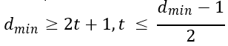  A decoding procedure for a linear block code  - For the received vector 𝑟 compute the syndrome 𝑠 = 𝑟𝐻^{𝑇}.  - Within the coset characterized by the syndrome 𝑠, identify the coset leader call it 𝑒₀. Compute the code vector 𝑠 = 𝑟 + 𝑒₀ as the decoded version of the vector 𝑟.  This procedure is called syndrome decoding. | CO3 | K3 | 2
QB402(A) | Design a ½ rate convolutional encoder with constraint length 3 and encode the message bits 1001 for the generator sequences g1 = {1, 1, 1} and g2 = {1, 0, 1}. Also, draw the code tree and trace the output sequence. Sketch code Trellis and State diagram for this code.  The impulse response of path 1 is (1, 1, 1). 𝑔 ¹(𝐷) = 1 + 𝐷 + 𝐷²  The impulse response of path 2 is (1, 0, 1). 𝑔 ²(𝐷) = 1 + 𝐷²  The message sequence is (10011). 𝑚(𝐷) = 1 + 𝐷³  The output polynomial of path 1 is c¹(𝐷)= 𝑔¹(𝐷) 𝑚(𝐷)  = (1 + 𝐷 + 𝐷²) (1 + 𝐷³) = 1 + 𝐷 + 𝐷² + 𝐷³ + 𝐷⁴ + 𝐷⁵  The output sequence of path 1 is (1111110)  The output polynomial of path 2 is c²(𝐷)= 𝑔²(𝐷) 𝑚(𝐷)  = (1 + 𝐷²) (1 + 𝐷³) = 1 + 𝐷² + 𝐷³ + 𝐷⁵  The output sequence of path 2 is (1011010)  The encoded sequence is (11, 10, 11, 11, 10, 11, 00)  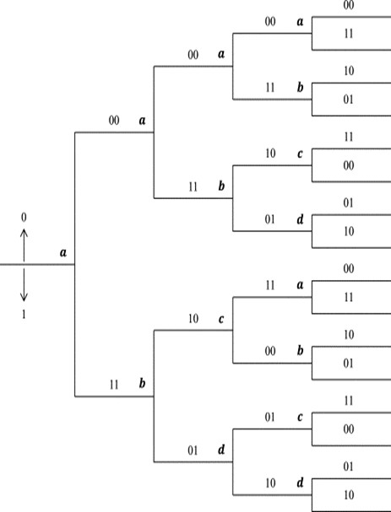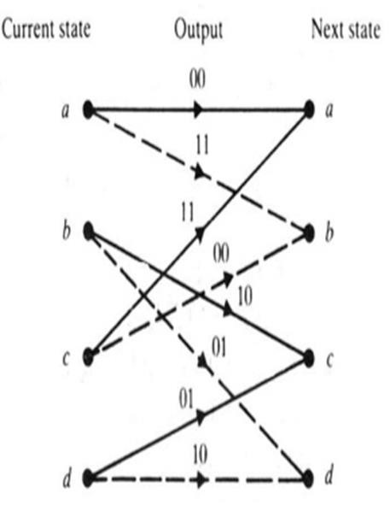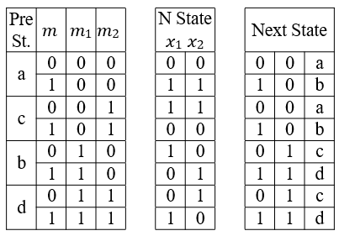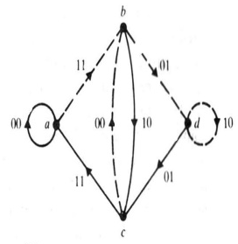  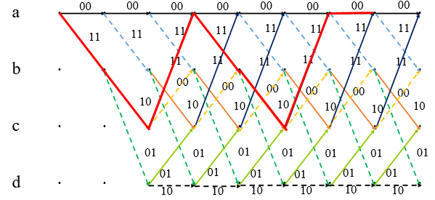 | CO4 | K4 | 4
Or
QB402(B) | With a necessary equation, explain the convolutional code.  The message bits come in serially rather than in large blocks, the use of convolutional coding may be the preferred method. The convolutional code generates redundant bits by using modulo -2 convolutions.  The encoder of a binary convolutional code with rate $\frac{1}{n}$, measure in bits per symbol. A finite state machine that consists of an M-stage shift register with prescribed connections to 𝑛 odulo-2 adders, and a multiplexer that serializes the output of the adders. An 𝐿 – bit message sequence produces a coded output sequence of length (𝐿 + 𝑀) bits. The code rate is $r=\frac{L}{n\left(L+M\right)}$, bits/symbol, 𝐿 ≫ 𝑀, $r≈\frac{1}{n}$ bits per symbol. Constraint length of a convolutional code, expressed in terms of message bits, is defined as the number of shift over which a single message bit can influence the encoder output.  Encoder with an M-stage shift register, the memory of the encoder equals M message bits, and K = M+1 shift are required for a message bit to the shift register and finally come out.  The output to the input of a convolutional encoder is characterized in terms of its impulse response, defined as the response of that path to a symbol 1 applied to its input, with each flip-flop in the encoder set initially in the 0 state.  A generator polynomial, defined as the unit delay transform of the impulse response. The generator sequence $(g_{0}^{(i)}, g_{1}^{(i)}, ……g_{M}^{(i)})$ denoted the impulse response of the $i^{th}$ path. Where the coefficients $(g_{0}^{(i)}, g_{1}^{(i)}, ……g_{M}^{(i)})$ equal 0 or 1. the generator polynomial of the $i^{th}$ path is defined by  𝑔 ^{𝑖}(𝐷) = ($g_{0}^{(i)}+g_{1}^{(i)}D+…+g_{M}^{\left(i\right)}D^{M}$)  𝐷 denotes the unit delay variable. | CO4 | K4 | 3
QB403(A) | The generator polynomial of (7, 4) cyclic code is X⁷+1 = (𝑝³ + 𝑝 + 1) (𝑝³ + 𝑝² + 1) (p+1). Find the generator matrix, parity check matrix, and code word of the above sequence message is (1001).  Solution  Message sequence (1001).  𝑋^{𝑛} + 1is 𝑛 = 2^{𝑚} − 1,  𝑔(𝑋) = 1 + 𝑋 + 𝑋³  ℎ(𝑋) = 1 + 𝑋 1 + 𝑋² + 𝑋³ = 1 + 𝑋 + 𝑋² + 𝑋⁴  Whose degree equals the number of message bits 𝑘 = 4. The message polynomial is given by  𝑚 (𝑋) = 1 + 𝑋³  Multiplying 𝑚(𝑋) by 𝑋^{𝑛−𝑘} = 𝑋³, 𝑋^{𝑛−𝑘} 𝑚(𝑋) = 𝑋³ + 𝑋⁶  The second step is to divide 𝑋^{𝑛−𝑘} 𝑚(𝑋) by 𝑔(𝑋)  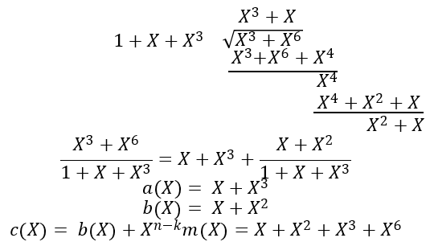  The code word is (011 1001).  𝑔 (𝑋) = 1 + 𝑋 + 𝑋³ , 𝑋𝑔(𝑋) = 𝑋 + 𝑋² + 𝑋⁴ , 𝑋²𝑔(𝑋) = 𝑋² + 𝑋⁴ + 𝑋⁵, 𝑋³𝑔(𝑋)= 𝑋³ + 𝑋⁴ + 𝑋⁶  (𝑋), (𝑋) , 𝑋²𝑔(𝑋), and 𝑋³𝑔(𝑋) code polynomial in (7,4) Hamming code. The generator matrix is  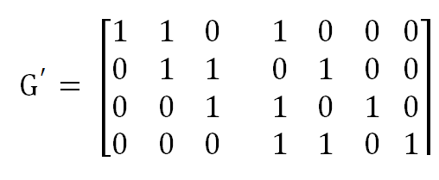  The generator matrix is not a systematic form, The systematic form,  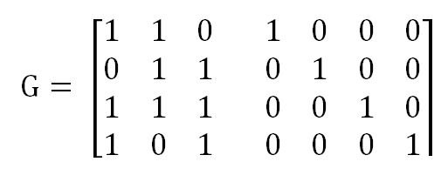  𝑋⁴ℎ(𝑋⁻¹)= 1 + 𝑋² + 𝑋³ + 𝑋⁴ ; 𝑋⁵ℎ(𝑋⁻¹) = 𝑋 + 𝑋³ + 𝑋⁴ + 𝑋⁵; 𝑋⁶ℎ(𝑋⁻¹)= 𝑋² + 𝑋⁴ + 𝑋⁵ + 𝑋⁶  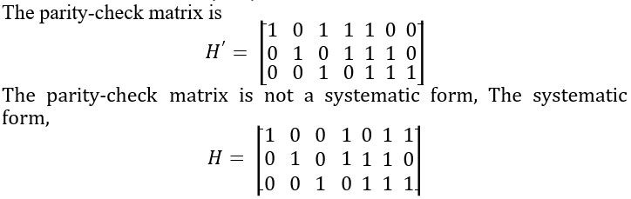 | CO4 | K4 | 4
Or
QB403(B) | With a necessary equation, explain the cyclic code.  Cyclic codes form a subclass of linear block code. Cyclic code possess a well-defined mathematical structure, which has led to the development of very efficient decoding schemes.  A binary code is said to be a cyclic code, two functional properties: Linearity property: the sum of any two code words in the code is also a code word.  Cyclic property: any cyclic shift of a code word in the code is also a code word. The code is a cyclic code if the n-tuples (𝐶_{𝑛−1}, 𝐶₀, … … . , 𝐶_{𝑛−2}), (𝐶_{𝑛−2}, 𝐶_{𝑛−1}, … … . , 𝐶_{𝑛−3}), ……., (𝐶₁, 𝐶₂, … … . , 𝐶_{𝑛−1}, 𝐶₀) are all code words in the code.  The algebraic property of cyclic codes 𝐶₀, 𝐶₁, … … . , 𝐶_{𝑛−1} of a code word to define the code polynomial, 𝑋 is an indeterminate, 𝑐 𝑋 = 𝑐₀ + 𝑐₁𝑋 + 𝑐₂𝑋² + …… . , 𝑐_{𝑛−1}𝑋^{𝑛−1}  Binary codes, the coefficients 1s and 0s. Power of 𝑋 in the polynomial c(𝑋) represents a one-bit shift in time. The code polynomial c(𝑋) be multiplied by 𝑋^{𝑖}, 𝑋^{𝑖}𝑐 𝑋 = 𝑋^{𝑖}(𝑐₀ + 𝑐₁𝑋 + 𝑐₂𝑋² + … … . , 𝑐_{𝑛−1}𝑋^{𝑛−1}) = 𝑐_{𝑛−𝑖} 𝑋^{𝑛} + … . +𝑐_{𝑛−1} 𝑋^{𝑛−𝑖−1} + 𝑐₀𝑋^{𝑖} + 𝑐₁𝑋^{𝑖+1} … … . , 𝑐_{𝑛−𝑖−1}𝑋^{𝑛−1}  The following definition  (𝑖)(X) = 𝑐_{𝑛−1} + … . +𝑐_{𝑛−1} 𝑋^{𝑖−1} + 𝑐₀𝑋^{𝑖} + 𝑐₁𝑋^{𝑖+1} … … .,+𝑐_{𝑛−𝑖−1}𝑋^{𝑛−1}  (𝑋) = 𝑐_{𝑛−𝑖} + 𝑐_{𝑛−𝑖+1}𝑋 … … . , +𝑐_{𝑛−1}𝑋^{𝑖−1}  The reformulated in the compact form  𝑋^{𝑖}𝑐(𝑋) = 𝑞(𝑋)(𝑋^{𝑛} + 1) + 𝑐^{(𝑖)}(𝑋)  ^{(𝑖)}(𝑋) is the remainder that results from dividing X^{i} c(𝑋) by (𝑋^{𝑛} + 1).  (𝑋) is a code polynomial, then ^{(i)} (𝑋)= X^{i} c(𝑋) mod (𝑋^{𝑛} + 1).  Polynomial 𝑋^{𝑛} + 1 and its factors play a major role in the generation of cyclic code. 𝑔(𝑋) be a polynomial of degree 𝑛 − 𝑘,  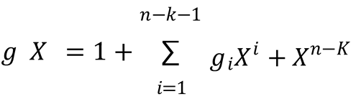  𝑔_{𝑖} is equal to 0 or 1. The polynomial (𝑋) has two terms with coefficient 1 separated by 𝑛 − 𝑘 – 1 terms. The polynomial (𝑋) is called the generator polynomial of a cyclic code.  𝑐(𝑋) = 𝑎(𝑋) 𝑔(𝑋),  (𝑋) is polynomial in 𝑋 with degree 𝑘 − 1.  𝑚₀, 𝑚₁, ···, 𝑚_{𝑘−1}  𝑏₀, 𝑏₁, ···, 𝑏_{𝑛−𝑘−1}  The generator polynomial (𝑋) and the requirement is to encode the message sequence (𝑚₀, 𝑚₁, … . . 𝑚_{𝑘−1}) into (𝑛, 𝑘) systematic cyclic code.  𝑚 (𝑋) = 𝑚₀ + 𝑚₁𝑋 + ⋯ . . +𝑚_{𝑘−1}𝑋^{𝑘−1}  𝑏 (𝑋) = 𝑏₀ + 𝑏₁𝑋 + ⋯ . . +𝑏_{𝑛−𝑘−1}𝑋^{𝑛−𝑘−1}  𝑐 (𝑋) = 𝑏 (𝑋) + 𝑋^{𝑘−1}𝑚(𝑋)  𝑎 (𝑋) 𝑔(𝑋) = 𝑏(𝑋) + 𝑋^{𝑘−1}𝑚(𝑋)  Equivalently, in light of modulo -2 addition,  $$\frac{X^{K-1}m\left(X\right)}{g\left(X\right)}=a\left(X\right)+\frac{b\left(X\right)}{g\left(X\right)}$$  The polynomial (𝑋) is the remainder left over after dividing 𝑋^{𝑘−1}(𝑋) by 𝑔(𝑋). Summarize the steps involved in the encoding procedure for an (𝑛, 𝑘) cyclic code assured  - Multiply the message polynomial m(𝑋) by 𝑋^{𝑛−𝑘}.  - Divide 𝑋^{𝑛−𝑘} (𝑋) by the generator polynomial (𝑋), obtaining the remainder (𝑋).  - Add (𝑋) to 𝑋^{𝑛−𝑘} (𝑋), obtaining the code polynomial (𝑋).  (𝑛, 𝑘) cyclic code is uniquely specified by its generator polynomial (𝑋) of order (𝑛 − 𝑘).  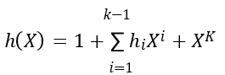  The coefficient ℎ_{𝑖} are 0 or 1, but separated by 𝑘 − 1 terms.  The generator polynomial (𝑋) is equivalent to the generator matrix G,. The parity-check polynomial ℎ(𝑋) is equivalent to the generator matrix H.  𝑔(𝑋) ℎ(𝑋) 𝑚𝑜𝑑 𝑋^{𝑛} + 1= 0; 𝑔(𝑋) ℎ(𝑋) =𝑋^{𝑛} + 1;  A cyclic code in systematic form, the syndrome can be calculated easily. The received word be represented by a polynomial of degree 𝑛 − 1 or less, (𝑋) = 𝑟₀ + 𝑟₁𝑋 + 𝑟₂𝑋² +… … . , 𝑟_{𝑛−1}𝑋^{𝑛−1}. (𝑋) denote the quotient and (𝑋) denote the remainder, the result of dividing (𝑋) by generator polynomial 𝑔(𝑋). The 𝑟(𝑋) as follows  The (𝑋) denote the quotient and (𝑋) denote the remainder; degree 𝑛 −𝑘 − 1,the result of dividing 𝑟(𝑋) by generator polynomial 𝑔(𝑋) . The 𝑟(𝑋) as follows 𝑟(𝑋) = 𝑞(𝑋) 𝑔(𝑋) + 𝑠(𝑋)  Properties of syndrome polynomial  - Syndrome of a received word polynomial is also the syndrome of the corresponding error polynomial. 𝑟(𝑋) = 𝑐(𝑋) + 𝑒(𝑋)  𝑞(𝑋) 𝑔(𝑋) + 𝑠(𝑋) = 𝑎(𝑋) 𝑔(𝑋) + 𝑒(𝑋)  [𝑞(𝑋) + 𝑎(𝑋)]𝑔(𝑋)+ 𝑠(𝑋) = 𝑒(𝑋)  𝑢(𝑋)𝑔(𝑋) + 𝑠(𝑋) = 𝑒(𝑋) ; 𝑢(𝑋) = 𝑞(𝑋) + 𝑎(𝑋)  - The syndrome of a received word polynomial (𝑋). The syndrome of (𝑋), a cyclic shift of (𝑋)is 𝑋𝑠(𝑋).  𝑋𝑟(𝑋) = 𝑋𝑞(𝑋)𝑔(𝑋) + 𝑋𝑠(𝑋)  - Syndrome polynomial (𝑋) is identical to the error polynomial (𝑋) , assuming that the error are confined to the 𝑛 − 𝑘 parity-check bits of the received word polynomial 𝑟(𝑋). | CO4 | K2 | 2
QB404A) | For a (6, 3) systematic linear block code, the three parity bits are given by P1=I1+I2, P2= I2+I3, P3=I1+I3. Find all the code vectors. Show that it is a hamming code. Calculate syndrome and decode the received sequence 101000.  Solution  The Generator Matrix, G = [P | I_{k}]  The Generator Matrix is:  1 1 0 1 0 0  0 1 1 0 1 0  1 0 1 0 0 1  **********  Codeword c = m G = m [P | I_{k}]  Message Bits Codeword Hamming Weight  0 0 0 0 0 0 0 0 0 0  0 0 1 1 0 1 0 0 1 3  0 1 0 0 1 1 0 1 0 3  0 1 1 1 1 0 0 1 1 4  1 0 0 1 1 0 1 0 0 3  1 0 1 0 1 1 1 0 1 4  1 1 0 1 0 1 1 1 0 4  1 1 1 0 0 0 1 1 1 3  **********  Minimum Hamming distance : 3  **********  Parity Check Matrix, H = [P^{T} | I_{n-k}]  Parity Check Matrix  1 0 0 1 0 1  0 1 0 1 1 0  0 0 1 0 1 1  **********  Enter the received codeword : 1 0 1 0 0 0  Parity Check Matrix Transpose H^{T}  0 0 0  1 0 0  0 1 0  0 0 1  1 1 0  0 1 1  1 0 1  Error position e = r H^{T}  The error position is, s : 0 0 0 0 0 1  **********  Syndrome Matrix  0 0 0 0 0 0 0 0 0  1 0 0 1 0 0 0 0 0  0 1 0 0 1 0 0 0 0  0 0 1 0 0 1 0 0 0  1 1 0 0 0 0 1 0 0  0 1 1 0 0 0 0 1 0  1 0 1 0 0 0 0 0 1  **********  Syndrome of given received codeword is : 1 0 1  Error position is s, 0 0 0 0 0 1  The correct codeword is : r + s = 1 0 1 0 0 1 | CO4 | K2 | 3
Or
QB404(B) | Design a ½ rate convolutional encoder with constraint length 3 and encode the message bits 1111 for the generator sequences g1 = {1, 1, 0} and g2 = {0, 1, 1}. Also, draw the code tree and trace the output sequence. Sketch code Trellis and State diagram for this code.  The impulse response of path 1 is (1, 1, 1). 𝑔 ¹(𝐷) = 1 + 𝐷  The impulse response of path 2 is (1, 0, 1). 𝑔 ²(𝐷) = 𝐷 + 𝐷²  The message sequence is (10011). 𝑚(𝐷) = 1 + 𝐷 + 𝐷² + 𝐷³  The output polynomial of path 1 is c¹(𝐷)= 𝑔¹(𝐷) 𝑚(𝐷)  = (1 + 𝐷) (1 + 𝐷 + 𝐷² + 𝐷³) = 1 + 𝐷⁴  The output sequence of path 1 is (1000100)  The output polynomial of path 2 is c²(𝐷)= 𝑔²(𝐷) 𝑚(𝐷)  = (𝐷 + 𝐷²) (1 + 𝐷 + 𝐷²+ 𝐷³) = 𝐷 + 𝐷⁵  The output sequence of path 2 is (0100010)  The encoded sequence is (10, 01, 00, 00, 10, 01, 00)  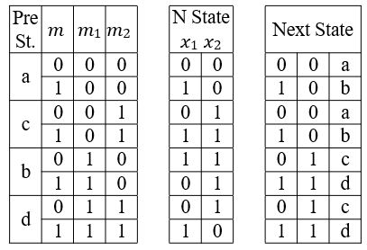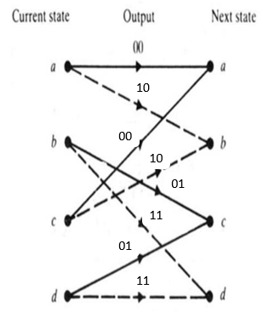  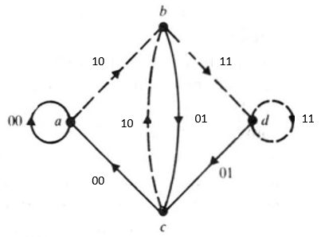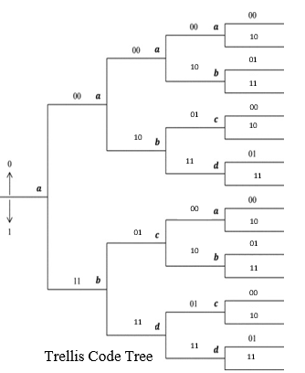  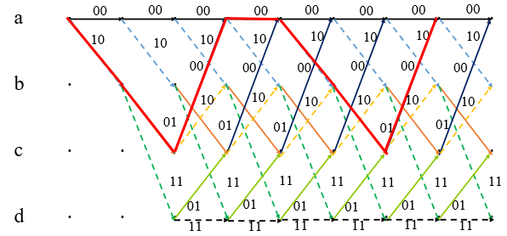 | CO4 | K2 | 3
QB501(A) | With a suitable diagram and the necessary equations, explain the working principle of a baseband spread spectrum system.  Spread spectrum modulation is that it can be provide protection against externally generated interfering signal with finite power. The jamming signal may be consists of a fairly powerful broadband noise or multitoned waveform that is directed at the receiver for the purpose of disrupting communications. Protection against jamming waveform is provided by purposely making the information bearing signal occupy a bandwidth far in excess of the minimum bandwidth necessary to transmit it.  The bandwidth of the an information bearing sequence involves the use of modulation. Let $\{b_{k}\}$ denote a binary data sequence, and $\left\{c_{k}\right\}$ denote a pseudo-noise sequence. The waveform $b(t)$ and $c(t)$ denote a their respective polar nonreturn –to zero representations in terms of two level equal in amplitude and opposite polarity, namely ±1.  The waveform $b(t)$ as a information bearing signal and $c(t)$ denote as the PN signal. The modulation is achieved by applying the data signal $b(t)$ and the PN signal $c(t)$ to a product modulator. Fourier transform theory that multiplication of two signals produces a signal whose spectrum equals the convolution of the spectra of the two component signals.  The message signal $b(t)$ is narrowband and the PN signal $c(t)$ is wideband, the product signal $m(t)$ will have a spectrum that is nearly the same as the wideband PN signal.  Information bearing signal $b(t)$ by the PN signal $c(t)$ each information bit is chopped up into a number of small time increments. This is commonly referred as chips.  The product signal $m(t)$represent the transmitted signal, the transmitted signal as  $$m\left(t\right)=c\left(t\right)b(t)$$  The received signal $r(t)$consists of the transmitted signal $m(t)$ plus an additive interference denoted by $i(t)$, channel model is  $$r\left(t\right)=m\left(t\right)+i\left(t\right)=c\left(t\right)b\left(t\right)+i(t)$$  The original message signal $b(t)$, the received signal $r(t)$ is applied to a demodulator that consists of a multiplier followed by an integrator, and a decision device. The multiplier is supplied with a locally generated PN sequence that is an exact replica of that used in the transmitter. The multiplier output in the receiver is  $$z\left(t\right)=c\left(t\right)r\left(t\right)=c^{2}\left(t\right)b\left(t\right)+c\left(t\right)i(t)$$  The data signal $b\left(t\right)$ is multiplied twice by the PN signal $c(t)$, whereas the unwanted signal $i(t)$ is multiplied only once. The PN signal $c(t)$ alternates between the levels -1 and +1, and the alternation is destroyed when it is squared; $c^{2}\left(t\right)=1$ for all $t$. Simplify the above equation  $$z\left(t\right)=b\left(t\right)+c\left(t\right)i(t)$$  The data signal $b(t)$ is reproduced at the multiplier output in the receiver, except for the effect of the interference represented by the additive term $c\left(t\right)i(t)$.  Multiplication of the interference $i(t)$ by the locally generated PN signal $c(t)$ means that the spreading code will affect the interference jut as it did the original signal at the transmitter. The data component $b(t)$ is narrowband, whereas the spurious component $c(t)i(t)$ is wideband. By applying the multiplier output to a baseband filter with a bandwidth just large enough to accommodate the recovery of the data signal $b(t)$, most of the power in the spurious component $c(t)i(t)$ is filtered out. The effect of the interference $i(t)$ is thus significantly reduced at the receiver output.  The low-pass filtering action is actually performed by the integrator that evaluates the area under the signal produced at the multiplier output. The integration is carried out for the bit interval $1 ≤i≤T_{b}$, providing sample value $v$.  A decision is made by the symbol 1 of the original data sequence was sent in the interval $1 ≤i≤T_{b}$, and if $v$ is less than zero, the receiver says that symbol 0 was sent. If $v$ is exactly zero the receiver makes a random guess in favor of 1 or 0.  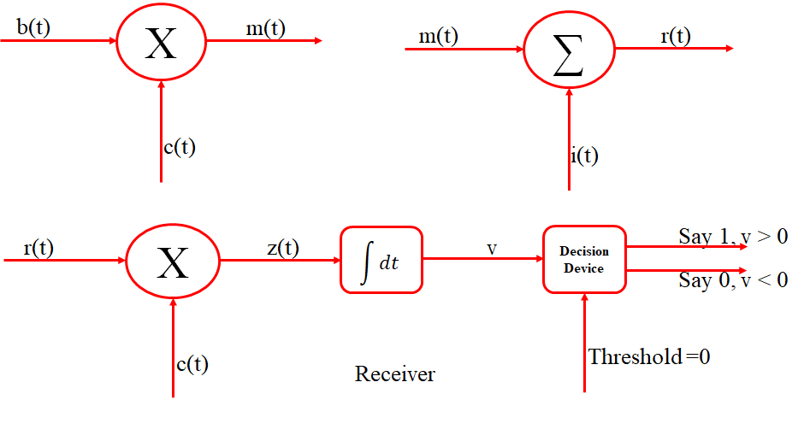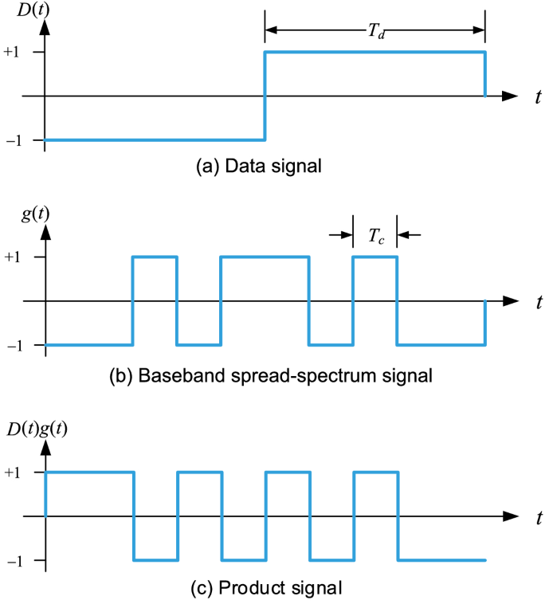 | CO5 | K2 | 2
Or
QB501(B) | Discuss in detail the operational principle of slow frequency hopping spread spectrum.  FH/MFSK transmitter, which involves frequency modulation followed by mixing. First, the incoming binary data are applied to an M-ary FSK modulator. The resulting modulated wave and the output from a digital synthesizer are then applied to a mixer that consists of a multiplexer followed by a BPF.  The filter is designed to select the sum frequency component resulting from the multiplication process as the transmitted signal. A $k$-bit segments of a PN sequence drive the frequency synthesizer, which enable the carrier frequency to hop over $2^{k}$ distinct values.  A single hop, the bandwidth of the transmitted signal is the same as that resulting from the use of a conventional MFSK with an alphabet of ${M=2}^{k}$ orthogonal signals. For a complete range of $2^{k}$ frequency hops, the transmitted FH/MFSK signal occupies a much larger bandwidth.  An implication of large FH bandwidth is that coherent detection is possible only within each hop, because frequency synthesizer are unable to maintain phase coherence over successive hops. Accordingly most FH spread spectrum communication system use noncoherent M-ary modulation scheme.  Receiver, the frequency hopping is first removed by mixing the received signal with the output of a local frequency synthesizer that is synchronously controlled in the same manner as that in the transmitter. The resulting output is then BPF, and subsequently processed by a noncoherent M-ary FSK detector.  M-ary detector, a bank of M noncoherent matched filter, each of which is matched to one of the MFSK tones. An estimate of the original symbol transmitted is obtained by selecting the largest filter output.  FH/MFSK tone of shortest duration is referred to as chip. The chip rate, $R_{c}$, for an FH/MFSK system is defined by  $$R_{c}=\max\left(R_{h}, R_{s}\right)$$  Where $R_{h}$ hop rate, $R_{b}$ incoming binary data, and $R_{s}$ is symbol rate.  A slow FH/MFSK signal is characterized by having multiple symbols transmitted per hop. Each symbol of a slow FH/MFSK signal is a chip.  $$R_{c}=R_{s}=\frac{R_{b}}{K} ≥ R_{b}$$  Where $K=\log_{2}{M}$. Each hop, the MFSK tones are separated in frequency by an integer multiple of the chip rate ensuring their orthogonality. The implication o this condition is that any transmitted symbol will not produce any crosstalk in the other $M-1$ noncoherent matched filter constituting the MFSK detector of the receiver.  Crosstalk, the spillover from one filter output into an adjacent one. The resulting performance of the slow FH/MFSK system is the same as that for the noncoherent detection of onventional MFSK signals in AWGN.  The jamming signal has an effect on the FH/MFSK receiver, in term of average probability of symbol error, equivalent to that of AWGN on a conventional noncoherent M-ary FSK receiver experiencing no jamming.  The jammer decides o spread its average power $J$ over the entire FH spectrum, the jammers effect is equivalent to an AWGN with power spectral density $N_{0}/2$, where $N_{0}=J/E_{c}$ is the FH bandwidth.  The symbol energy-to-noise spectral density ratio  $$\frac{E}{N_{0}}=\frac{P/J}{W_{c}/R_{c}}$$  Where $P/J$ is the reciprocal of the jamming margin.  The processing gain is defined by  $$PG=\frac{W_{c}}{R_{c}}$$  The processing gain in decibel is equal to  $$10\log_{10}{2^{k} }≅3k$$  Where $k$ is the length of the PN segment employed to select a frequency hop.  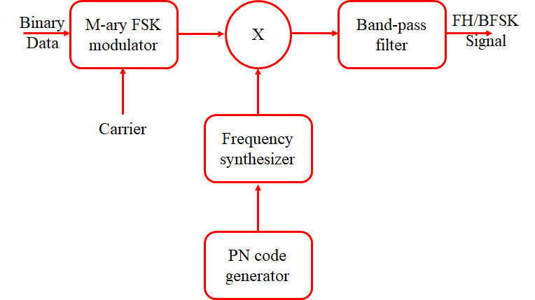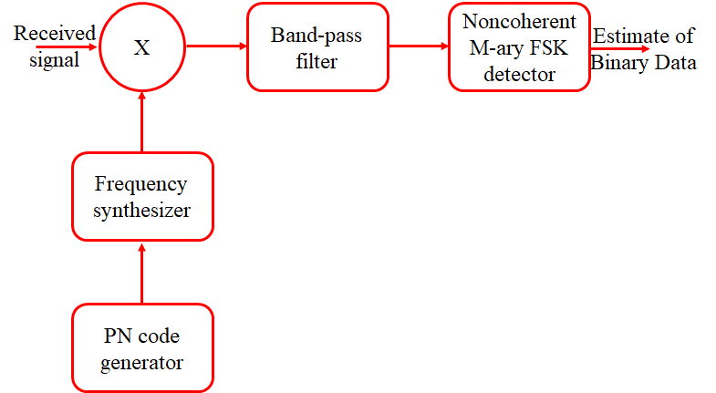 | CO5 | K3 | 3
QB502(A) | Explain the working principle of DSSS BPSK with a suitable diagram and derive expression for probability of error and antijam characteristics.  This technique in passband transmission over a satellite channel. The transmitter diagram first converts the incoming binary data sequence $b_{k}$ into a polar NRZ waveform $b(t)$, which is followed by two stages of modulation.  A product modulator with data signal$b(t)$ as inputs.  Consists of a Binary PSK modulator, the transmitted signal $x(t)$ is thus a DS/BPSK signal. The phase modulation $ф(t)$ of $x(t)$ has one of two values 0 and , depending on the polarities of the message signal $b(t)$ and PN signal $c(t)$ at time $t$.  The waveform for the second stage of modulation. The DS/BPSK waveform that results from the second stage of modulation.  The receiver consists of two stage demodulation.  - The received signal $y(t)$ and a locally generated carrier are applied to a product modulator follows by a LPF whose bandwidth is equal to that of the original message signal $m(t)$. This stage of the demodulation process reverse the PSK applied to the transmitted signal.  - Demodulation perform spectrum dispreading by multiplexing the LPF output by a locally generated replica of the PN signal $c\left(t\right),$ followed by integration over a bit interval $0 ≤t ≤T_{b}$ and finally decision making devices, output is $v$, is compared with a threshold of zero volts. If $v$ > 0, the receiver decides in favor of symbol 1, If $v$ < 0, the receiver decides in favor of symbol 0, If $v$ exactly 0, the receiver makes a random guess in favor of 1 or 0.  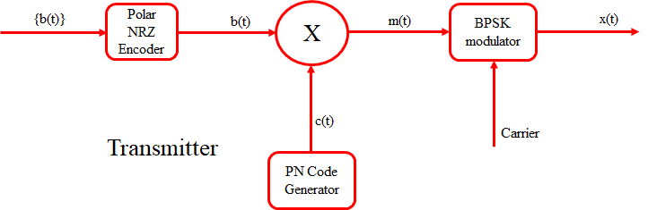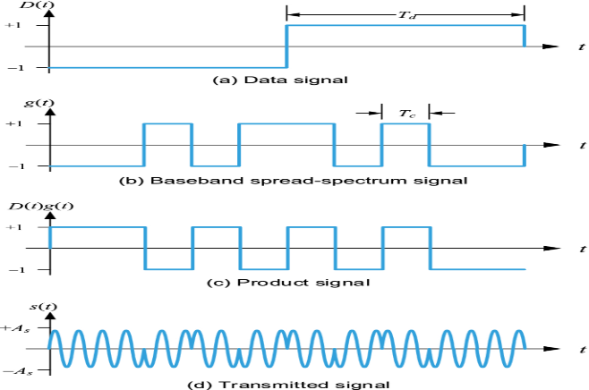  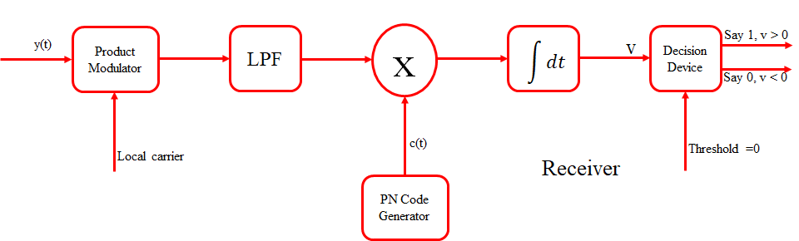  Probability of Error  The coherent detector output $V$. The equivalent noise component $v_{cj}$ produced by external interference denote the ample value of a random variable $V_{cj}$  $$V= ±\sqrt{E_{b}}+V_{cj}$$  Where $E_{b}$ is the signal energy per bit; the plus sign corresponds to information bit 1, and the minus sign corresponds to information bit 0. The received bit in an interval (0, $T_{b}$) is 1 if the detector output exceed a threshold of zero, and that is 0 if the detector output is less than the threshold; if the detector output is exactly zero, the receiver makes a random guess in favor of or 0.  The average probability pf error is the same as the conditional probability of the receiver making a decision on favor of symbol 1, given that symbol 0 was sent.  $$P_{e}=P\left(V>0 | symbol 0 was sent\right)=P(V_{cj}>√E_{b})$$  $$P_{e}=\frac{1}{2}\operatorname{erfc}\left(\sqrt{\frac{E_{b}}{{JT}_{c}}}\right)$$  Antijam Characteristics  The formula for the average probability of error for a coherent BPSK system reproduced  $$P_{e}=\frac{1}{2}\operatorname{erfc}\left(\sqrt{\frac{E_{b}}{{JT}_{c}}}\right)$$  The interference may be treated as wideband noise of power spectral density $\frac{N_{0}}{2}$  $$\frac{N_{0}}{2}=\frac{JT_{c}}{2}$$  The signal energy bit $E_{b}=PT_{b}$, where $P$ is the average signal power and $T_{b}$ is the bit duration. The signal energy per bit-to-noise spectral density ratio ad  $$\frac{E_{b}}{N_{0}}=\left(\frac{T_{b}}{T_{c}}\right)\left(\frac{P}{J}\right)$$  The processing gain as reformulate as  $$\frac{J}{P}=\frac{PG}{E_{b}/N_{0}}$$  $J/P$ is jamming margin, expressed in decibels are related by  $${\left(Jamming margin\right)}_{dB}={\left(Processing gain\right)}_{dB}=10\log_{10}{{\left(\frac{E_{b}}{N_{0}}\right)}_{min}}$$  ${\left(\frac{E_{b}}{N_{0}}\right)}_{min}$is the minimum value needed to support a prescribed average probability of error. | CO5 | K3 | 4
Or
QB502(B)* | Write short notes on CDMA and SDMA  CDMA  CDMA systems, the narrowband message signal is multiplied by a very large bandwidth signal called the spreading signal. The spreading signal is a pseudo-noise code sequence that has a chip rate which is ordered of magnitudes grater than the data rate of the message.  All users in a CDMA systems, use the same carrier frequency and may transmit simultaneously. Each user has its own pseudorandom codeword which is approximately orthogonal to all other codewords.  The receiver performs a time correlation operation to detect only the specific desired codeword.  All other codewords appear as noise due to decorrelation. The message signal, the receiver needs to know the codeword used by the transmitter. Each user operates independently with no knowledge of the other users.  The power of multiple users at a receiver determine the noise floor after decorrelation. If the power of each user within a cell is not controlled such that they do not appear equal at the base station receiver, then the near-far problem occurs.  Near-far problem occurs when many mobile users share the same channel. The strongest received mobile signal will capture the demodulation at a base station. Strongest received signal levels raise the noise floor at the base station demodulator for the weaker signals, thereby decreasing the probability that weaker signals will be received.  Near-far problem, power control is used n most CDMA implementation.  CDMA features:  - Many users of a CDMA system share the same frequency.  - CDMA has a soft capacity limit. Increasing number of users in a CDMA system raises the noise floor in a linear manner.  - There is no absolute limit on the number of users in CDMA. Rather the system performance gradually degrades for all users as the number of users is increased, and improve as the number of users is decreased.  - Multipath fading may be substantially reduced because the signal is spread over a large spectrum. The inherent frequency diversity will mitigate the effect of small-scale fading.  - Channel data rates are very high in CDMA systems, the symbol duration is very short and usually much less than the channel delay spread.  - CDMA uses co-channel cells, it can use macroscopic spatial diversity to provide soft handoff. Soft handoff is performed by the MSC, which can simultaneously monitor a articular user from two or more base station.  - Self-jamming is a problem in CDMA system.  - Near-far problem occurs at a CDMA receiver if an individual user has a high detected power as compared to the desired user.  SDMA  SDMA controls the radiated energy for each user in space.  Serves different users by using spot beam antenna. Different area covered by the antenna beam may be served by the same or different frequency.  Sectorized antennas may be thought of as a primitive application of SDMA.  In future, adaptive antennas will likely be used to simultaneously steer energy in the direction of many users at once and appear to be best suited for TDMA and CDMA base station architecture.  Reverse link presents the most difficulty in cellular systems for several reason:  - The base station has complete control over the power of all the transmitted signals on the forward link.  - Transmitted power is limited by battery consumption at the subscriber unit, therefore there are limits on the degree to which power may be controlled on the reverse link.  - Base station antenna is made to spatially filter each desired user so that more energy is detected from each subscriber, then the reverse link for each user is improved and less power is required.  Adaptive antennas used at the base station promise to mitigate some of the problem on the reverse link.  The limiting case of infinitesimal beam width and infinitely fast tracking ability, adaptive antennas implementing optimal SDMA, thereby providing a unique channel that is free from the interference of all other users in the cell.  SDMA all users within the system would be able to communicate at the same time using the same channel.  A perfect adaptive antenna system would be able an optimal manner to collect all of the available signal energy from each user.  The perfect adaptive antenna system is not feasible since it require infinitely large antennas.  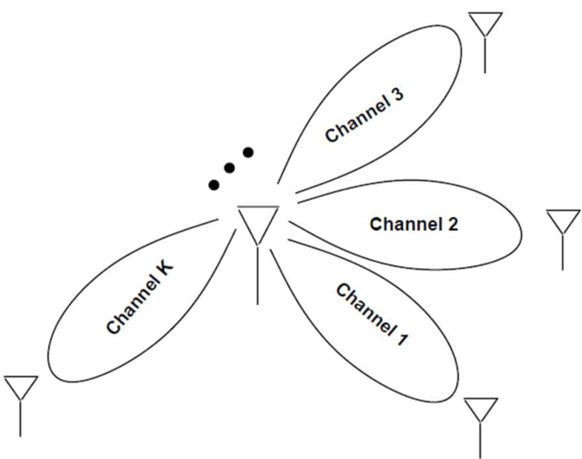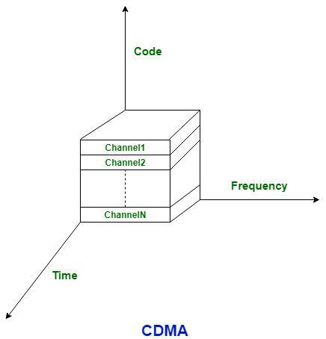 | CO5 | K2 | 2
QB503(A)* | Discuss in detail about TDMA and FDMA.  TDMA  TDMA systems divide the radio spectrum into time slots, and in each slot only one user is allowed to transmit or receive. Each user occupies a cyclically repeating time slot, where $N$ time slots comprise a frame. Transmit data in a buffer-and-burst method, thus the transmission for any user is uncontinuous. TDMA systems accommodate digital data and digital modulation.  Transmission from various users is interlaced into a repeating frame structure.  A frame consists of a number of slots. Each frame is made up of a preamble, an information message, and tail bits.  TDMA/TDD, half of the time slots in the frame information message would be used for the forward link channels and half would be used for reverse link channels. Similar frame structure would be used solely for either forward or reverse transmission, but the carrier frequency would be different for the forward and reverse links.  TDMA system intentionally induce several time slots of delay between the forward and reverse time slots of a particular user, so that duplexers are not required in the subscriber unit.  The preamble contains the address and synchronization information that both the base station and the subscribers use to identify each other.  Guard times are utilized to allow synchronization of the receiver between different slots and frames.  Feature of TDMA  - Share a single carrier frequency with several users, where each user makes use of nonoverlapping time slots.  - Data transmission for users of a TDMA system is not continuous, but occurs in bursts. This results in low battery consumption.  - Discontinuous transmission, the handoff process is much simpler for a subscriber unit.  - Different time slots for transmission and reception, thus duplexer are not required.  - Adaptive equalization is usually in TDMA systems, transmission rate is generally very high as compared to FDMA.  - Guard time should be minimized.  - High synchronization overhead is required, because of burst transmission. Transmission are slotted and thus require the receivers to be synchronized for each data burst.  - Guard slots are necessary overheads as compared to separate users, this results in the TDMA systems having larger overheads.  - Advantage in that it is possible to allocate different numbers of time slots per frame to different users. Bandwidth can be supplied on demand to different users by concatenating time slot based on priority.  Number of overhead bits per frame is  $$b_{OH}=N_{r}b_{r}+N_{t}b_{P}+N_{t}b_{g}+N_{r}b_{g}$$  Total number of bits per frame $b_{T }=T_{f}R$  Frame efficiency $η_{f}=1 -\frac{b_{OH}}{b_{T}}×100\%$  Number of channel, $N=\frac{m\left(B_{tot}-2B_{guard}\right)}{B_{c}}$  Where $N_{r}$ number of reference bursts per frame, $b_{r}$ number of overhead bits per reference burst, $N_{t}$ number of traffic burst per frame, $b_{P}$ number of overhead bits per preamble in each slot, $b_{g}$ number of equivalent bits in each guard time interval., $T_{f}$ frame duration, $R$ channel bit rate, $m$ maximum number of TDMA users support on each radio channel, $B_{c}$ channel bandwidth, $B_{t}$ total spectrum allocation and $B_{guard}$ guard band allocated at the edge of the allocated spectrum.  FDMA  Frequency division multiple access assign individual channels to individual users. Each user is allocated a unique frequency band or channel. These channels are assigned on demand to users who request service, during the period of the call, no other user can share the same frequency band. Frequency Division Duplex systems, the users are assigned a channel as a pair of frequencies: one frequency is used for the forward channel, while the other frequency is used for the reverse channel. FDMA systems which accommodate analog FM.  Feature of FDMA:  - FDMA channel carries only one phone circuit at a time.  - Channel is not in use, then it sits idle and cannot be used by other users to increase or share capacity.  - After assignment of a voice channel, the base station and the mobile transmit simultaneously and continuously.  - FDMA channels are relatively narrow (30 kHz) as each channel supports only one circuit per carrier.  - Symbol time is large as compare to the average delay spread.  - Complexity of FDMA mobile systems lower when compared to TDMA systems.  - FDMA is continuous transmission scheme, fewer bits are needed for overhead purposes as compared to TDMA.  - FDMA systems have higher cell site system costs as compared to TDMA.  - FDMA mobile unit used duplexer. Both transmitter and receiver operate at the same time.  - FDMA require tight RF filtering to minimize adjacent channel interference.  Number of channel that can be simultaneously support in a FDMA system is given by  $$N=\frac{B_{t}-2B_{guard}}{B_{c}}$$  Where $B_{c}$ channel bandwidth, $B_{t}$ total spectrum allocation and $B_{guard}$ guard band allocated at the edge of the allocated spectrum.  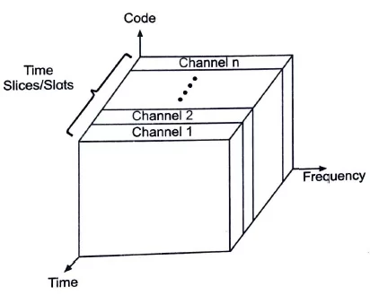  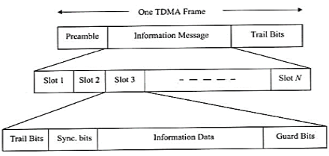  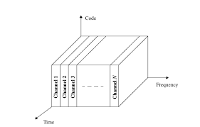 | CO5 | K3 | 4
Or
QB503(B)* | Define the term spread spectrum. List out the advantage of spread spectrum. (7)  A form of secure communication in a hostile environment such that the transmitted signal is not easily detected or recognized by unwanted listeners. This requirement is catered to by a class of signaling techniques known collectively as spread-spectrum modulation.  Primary advantage of a spread spectrum communication system is its ability to reject interference, whether it be the unintentional interference by another user simultaneously attempting to transmit through the channel, the intentional interference by a hostile transmitter attempting to jam the transmission.  Definition of spread spectrum modulation:  - Spread spectrum is means of transmission in which the data sequence occupies a bandwidth in excess of the minimum bandwidth necessary to send it. (FM and PCM satisfy the condition)  - Spectrum spreading is accomplished before transmission through the use of a code that is independent of the data sequence. The same code is used in the receiver to despread the received signal so that the original data sequence may be recovered. (They are not Spread Spectrum technique, not satisfy the condition)  Spread Spectrum technique originally developed for  - Military application.  - Civilian applications.  - Multipath rejection in a ground based mobile radio environment.  - Multiple access communications in which a number of independent users are required to share a common channel without an external synchronization mechanism.  - Eg: A ground based radio environment involving mobile vehicle that must communicate with a central station.  The principle of Spread Spectrum modulation, is direct sequence and frequency hopping technique.  - A direct sequence Spread Spectrum technique, two stage of modulation are used. First, the incoming data sequence is used to modulate a wideband code. This code transform the narrowband data sequence into a noise like wideband signal. The resulting wideband signal undergoes a second modulation using PSK technique.  - Frequency hop Spread Spectrum technique, on other hand, the spectrum of a data modulate carrier is wideband by changing the carrier frequency in a pseudo random manner.  Both of these technique rely on the availability of a noiselike spreading code called pseudo random or pseudo noise sequence.  Write short notes on SDMA. (6)  SDMA controls the radiated energy for each user in space.  Serves different users by using spot beam antenna. Different area covered by the antenna beam may be served by the same or different frequency.  Sectorized antennas may be thought of as a primitive application of SDMA.  In future, adaptive antennas will likely be used to simultaneously steer energy in the direction of many users at once and appear to be best suited for TDMA and CDMA base station architecture.  Reverse link presents the most difficulty in cellular systems for several reason:  - The base station has complete control over the power of all the transmitted signals on the forward link.  - Transmitted power is limited by battery consumption at the subscriber unit, therefore there are limits on the degree to which power may be controlled on the reverse link.  - Base station antenna is made to spatially filter each desired user so that more energy is detected from each subscriber, then the reverse link for each user is improved and less power is required.  Adaptive antennas used at the base station promise to mitigate some of the problem on the reverse link.  The limiting case of infinitesimal beam width and infinitely fast tracking ability, adaptive antennas implementing optimal SDMA, thereby providing a unique channel that is free from the interference of all other users in the cell.  SDMA all users within the system would be able to communicate at the same time using the same channel.  A perfect adaptive antenna system would be able an optimal manner to collect all of the available signal energy from each user.  The perfect adaptive antenna system is not feasible since it require infinitely large antennas.   | CO5 | K2 | 2
QB504(A)* | With suitable equation, explain the working principle of pseudo noise generation. (7)  A pseudo noise sequence is a periodic binary sequence with a noiselike waveform that is usually generated by means of a feedback register.  A feedback register consists of an ordinary shift register made up of m flip-flop and a logic circuit that are interconnected to form a multiloop feedback circuit.  The flip-flop in the shift register are regulated by a single timing clock. The state of each flip-flop is shifted to the next one down the line.  The clock pulse the logic circuit computes a Boolean function of the states of the flip-flops. The result is then fed back as the input to the first flip-flop, thereby preventing the shift register from emptying. The PN sequence so generated is determined by the length $m$ of the shift register, its initial state, and the feed-back logic.  $s_{i}(k)$ denote the state of the $i^{th}$ flip-flop after the $k^{th}$ clock pulse; state may be represented by symbol 0 or 1. The shift register after the $k^{th}$ clock pulse is then defined by the set ${\{s}_{1}\left(k\right),s_{2}\left(k\right)….,s_{m}(k)\}$ where$k≥0$. The initial state $k$ is zero. The definition of a shift register,  $$s_{i}\left(k+1\right)=s_{i-1}\left(k\right), \left\{\begin{aligned}k ≥0 \\ 1 ≤i≤m\end{aligned}\right.$$  Where $s_{i}\left(k\right)$ denote the state of the flip-flop after the $k^{th}$ clock pulse.  $s_{0}(k)$ is a Boolean function of the individual states $s_{1}\left(k\right),s_{2}\left(k\right)….,s_{m}(k)$. For a specified length $m$ this Boolean function uniquely determine the subsequent sequence of state and therefore the PN sequence produced at the output of the final flip-flop in the shift register. A total number of $m$ flip-flop the number of possible states of the shift register is at most $2^{m}$.  Feedback shift register is said to be linear when the feedback logic consists entirely of modulo-2 adder. The zero state is not permitted, a zero state, the input $s_{0}\left(k\right)$ produced by the feedback logic would be 0, the shift register would then continue to remain in the zero state, and the output would therefore consist entirely of 0s.  The period of a PN sequence produced by a linear feedback shift register with $m$ flip-flop cannot exceed $2^{m}-1$ , the PN sequence is called a maximal length sequence or simply $m$- sequence.  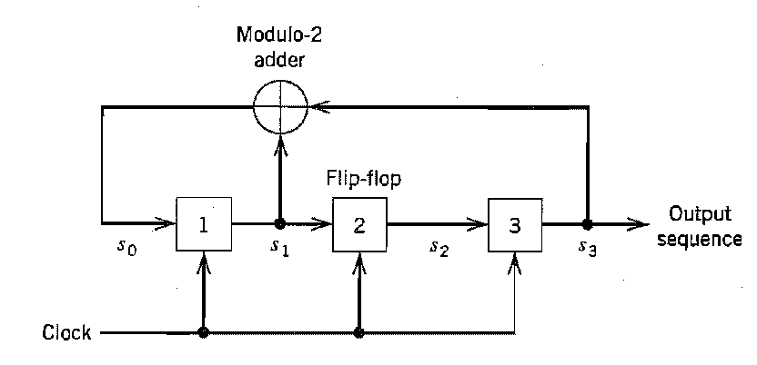  Comprise the building block of MIMO system. (6)  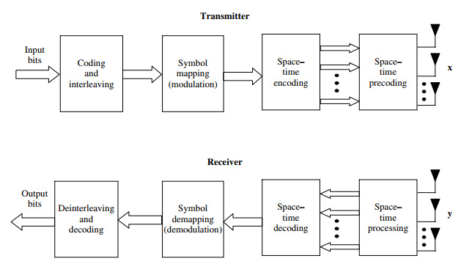  The information bits to be transmitted are encoded and interleaved. The interleaved code word is mapped to data symbols by the symbol mapper (QAM). These data symbols are input to a space-time streams.  The spatial data stream are mapped to the transmit antennas by the space-time precoding block. The signal launched from the transmit antennas propagate through the channel and arrive at the receiver antenna array.  The receiver collect the signals at the output of each receive antenna element and reverses the transmitter operations in order to decode the data: receive space-time processing, followed by space-time decoding, symbol demapping, deinterleaving and decoding.  The building blocks offers the opportunity for significant design challenges and complexity-performance of the blocks, the functionality and the interactions between the blocks. | CO5 | K2 | 3
Or
QB504(B)* | Comprise the building block of MIMO in ad hoc network. (7)  A wireless ad hoc network, At a given instant of time, a subset of terminals will be sources of data and another subset the intended destinations. The terminals in the network that are neither sources nor destinations may act as relays to assist data transmission in the network. Thus the number of operating modes in an ad hoc network is very large and will, in general, comprise of combinations of multiple-access, broadcast, relay and interference channels. While the ultimate performance limit of an ad hoc network is unknown, it is clear that leveraging the spatial dimension through the use of MIMO technology in each of the building blocks. (i.e., the constituent multiple-access, broadcast, relay and interference channels) will increase the overall network capacity.  Distributed MIMO is a means of realizing the gains of MIMO with single-antenna terminals in a network, allowing a gradual migration to a true MIMO network. The approach requires some level of cooperation between network terminals. This can be accomplished through suitably designed protocols. The cooperating terminals form a virtual antenna array that leverages the gains of MIMO in a distributed fashion. Substantial performance gains can be realized through this approach. The concept may be applied to both cellular as well as ad hoc wireless networks.  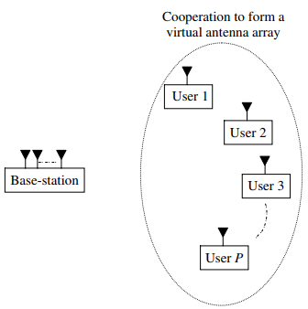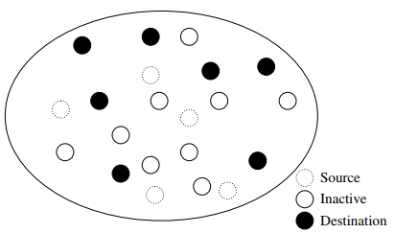  List out the MIMO wireless standard. (6)  With the advent of the Internet and rapid proliferation of computational and communication devices, the demand for higher data rates is ever growing. In many circumstances, the wireless medium is an effective means of delivering a high data rate at a cost lower than that of wireline techniques (such as DSL or cable modem). Limited bandwidth and power makes MIMO technology indispensable in meeting the increasing demand for data.  MIMO technology is now at the core of many existing and emerging wireless standards such as  IEEE 802.11 (for wireless local area networks or WLAN)  IEEE 802.16 (for wireless metropolitan area networks or WMAN)  IEEE 802.20 (for mobile broadband wireless access or MBWA)  While MIMO is compatible with any modulation scheme, the preferred choice for next-generation networks, to tackle the increased bandwidth delay spread product, is orthogonal frequency-division multiplexing (OFDM).  OFDM significantly reduces the computational complexity of equalization at the receiver by dividing an otherwise frequency-selective channel into narrower frequency-flat fading sub-channels called tones.  The associated multi-user format is orthogonal frequency division multiple access (OFDMA). In OFDMA multiple users are allocated tones depending on individual throughput and delay constraints. As an example of the data rates that will be realized.  IEEE 802.11n specification promises a throughput in excess of 200 Mbps. The experimental throughput for the IEEE 802.11n specification with a 2 ×2 MIMO configuration in 20 and 40 MHz channels. | CO5 | K2 | 3
(PART C – 15 Marks)
QC101 A | Define the term quantization. Discuss the type of quantization and derive the expression for signal to noise power.  Quantization within the finite amplitude range of the signal, we find an infinite number of amplitude levels.    Amplitude quantization is defined as the process of transforming the sample amplitude $m\left(nT_{s}\right)$, of a message signal m(t) at a time t=$nT_{s}$ into a discrete amplitude taken from a finite set of possible amplitude.  The signal amplitude m is specified by the index k if it lies inside partition cell. The quantization process is memoryless and instantaneous. The quantizer inputs are called decision levels or decision threshold. The spacing between two adjacent representation level is called quantum or step-size. There are three types of Quantization - Uniform Quantization, Non-uniform Quantization and Vector quantization.  Vector quantization: is used in speech coding technique. Uniform Quantization: in which the quantization levels are uniformly spaced. Non-uniform Quantization: in which the quantization levels are unequal and mostly the relation between them is logarithmic. There are two types of uniform quantization. They are Mid-Rise type and Mid-Tread type. The following figures represent the two types of uniform quantization.  The Mid-Rise type is so called because the origin lies in the middle of a raising part of the stair-case like graph. The quantization levels in this type are even in number. The Mid-tread type is so called because the origin lies in the middle of a tread of the stair-case like graph. The quantization levels in this type are odd in number. Both the mid-rise and mid-tread type of uniform Quantizer are symmetric about the origin. Quantization introduces an error defined as the difference between the input signal m and the output signal v. The error is called quantization error. Quantization error Q of sample value q, Q = M - V or q = m – v  Input m having zero mean, quantizer assumed to be symmetric, quantization error Q, will also have zero mean. M is continuous amplitude in range ($-m_{max}$, $+m_{max}$) and L is total level of representation, the step size of the quantizer is  $$∆=\frac{2m_{max}}{L}$$  The probability density function of the quantization error Q as  $$f_{Q}\left(q\right)=\left\{\begin{aligned}\frac{1}{∆}, -\frac{∆}{2}<q ≤\frac{∆}{2} \\ 0, otherwise \end{aligned}\right.$$  The mean of the quantization error being zero, variance is the same as the mean square value,  $$σ_{Q}^{2}=E\left[Q^{2}\right]= \int_{-\frac{∆}{2}}^{\frac{∆}{2}}{q^{2}f_{Q}\left(q\right) dq}= \frac{1}{∆} \int_{-\frac{∆}{2}}^{\frac{∆}{2}}{q^{2} dq}= \frac{∆^{2}}{12}$$  L – ary number k, R denotes the number of bits per sample used in the construction of the binary code.  $$L=2^{R}, R=\log_{2}{L}$$  Step size is $∆ = \frac{2m_{max}}{2^{R}},$the variance rewritten as  $$σ_{Q}^{2}=\frac{1}{3}m_{max}^{2}2^{-2R}$$  P denotes average power of the message signal, output signal-to-noise ratio of a uniform quantizer is  $$SNR_{o}= \frac{P}{σ_{Q}^{2}}=\left(\frac{3P}{m_{max}^{2}}\right) 2^{2R}$$   | CO1 | K2 | 4
Or
QC101 B | With supporting derivation, prove that if a signal contains no frequency higher than W Hz, it may be reconstructed from its samples at a sequence of points spaced 1/2W seconds apart.  Sampling process is usually described in time domain  Sampling process, analog signal is converted into a corresponding sequence of samples that are usually spaced uniformly in time.  Sampling period is Ts,  sampling rate is $f_{s}=\frac{1}{T_{s}}$  Ideal or Instantaneous or Impulse Sampling: sampling signal is a periodic impulse train. The area of each impulse in the sampled signal is equal to the instantaneous value of the input signal.  $g_{δ}\left(t\right)=\sum_{-α}^{α}{g\left(nT_{s}\right)δ(t-nT_{s})}$ --------------- (1)  Where $g_{δ}\left(t\right)$as ideal sampled signal.  Where $δ(t-nT_{s})$ delta function at time t= $nT_{s}$  Fourier transform pairs, $g_{δ}\left(t\right)=f_{s}\sum_{-α}^{α}{G(f-{nf}_{s})}$----------- (2)  Fourier transform of $δ(t-nT_{s})$ = $e^{-j2πft}$ = $e^{-j2πfnT_{s}}$  Equ (1) can be rewritten as discrete time FT  $G_{δ}\left(f\right)=\sum_{-α}^{α}{g\left(nT_{s}\right)e^{-j2πfnT_{s}}}$ ---------- (3)  $G_{δ}\left(f\right)=\sum_{-α}^{α}{g\left(nT_{s}\right)e^{-j(\frac{πnf}{W})}}$ ---------- (4)  Equ (2) can be rewritten as  ${G_{δ}\left(f\right)= f}_{s}\sum_{-α}^{α}{G(f-nf_{s})}=f_{s} G\left(f\right)+f_{s}\sum_{\begin{aligned}-α \\ n≠0\end{aligned}}^{α}{G(f-nf_{s})}$ ------- (5)  Conditions G(f) = 0 for |$f_{s}$| ≥ W; $f_{s}$= 2W  Equ (5) can be rewritten as $G_{δ}\left(f\right)=f_{s}G\left(f\right)$;  $G\left(f\right)=\frac{1}{f_{s}}G_{δ}\left(f\right)$ -------- (6)  Sub (4) in (6); = $\frac{1}{2W}$ $\sum_{-α}^{α}{g\left(\frac{n}{2W}\right)e^{-j(\frac{πnf}{W})}}$ ---(7)  The sample of a signal g(t) are specified for all n, the Fourier transform G(f) of the signal is uniquely determined by using discrete time Fourier transform of (7).  Reconstructing original signal apply inverse Fourier transform;  $g\left(t\right)=\int_{-α}^{α}{G(f) e^{j2πft}df}$ ------------ (8)  Sub (6) in (7),  = $\frac{1}{2W} \int_{-α}^{α}{\sum_{-α}^{α}{g\left(\frac{n}{2W}\right)e^{-j(\frac{πnf}{W})} e^{j2πft}df}}$  = $\frac{1}{2W} \int_{-W}^{W}{\sum_{-α}^{α}{g\left(\frac{n}{2W}\right)e^{j2πf(t - \frac{n}{2W})}df}}$  = $\sum_{-α}^{α}{g\left(\frac{n}{2W}\right)}\frac{1}{2W}\int_{-W}^{W}{e^{j2πf(t - \frac{n}{2W})}df}$  = $\sum_{-α}^{α}{g\left(\frac{n}{2W}\right)}$ $\left(\frac{sin⁡(2πwt-nπ)}{2πWt-nπ}\right)$  g(t)= $\sum_{-α}^{α}{g\left(\frac{n}{2W}\right)}$ sinc (2wt-n); –α < t < α  The above equation is interpolation formula for reconstructing the original signal g(t).  The sampling signal is strictly band limited signals,  - The band limited signal of finite energy, which has no frequency components higher than WHz, is completely described by specifying the value of the signal at instants of time separated by time 1/2W seconds.  - The band limited signal of finite energy, which has no frequency components higher than WHz, may be completely recovered from a knowledge of its sample taken at the rate of 2W samples per second.  It is the minimum sampling rate required to accurately capture an analog signal in digital form without information loss. It is also known as Nyquist Frequency or Nyquist Limit.  It is defined as twice the maximum frequency component present in the analog signal. Mathematically it can be represented as:  $$f_{s}=2f_{max}$$  Nyquist interval, reciprocal of the Nyquist rate, which is the smallest sampling rate required to accurately capture an analog signal in digital form without information loss.  $$T=\frac{1}{Nyquist rate}=\frac{1}{f_{s}}$$  A signal can be exactly reproduced if it is sampled at the rate $f_{s}$ which is greater than twice the maximum frequency.  If​ $f_{s} <2f_{max}$, then it is the case of under sampling.  If $f_{s}=2f_{max}$, then it is the case of sampling at Nyquist Rate and it is perfect sampling.  If $f_{s}>2f_{max}$​, then it is the case of oversampling.  Undersampling: rate is less than the Nyquist rate, making it impossible to extract the original signal from the sampled signal. Because the spectra overlap, some frequency components of the original signal will acquire a new frequency; this process is known as frequency aliasing.  Oversampling: is when more samples are taken that are necessary to capture the signal's frequency. It can be done to measure more accurately, enhancing SNR, providing more detailed information for further processing  Aliasing: When a high-frequency signal is represented at lower frequency. Means it occurs when the sampling rate is insufficient and fails to capture the signal properly. When the signals are sampled at lower frequency than the Nyquist frequency, high frequency components fold back in the low frequency range. This may lead to distorted signal representation.  Avoid Aliasing: Sampling at Nyquist Rate, Using Anti-Aliasing Filter is used in signal processing and digital data collection systems to prevent or eliminate aliasing effects.  Filtering High-Frequency Components: The anti-aliasing filter is used to remove high-frequency components in analog signals that exceed the Nyquist frequency, which is half the sampling rate of the ADC. If these high-frequency components are not filtered, they will cause aliasing which results in incorrect information.  Preventing Aliasing: The anti-aliasing filter ensures that only the desired frequency are represented in the digital signal by attenuating the high-frequency components.  Improved Signal Quality: It improves signal quality and allows for more accurate data gathering. It helps to retain the original signal's integrity and decreases the possibility of errors in later digital processing.     | CO1 | K2 | 4
QC201 A | Draw the block diagram of PCM; explain the function performed by each block. With suitable diagram, explain nonuniform quantization. | CO2 | K2 | 4
Or
QC202 B | A compact disc records audio signals digitally by using PCM. Assume the audio signal bandwidth to be 15kHz.  - What is Nyquist rate?  - If the Nyquist sample are quantized into 65536 levels and then binary coded, determine the number of binary digits per seconds required to encode a sample.  - Determine the number of binary digits per second required to encode the audio signal.  - For practical reason, the signals are sampled at a rate well above Nyquist rate at 44100 samples per second. If 65536 determine number of bits per second required to encode the signal and transmission bandwidth of encoded signal.  Solution:  Audio signal bandwidth = 15 kHz  The Nyquist rate is:  Nyquist rate=2×Bandwidth=2×15,000 Hz=30,000 samples per second  Number of quantization levels = 65536  Number of bits per sample = log_2⁡65536 = 16 bits  Binary digits per second=Sampling rate × Bits per sample  Binary digits per second=30,000 × 16 = 480,000 bits per second (bps)  Sampling rate = 44,100 samples per second  Bits per sample = 16  The number of bits per second is:  Binary digits per second=sampling rate × bits per sample = 44,100 × 16=705,600 bps | CO2 | K2 | 4
QC301 A | With a suitable diagram, explain the working principles of both the transmitter and receiver in Frequency Shift Keying (FSK), and derive the expression for Bit Error Rate.  Non-linear method of passband data transmission, coherent FSK, Symbols 1 and 0 are distinguished from each other by transmitting one of two sinusoidal waves that differ in frequency by a fixed amount. A typical pair of sinusoidal waves is  $$s_{i}\left(t\right)=\left\{\begin{aligned}\sqrt{\frac{2E_{b}}{T}}cos\text{ (2}\text{π}f_{i}\text{t), 0 ≤ t ≤ } T_{b} \\ &0, otherwise \end{aligned}\right.$$  Where $E_{b}$ is transmitted signal energy per bit, $i=1, 2$ Transmitted frequency is $f_{i}=\frac{n_{c}+i}{T_{b}}$ , $n_{c}$ fixed integer, $i=1, 2$. symbol 1 is represented by $s_{1}(t)$ and symbol 0 is by $s_{2}(t)$.  Sunde’s FSK, it is a continuous-phase signal in the sense that phase continuity is maintained, including inter-bit switching times. The signal $s_{1}(t)$and $s_{2}(t)$ are orthogonal, but not normalized to have unit energy.  $$ф_{1}\left(t\right)=\left\{\begin{aligned}\sqrt{\frac{2}{T_{b}}}cos\text{ (2}\text{π}f_{i}\text{t), 0 ≤ t ≤ } T_{b} \\ &0, otherwise \end{aligned}\right.$$  Where, $i=1, 2$ , the coefficient $s_{ij}$ for $i=1, 2$ and $j=1, 2$ is defined by  $$s_{ij}=\int_{0}^{T_{b}}{s_{i}\left(t\right)ф_{j}\left(t\right)dt}=\int_{0}^{T_{b}}{\sqrt{\frac{2E_{b}}{T}}cos\text{ (2}\text{π}f_{i}\text{t)}\sqrt{\frac{2}{T_{b}}}cos\text{ (2}\text{π}f_{j}\text{t) dt}}$$  $$=\left\{\begin{aligned}\sqrt{E_{b}}\text{, } i=j \\ &0, i ≠j\end{aligned}\right.$$  Unlikely PSK and FSK system is characterized by having a signal space that is two dimensional , with two message points. The two message points are defined by $s_{1}= \left[\begin{aligned}\sqrt{E_{b}} \\ 0\end{aligned}\right]$ and $s_{2}=\left[\begin{aligned}0 \\ \sqrt{E_{b}}\end{aligned}\right]$ with the Euclidean distance between them equal to $\sqrt{{2E}_{b}}$.  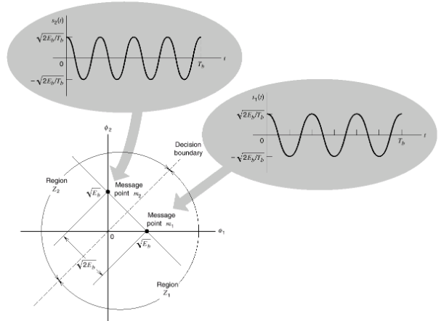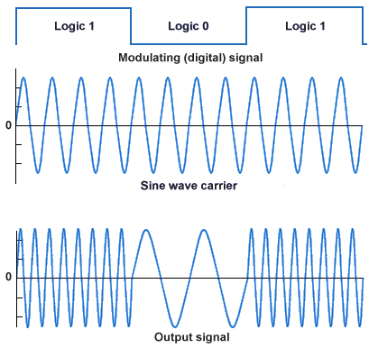  Error probability of Binary FSK  The observation vector $x$ has two elements $x_{1}$ and $x_{2}$ are defined by  $x_{1}=\int_{0}^{T_{b}}{x(t)ф_{1}\left(t\right)dt}$, and $x_{2}=\int_{0}^{T_{b}}{x(t)ф_{2}\left(t\right)dt}$  Where $x(t)$ is the received signal, the form of which depends on which symbol was transmitted. Symbol 1 was transmitted $x(t)$ equals $s_{1}\left(t\right)+w(t)$, $w\left(t\right)$ is the sample WGN process of zero mean and power spectral density $\frac{N_{0}}{2}$, on other hand, Symbol 0 was transmitted $x(t)$ equals $s_{0}\left(t\right)+w(t)$.  The observation space is partitioned into two region $Z_{1}$and $Z_{2}$. The decision boundary, separation region $Z_{1}$ from region $Z_{2}$ is the perpendicular bisector of the line joining the two message points.  The receiver decides in favor of symbol 1 if the received signal point represented by the observation vector $x$ falls inside region $Z_{1}$. This occur when $x_{1}>x_{2}$.  When $x_{1}<x_{2}$, the received signal point falls inside region $Z_{2}$, and the receiver decides in favor 0. On the decision boundary, $x_{1}=x_{2}$, in which case the receiver makes a random guess in favor of symbol 1 or 0.  Gaussian variable $Y$ whose sample value $y$ is equal to the difference between $x_{1}$ and $x_{2}$; ${y=x}_{1}-x_{2}$.  The mean value of the random variable $Y$ depends on which binary symbol was transmitted. Symbol 1 was transmitted, the gaussian random variables $X_{1}$ and $X_{2}$, whose sample value are denoted by $x_{1}$ and $x_{2}$, have mean values equal to $\sqrt{E_{b}}$ and zero, respectively.  The conditional mean of random variable $Y$, given that symbol 1 was transmitted, is  $$E\left[Y | 1\right]=E\left[X_{1} | 1\right]-E\left[X_{2} | 1\right]= +\sqrt{E_{b}}$$  Similarly symbol 0 was transmitted, is  $$E\left[Y | 0\right]=E\left[X_{1} | 0\right]-E\left[X_{2} | 0\right]=-\sqrt{E_{b}}$$  The variance of the random variable $Y$, is independent of which binary symbol was transmitted. The random variables $X_{1}$ and $X_{2}$ are statistically independent, each with a variance equal to $\frac{N_{0}}{2}$, it follows that  $$var\left[Y\right]=var\left[X_{1}\right]+var[X_{2}]=N_{0}$$  Suppose, symbol 0 was transmitted . The conditional probability density function of the random variable $Y$ is then given by  $$f_{Y}\left(y | 0\right)= \frac{1}{\sqrt{2{\text{π}N}_{0}}}\exp\left[- \frac{{\left(y+\sqrt{E_{b}}\right)}^{2}}{2N_{0}}\right]$$  The condition $x_{1}>x_{2}$, or equivalently, $y>0$, corresponds to the receiver making a decision in favor of symbol 1, the conditional probability of error, given that symbol 0 was transmitted, is  $$p_{10}=P\left(y>0\right|symbol 0 was send)= \int_{0}^{∞}{ f_{Y}\left(y | 0\right) dy}$$  $$=\frac{1}{\sqrt{2{\text{π}N}_{0}}}\int_{0}^{∞}{\exp\left[- \frac{{\left(y+\sqrt{E_{b}}\right)}^{2}}{2N_{0}}\right]dy}$$  Put  $$- \frac{\left(y+\sqrt{E_{b}}\right)}{\sqrt{2N_{0}}}=z$$  Changing the variable of integration from $y$to $z$,  $$p_{10}=\frac{1}{\sqrt{\text{π}}}\int_{\sqrt{\frac{E_{b}}{2N_{0}}}}^{∞}{\exp\left[- z^{2}\right]dz}=\frac{1}{2}\operatorname{erfc}\left(\sqrt{\frac{E_{b}}{{2N}_{0}}}\right)$$  The $p_{01}$, the conditional probability of error given that symbol 1 was transmitted has the same value. The averaging $p_{10}$ and $p_{01}$, the average probability of bit error or equivalently the bit error rate for coherent binary FSK is  $P_{e}=\frac{1}{2}\operatorname{erfc}\left(\sqrt{\frac{E_{b}}{{2N}_{0}}}\right)$  Generation and Detection  The incoming binary data sequence is first applied to an on-off level encoder, at the output of which symbol 1 is represented by a constant amplitude of $\sqrt{E_{b}}$ volts and symbol 0 is represented by zero volts. By suing inverter in the lower channel,  Symbol 1 at the input, the oscillator with frequency $f_{1}$ in the upper channel is switched on while the oscillator with frequency $f_{2}$ in the lower channel is switched off, with the result that frequency $f_{1}$ is transmitted.  Symbol 0 at the input, the oscillator in the upper channel is switched off and the oscillator on the lower channel is switched on, with result that frequency $f_{2}$ is transmitted.  The two frequency $f_{1}$ and $f_{2}$ are chosen to equal different integer multiples of the bit rate $\frac{1}{T_{b}}$.  The oscillator are synchronized, so that their outputs satisfy the requirements of the two orthonormal basic function $ф_{1}$ and $ф_{2}$.  The original binary sequence given the noisy received signal $x(t)$, it consists of two correlator with a common input, which are supplied with locally generated coherent reference signal $ф_{1}$ and $ф_{2}$.  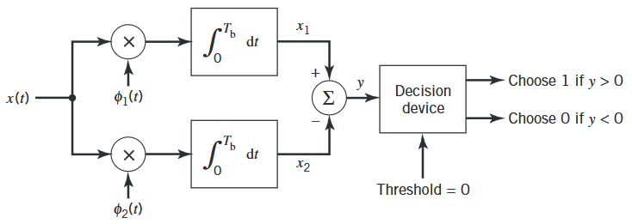  The correlator outputs are the subtracted, one from the other. The resulting $y$, is compared with a threshold of zero volts. If $y>0$, the receiver decide in favor of 1, On other hand, if $y< 0$, it decide in favor of 0. If $y= 0$, the receiver makes a random guess in favor of 1 or 0.  Power Spectral of binary FSK  Sunde’s FSK, the transmitted frequency $f_{1}$ and $f_{2}$ differ by an amount equal to the bit rate $\frac{1}{T_{b}}$ and their arithmetic mean equals the nominal carrier frequency $f_{c}$; phase continuity is always maintained, including inter-bit switching times. The special binary FSK signal as  $$s\left(t\right)=\sqrt{\frac{2E_{b}}{T_{b}}}\cos\left(2\text{π}f_{c}t ±\frac{\text{π}t}{T_{b}}\right)0 ≤t ≤T_{b}$$  $$s\left(t\right)=\sqrt{\frac{2E_{b}}{T_{b}}}\cos\left(±\frac{\text{π}t}{T_{b}}\right)\cos\left(2\text{π}f_{c}t\right)-\sqrt{\frac{2E_{b}}{T_{b}}}\sin\left(±\frac{\text{π}t}{T_{b}}\right)sin⁡(2\text{π}f_{c}t)$$  $$s\left(t\right)=\sqrt{\frac{2E_{b}}{T_{b}}}\cos\left(\frac{\text{π}t}{T_{b}}\right)\cos\left(2\text{π}f_{c}t\right)∓\sqrt{\frac{2E_{b}}{T_{b}}}\sin\left(\frac{\text{π}t}{T_{b}}\right)sin⁡(2\text{π}f_{c}t)$$  The plus sign corresponds to transmitting symbol 0, and the minus sign corresponds to transmitting symbol 1. The in-phase and quadrature components of a binary FSK signal with continuous phase  - The in-phase components is completely independent of the input binary wave, it equals $\sqrt{\frac{2E_{b}}{T_{b}}}\cos\left(\frac{\text{π}t}{T_{b}}\right)$ for all the values of time t. The power spectral density of this components consists of two delta functions, weighted by the factor $\frac{E_{b}}{{2T}_{b}}$ and occurring at $f= ±\frac{1}{{2T}_{b}}$.  - The quadrature components is directly related to the input binary wave. During the signal interval $0 ≤t ≤T_{b}$, it equals $-g(t)$ when we have symbol 1 and $+g(t)$when we have symbol 0. the symbol shaping function $g(t)$ is defined by  $$g\left(t\right)=\left\{\begin{aligned}\sqrt{\frac{{2E}_{b}}{T_{b}}\sin\left(\frac{\text{π}t}{T_{b}}\right)}\text{, 0 ≤ t ≤ }T_{b} \\ &0, otherwise \end{aligned}\right.$$  Energy spectral density of this symbol shaping function equals  $$Ψ_{g}\left(t\right)= \frac{8T_{b}E_{b}Cos^{2}({\text{π}T}_{b}f)}{{{\text{π}}^{2}\left(4T_{b}^{2}f^{2}-1\right)}^{2}}$$  The baseband power spectral density of Sunde’s FSK signal equals the sum of the power spectral densities of in-phase and quadrature components,  $$S_{B}\left(f\right)=\frac{E_{b}}{2T_{b}}\left[δ\left(f -\frac{1}{2T_{b}}\right)+δ\left(f+\frac{1}{2T_{b}}\right)\right]+\frac{8T_{b}E_{b}Cos^{2}({\text{π}T}_{b}f)}{{{\text{π}}^{2}\left(4T_{b}^{2}f^{2}-1\right)}^{2}}$$ | CO3 | K3 | 4
Or
QC 301 B | Elaborate on the operational principles of the transmitter and receiver in PSK, and derive the expression for the BER.  A coherent binary PSK system, the pair of the signals $s_{1}\left(t\right)$ and $s_{2}\left(t\right)$ used to represent binary symbol 0 and 1, respectively, is defined by  $$s_{1}\left(t\right)= \sqrt{\frac{2E_{b}}{T_{b}}} cos⁡(2{\text{π}f}_{c}t)$$  $$s_{2}\left(t\right)= \sqrt{\frac{2E_{b}}{T_{b}}}\cos\left(2{\text{π}f}_{c}t+\text{π}\right)=-\sqrt{\frac{2E_{b}}{T_{b}}}\cos\left(2{\text{π}f}_{c}t\right)$$  Where $0 ≤t ≤T_{b}$ and $E_{b}$ is the transmitted signal energy per bit, carrier frequency $f_{c}$is chosen equal to $\frac{n_{c}}{T_{b}}$ for some fixed integer $n_{c}$. A pair of sinusoidal waves that differ only in a relatively phase-shift of 180 degrees, are referred to as antipodal signals.  The binary PSK, there is only one basic function of unit energy,  $$ф_{1}\left(t\right)=\sqrt{\frac{2}{T_{b}}}\cos\left(2{\text{π}f}_{c}t\right) 0≤t<T_{b}$$  The transmitted signals $s_{1}(t)$ and $s_{2}(t)$ in terms of $ф_{1}\left(t\right)$ as follows  $$s_{1}\left(t\right)= \sqrt{E_{b}}{ ф}_{1}\left(t\right) 0≤t<T_{b}$$  $$s_{2}\left(t\right)=-\sqrt{E_{b}}{ ф}_{1}\left(t\right) 0≤t<T_{b}$$  PSK system is characterized by having a signal space that is one-dimensional, with a signal constellation consisting of two message points.  The coordinates of the message points are  $$s_{11}=\int_{0}^{T_{b}}{s_{1}\left(t\right)ф_{1}\left(t\right) dt}= \sqrt{E_{b}}$$  $$s_{21}=\int_{0}^{T_{b}}{s_{2}\left(t\right)ф_{1}\left(t\right) dt}=-\sqrt{E_{b}}$$  $s_{1}\left(t\right)$ is located at $s_{11}= \sqrt{E_{b}}$  $s_{2}\left(t\right)$ is located at $s_{21}=-\sqrt{E_{b}}$  Error probability of Binary PSK : A rule for making in favor of symbol 1 or 0. Set of point closet to message point 1 at $\sqrt{E_{b}}$ and message point 2 at $-\sqrt{E_{b}}$.  By constructing the midpoint of the line joining these two message points, and marking off the appropriate decision regions. The decision regions are marked $Z_{1}$ and $Z_{2}.$  The decision rule is now simply to decide that signal $s_{1}\left(t\right)$ (bin symbol 1) was transmitted if the received signal point falls in region $Z_{1}$, and decide that signal $s_{2}\left(t\right)$ (bin symbol 0) was transmitted if the received signal point falls in region $Z_{2}$.  Two kinds of erroneous, signal $s_{2}\left(t\right)$ is transmitted, but the noise is such that the received signal point falls inside region $Z_{1}$ and so the receiver decides in favor to the signal $s_{1}\left(t\right)$.  Signal $s_{1}\left(t\right)$ is transmitted, but the noise is such that the received signal point falls inside region $Z_{2}$ and so the receiver decides in favor to the signal $s_{2}\left(t\right)$.  The probability of making an error of the first kind, the decision region associated with symbol 1 or signal $s_{1}\left(t\right)$ is described by  $$Z_{1}:0<x_{1}< ∞$$  The observable elements $x_{1}$ is related to the received signal $x(t)$ by  $$x_{1}= \int_{0}^{T}{x\left(t\right)ф_{1}\left(t\right)dt}$$  The conditional probability density function of random variable $X_{1}$, is given that symbol 0 was transmitted, is defined by  ${f_{x}}_{1}\left(x_{1} | 0\right)=\frac{1}{\sqrt{\text{π}N_{0}}}exp\left[-\frac{1}{N_{0}}{\left(x_{1}-s_{21}\right)}^{2}\right]=\frac{1}{\sqrt{\text{π}N_{0}}}exp\left[-\frac{1}{N_{0}}{\left(x_{1}+\sqrt{E_{b}}\right)}^{2}\right]$  The conditional probability of the receiver deciding in favor of symbol 1, given that symbol 0 was transmitted  $$p_{10}=\int_{0}^{∞}{{f_{x}}_{1}\left(x_{1} | 0\right)dx_{1}}=\frac{1}{\sqrt{\text{π}N_{0}}}\int_{0}^{∞}{exp\left[-\frac{1}{N_{0}}{\left(x_{1}+\sqrt{E_{b}}\right)}^{2}\right]dx_{1}}$$  Replace $z=-\frac{1}{\sqrt{N_{0}}}\left(x_{1}+\sqrt{E_{b}}\right)$  $$p_{10}=\frac{1}{\sqrt{N_{0}}}\int_{\sqrt{E_{b}/N_{0}}}^{∞}{exp⁡(-z^{2})dz}=\frac{1}{2} erfc⁡\left(\sqrt{\frac{E_{b}}{N_{0}}}\right)$$  The conditional probability of the receiver deciding in favor of symbol 0, given that symbol 1 was transmitted.  Averaging the conditional error probability $p_{10}$ and $p_{01}$, the average probability of symbol error, equivalently, the bit error rate for coherent binary PSK is $P_{e}= \frac{1}{2} erfc⁡\left(\sqrt{\frac{E_{b}}{N_{0}}}\right)$  The input binary sequence in polar form with symbol 1 and 0 represented by constant amplitude level of $\sqrt{E_{b}}$ and -$\sqrt{E_{b}}$.  Signal transmission is performed by a Polar NRZ level encoder.  Binary wave and a sinusoidal carrier $ф_{1}\left(t\right)$, whose frequency $f_{c}=\frac{n_{c}}{T_{b}}$for some fixed integer $n_{c}$, are applied to a product modulator. The carrier and timing pulse used to generate the  binary wave are usually extracted from a common master clock. PSK modulated wave is obtained at the modulator output.  Detect the original binary sequence of 1 and 0, the noisy PSK signal $x(t)$ to a correlator, which is also supplied with locally generated coherent reference signal $ф_{1}\left(t\right)$.  The correlator output is $x_{1}$, is compared with a threshold of zero volts. If $x_{1}$> 0, the receiver decides in favor of symbol 1,  If $x_{1}$< 0, the receiver decides in favor of symbol 0,  If $x_{1}$exactly 0, the receiver makes a random guess in favor of 1 or 0.  The complex envelop of a binary PSK wave consists of an in-phase component only. The symbol 1 or 0 at the modulator input during the signaling interval 0 ≤ t ≤ $T_{b}$, in-phase component equals $g(t)$ or $-g(t)$. Where $g(t)$ is the symbol shaping function defined by  $$g\left(t\right)=\left\{\begin{aligned}\sqrt{\frac{2E_{b}}{T_{b}}}\text{, 0 ≤ t ≤ }T_{b} \\ &0, otherwise \end{aligned}\right.$$  The input binary wave is random, with symbol 1 and 0 equally likely. The symbol transmitted during the different time slots being statistically independent.  The power spectral density of a random binary wave so described is equal to the energy spectral density of the symbol shaping function divided by the symbol duration.  The energy spectral density of a Fourier transformable signal $g(t)$ is defined as the squared magnitude of the signals Fourier transform.  The baseband power spectral density of a binary PSK signal equals  $$S_{B}\left(f\right)= \frac{2E_{b}\sin^{2}{({\text{π}T}_{b}f)}}{{\left({\text{π}T}_{b}f\right)}^{2}}=2E_{b}sinc^{2}(T_{b}f)$$  This power spectrum falls off as the inverse square of frequency.       | CO4 | K4 | 3
QC 401 A* | For a (7, 4) systematic linear block code, the three parity bits are given by P1=I1+I2, P2= I2+I3, P3=I1+I2+I3 and P4=I1+I3. Find the generated matrix, all the code vectors, hamming weight, distance, and parity check matrix. Show that it is a hamming code. Calculate syndrome and decode the received sequence 1011111.  Solution:  The Generator Matrix, G = [P | I_{k}]  The Generator Matrix is:  1 1 0 1 0 0 0  0 1 1 0 1 0 0  1 1 1 0 0 1 0  1 0 1 0 0 0 1  **********  Codeword c, = m G = m [P | I_{k}]  Message Bits Codeword Hamming Weight  0 0 0 0 0 0 0 0 0 0 0 0  0 0 0 1 1 0 1 0 0 0 1 3  0 0 1 0 1 1 1 0 0 1 0 4  0 0 1 1 0 1 0 0 0 1 1 3  0 1 0 0 0 1 1 0 1 0 0 3  0 1 0 1 1 1 0 0 1 0 1 4  0 1 1 0 1 0 0 0 1 1 0 3  0 1 1 1 0 0 1 0 1 1 1 4  1 0 0 0 1 1 0 1 0 0 0 3  1 0 0 1 0 1 1 1 0 0 1 4  1 0 1 0 0 0 1 1 0 1 0 3  1 0 1 1 1 0 0 1 0 1 1 4  1 1 0 0 1 0 1 1 1 0 0 4  1 1 0 1 0 0 0 1 1 0 1 3  1 1 1 0 0 1 0 1 1 1 0 4  1 1 1 1 1 1 1 1 1 1 1 7  **********  Minimum Hamming distance : 3  **********  Parity Check Matrix, H = [P^{T} | I_{n-k}]  Parity Check Matrix  1 0 0 1 0 1 1  0 1 0 1 1 1 0  0 0 1 0 1 1 1  **********  Parity Check Matrix Transpose, H^{T}  0 0 0  1 0 0  0 1 0  0 0 1  1 1 0  0 1 1  1 1 1  1 0 1  Enter the received codeword , r: 1 0 1 1 1 1 1  Error position s = H^{T} r  **********  Syndrome Matrix  0 0 0 0 0 0 0 0 0 0  1 0 0 1 0 0 0 0 0 0  0 1 0 0 1 0 0 0 0 0  0 0 1 0 0 1 0 0 0 0  1 1 0 0 0 0 1 0 0 0  0 1 1 0 0 0 0 1 0 0  1 1 1 0 0 0 0 0 1 0  1 0 1 0 0 0 0 0 0 1  **********  Syndrome of given received codeword is : 0 1 0  The error position is, s : 0 1 0 0 0 0 0  The correct codeword is, r + s = : 1 1 1 1 1 1 1 | CO4 | K3 | 4
Or
QC 401 B* | For the convolution encoder shown in the figure, sketch the code tree, trellis encoder, state diagram and trellis convolutional encoder diagram. Determine the output data sequence of the input message 11110.  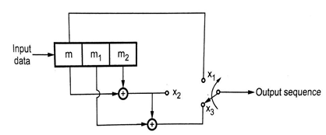  The impulse response of path 1 is (1, 0, 0). 𝑔 ¹(𝐷) = 1  The impulse response of path 2 is (1, 1, 1). 𝑔 ²(𝐷) = 1 + 𝐷 + 𝐷²  The message sequence is (11110). 𝑚(𝐷) = 1 + 𝐷 + 𝐷² + 𝐷³  The output polynomial of path 1 is c¹(𝐷) = 𝑔¹(𝐷) 𝑚(𝐷)  = (1 ) (1 + 𝐷 + 𝐷² + 𝐷³) = 1 + 𝐷 + 𝐷² + 𝐷³  The output sequence of path 1 is (1111000)  The output polynomial of path 2 is c²(𝐷)= 𝑔²(𝐷) 𝑚(𝐷)  = (1 + 𝐷 + 𝐷²) (1 + 𝐷 + 𝐷²+ 𝐷³) = 1 + 𝐷² + 𝐷³ + 𝐷⁵  The output sequence of path 2 is (1011010)  The encoded sequence is (11, 10, 11, 11, 00, 01, 00)  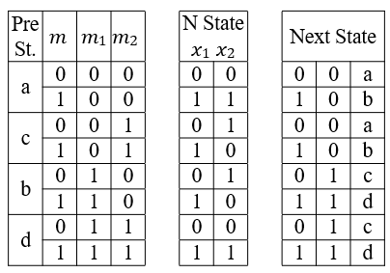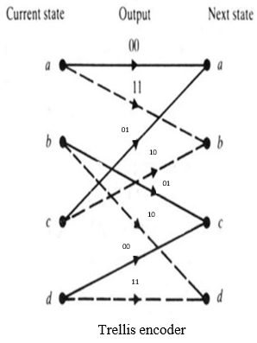  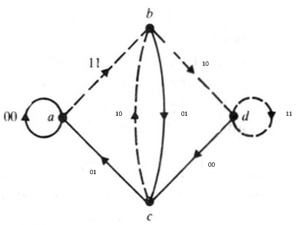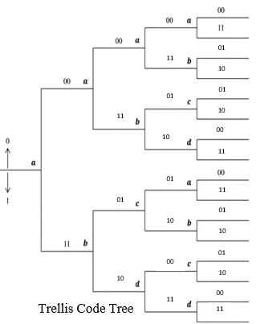  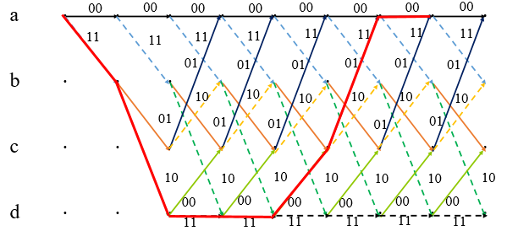 | CO4 | K3 | 4
QC 501 A | With a suitable diagram, explain the working principle of the model analysis of DSSS-BPSK transmitter and receiver, and derive the necessary expression.  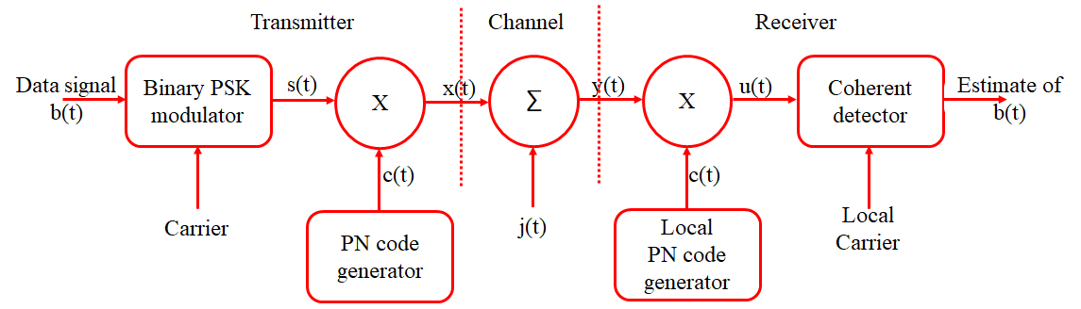  For analysis, more convenient to interchange the order of these operations, as shown in above. The spectrum spreading and BPSK are both linear operations. Likewise for the phase demodulation and spectrum dispreading.  The interchange of operations to be feasible, it is important to synchronize the incoming data sequence and the PN sequence.  The model above also includes representations of the channel and the receiver.  The interference $j(t)$ limits performance, the effect of channel noise may be ignored. The channel output is  $$y\left(t\right)=x\left(t\right)+j\left(t\right)=c\left(t\right)s\left(t\right)+j(t)$$  Where $s(t)$ is the BPSK, $c(t)$ is the PN signal, and interference signal is denoted by $j(t)$.  The received signal $y(t)$ is first multiplied by the PN signal $c(t)$ yielding an output that equals the coherent detector input $u(t)$.  $$u\left(t\right)=c\left(t\right)y\left(t\right)=c^{2}\left(t\right)s\left(t\right)+c\left(t\right)j\left(t\right)=s\left(t\right)+c\left(t\right)j(t)$$  The PN signal $c(t)$ satisfies,  $c^{2}\left(t\right)=1$ for all $t$  The coherent detector input $u(t)$ consists of a binary PSK signal $s(t)$ embedded in additive code-modulated interference denoted by $c(t)j(t)$. The modulated nature of the latter component forces the interference signal to spread its spectrum such that the detection of information bits at the receiver output is afforded increased reliability.  Signal-Space Dimensionality and Processing gain  Signal-space representation of the transmitted signal and the interfering signal (Jammer). The set of orthogonal basic functions  $$ф_{k}\left(t\right)= \left\{\begin{aligned}\sqrt{\frac{2}{T_{c}}}\cos\left(2f_{c}t\right) kT_{c} ≤t ≤ \left(k+1\right)T_{c} \\ 0 otherwise \end{aligned}\right.$$  $$ф^{'}\left(t\right)= \left\{\begin{aligned}\sqrt{\frac{2}{T_{c}}}\sin\left(2f_{c}t\right) kT_{c} ≤t ≤ \left(k+1\right)T_{c} \\ 0 otherwise \end{aligned}\right.$$  Where $k$ = 0,1,2 …. $N-1$. $T_{c}$ chip duration, $N$ number of chips per bit.  The transmitted signal $x(t)$ for the interval of an information bits as  $$x\left(t\right)=c\left(t\right)s\left(t\right)= ±\sqrt{\frac{2E_{b}}{T_{c}}}c\left(t\right) cos⁡(2f_{c}t)$$  $$=±\sqrt{\frac{E_{b}}{N}}\sum_{k=0}^{N-1}{c_{k}}ф_{k}\left(t\right), 0 ≤t ≤T_{b}$$  Where $E_{b}$ is the signal energy per bit; the plus sign corresponds to information bit 1, and the minus sign corresponds to information bit 0. The code sequence {$c_{0},c_{1}….c_{N-1}$} denotes the PN sequence, with $c_{k}=±1$. The transmitted signal $x(t)$ is therefore $N$ dimensional in that it require a minimum of $N$ orthonormal functions for its representation.  The interfering signal (Jammer), $j\left(t\right)$. The jammer likes to place all of its available energy in exactly the same $N$ dimensional signal-space as the transmitted signal $x\left(t\right)$; jammer can hope to know is the transmitted signal bandwidth. Moreover, there is no way that the jammer can have knowledge of the signal space. The jammer by the general fom  $$j\left(t\right)=\sum_{k=0}^{N-1}{j_{k}}ф_{k}\left(t\right), +\sum_{k=0}^{N-1}{c_{k}^{'}}ф_{k}^{'}\left(t\right), 0 ≤t ≤T_{b}$$  Where  $$j_{k}= \int_{0}^{T_{b}}{j\left(t\right)ф_{k}(t)} k=0,1……N-1$$  $$j_{k}^{'}= \int_{0}^{T_{b}}{j\left(t\right)ф_{k}^{'}(t)} k=0,1……N-1$$  The interference $j\left(t\right)$ is $2N$ – dimensional, it has twice the number of dimensions required for representing the transmitted signal DS/BPSK signal $x\left(t\right)$. The average power of the interference $j\left(t\right)$ as  $$J=\frac{1}{T_{b}}\int_{0}^{T_{b}}{j^{2}\left(t\right)dt=\frac{1}{T_{b}}}\sum_{k=0}^{N-1}{j_{k}^{2}}+\frac{1}{T_{b}}\sum_{k=0}^{N-1}{j_{k}^{'2}}$$  Moreover, due to lack of knowledge of signal phase, the best strategy a jammer can apply is to place equal in the cos and sin so ordinates may assume  $$\sum_{k=0}^{N-1}{j_{k}^{2}}=\sum_{k=0}^{N-1}{j_{k}^{'2}}$$  $$J=\frac{2}{T_{b}}\sum_{k=0}^{N-1}{j_{k}^{2}}$$  The SNR measured at the input and output of the DS/BPSK receiver, the coherent detector output as  $$v=\sqrt{\frac{2}{T_{b}}}\int_{0}^{T_{b}}{u\left(t\right)\cos\left(2{\text{}f}_{c}t\right)dt }=v_{s}+v_{cj}$$  Where the components $v_{s}$ and $v_{cj}$ are due to the despread BPSK, $s(t)$, the spread interference, $c\left(t\right)j(t)$, respectively.  $$v_{s}=\sqrt{\frac{2}{T_{b}}}\int_{0}^{T_{b}}{s\left(t\right)\cos\left(2{\text{}f}_{c}t\right)dt }$$  $$v_{cj}=\sqrt{\frac{2}{T_{b}}}\int_{0}^{T_{b}}{c\left(t\right)j\left(t\right) cos\left(2{\text{}f}_{c}t\right)dt }$$  The despread BPSK signal $s\left(t\right)$ equals  $$s\left(t\right)=±\sqrt{\frac{2E_{b}}{T_{b}}}\cos\left(2\text{}f_{c}t\right) 0 ≤t ≤T_{b}$$  Where the plus sign corresponds to information bit 1, and the minus sign corresponds to information bit 0. The carrier frequency $f_{c}$ is an integer multiple of $\frac{1}{T_{b}}$  $$v_{s}=±\sqrt{E_{b}}$$  The component $v_{cj}$ due to interference. The PN signal $c(t)$ in the explicit form of a sequence {$c_{0}, c_{1}…..c_{N-1}$}. The corresponding form  $$v_{cj}=\sqrt{\frac{2}{T_{b}}}\sum_{k=0}^{N-1}{c_{k}}\int_{kT_{c}}^{{(k+1)T}_{c}}{j\left(t\right)\cos\left(2f_{c}t\right)dt }=\sqrt{\frac{T_{c} }{T_{b}}}\sum_{k=0}^{N-1}{c_{k}}\int_{0}^{T_{b}}{j\left(t\right)ф_{k}(t)dt }$$  The PN sequence as an independent and identically distributed binary sequence.  $$v_{cj}= \sqrt{\frac{T_{c} }{T_{b}}}\sum_{k=0}^{N-1}{c_{k}j_{k}}; V_{cj}=\sqrt{\frac{T_{c} }{T_{b}}}\sum_{k=0}^{N-1}{C_{k}j_{k}}$$  Where $V_{cj}$ and $C_{k}$ are random variables with sample $v_{cj}$ and $c_{k}$. The probability of the event $C_{k}=±1$ is  $$P\left(C_{k}=1\right)=P\left(C_{k}=-1 \right)=\frac{1}{2}$$  The mean of the random variable $V_{cj}$ is zero, for fixed $k$,  $$E\left[C_{kj} | j_{k}\right]=j_{k}P\left(C_{k}=1\right)-j_{k}P\left(C_{k}=-1\right)=\frac{1}{2}j_{k}-\frac{1}{2}j_{k}=0$$  Variance of $V_{cj}$ is given by  $$var\left[V_{cj} | j\right]=\frac{JT_{c}}{2}$$  The signal component at the coherent detector output equals $±\sqrt{E_{b}}$ , where $E_{b}$ is the signal energy per bit. The output SNR as the instantaneous peak power $E_{b}$ divided by the variance of the equivalent noise component  $$SNR_{O}=\frac{2E_{b}}{JT_{c}}$$  Average signal power at the receiver input equals $\frac{E_{b}}{T_{b}}$. An input SNR as  $$SNR_{I}=\frac{E_{b}/T_{b}}{J}$$  The output SNR in terms of the input SNR as  $$SNR_{O}=\frac{2T_{b}}{T_{c}}SNR_{I}$$  To express SNR in decibels. Introduce a term called the processing gain (PG).  The gain in SNR obtained by the use of spread spectrum,  $$PG= \frac{T_{b}}{T_{c}}$$  The gain achieved by processing a spread-spectrum signal over an unspread signal.  $$10\log_{10}{{\left(SNR\right)}_{O} =10 \log_{10}{{\left(SNR\right)}_{I}+3+10 \log_{10}{(PG)}} dB}$$  Probability of Error  The coherent detector output $V$. The equivalent noise component $v_{cj}$ produced by external interference denote the ample value of a random variable $V_{cj}$  $$V= ±\sqrt{E_{b}}+V_{cj}$$  Where $E_{b}$ is the signal energy per bit; the plus sign corresponds to information bit 1, and the minus sign corresponds to information bit 0. The received bit in an interval (0, $T_{b}$) is 1 if the detector output exceed a threshold of zero, and that is 0 if the detector output is less than the threshold; if the detector output is exactly zero, the receiver makes a random guess in favor of or 0.  The average probability pf error is the same as the conditional probability of the receiver making a decision on favor of symbol 1, given that symbol 0 was sent.  $$P_{e}=P\left(V>0 | symbol 0 was sent\right)=P(V_{cj}>√E_{b})$$  $$P_{e}=\frac{1}{2}\operatorname{erfc}\left(\sqrt{\frac{E_{b}}{{JT}_{c}}}\right)$$  Antijam Characteristics  The formula for the average probability of error for a coherent BPSK system reproduced  $$P_{e}=\frac{1}{2}\operatorname{erfc}\left(\sqrt{\frac{E_{b}}{{JT}_{c}}}\right)$$  The interference may be treated as wideband noise of power spectral density $\frac{N_{0}}{2}$  $$\frac{N_{0}}{2}=\frac{JT_{c}}{2}$$  The signal energy bit $E_{b}=PT_{b}$, where $P$ is the average signal power and $T_{b}$ is the bit duration. The signal energy per bit-to-noise spectral density ratio ad  $$\frac{E_{b}}{N_{0}}=\left(\frac{T_{b}}{T_{c}}\right)\left(\frac{P}{J}\right)$$  The processing gain as reformulate as  $$\frac{J}{P}=\frac{PG}{E_{b}/N_{0}}$$  $J/P$ is jamming margin, expressed in decibels are related by  $${\left(Jamming margin\right)}_{dB}={\left(Processing gain\right)}_{dB}=10\log_{10}{{\left(\frac{E_{b}}{N_{0}}\right)}_{min}}$$  ${\left(\frac{E_{b}}{N_{0}}\right)}_{min}$is the minimum value needed to support a prescribed average probability of error. | CO5 | K3 | 4
Or
QC 501 B* | Compare the various multiple access technologies. (7)  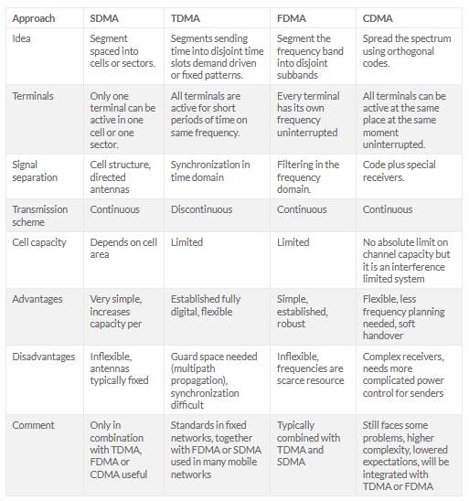  Using a suitable diagram, explain the principles of MIMO in cellular system. (8)  In a cellular wireless communication network, multiple users may communicate at the same time or frequency. The more aggressive the reuse of time and frequency resources, the higher the network capacity will be, provided that transmitted signals can be detected reliably.  Multiple users may be separated in time (time-division) or frequency (frequency-division) or code (code-division). The spatial dimension in MIMO channels, provides an extra dimension to separate users, allowing more aggressive reuse of time and frequency resources, thereby increasing the network capacity.  A base-station equipped with $L$ antennas communicates with $P$ users, each equipped with $M$ antennas. The channel from the base-station to the users (the downlink) is a broadcast channel (BC) while the channel from the users to the base-station (the uplink) is a multiple-access channel (MAC).  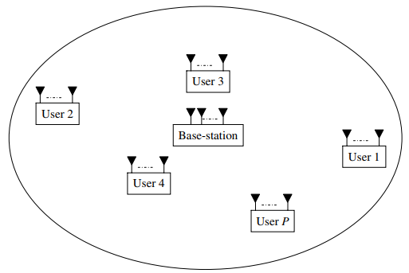The set of rate-tuples ${(R}_{1}, R_{2},…..R_{P})$ that can be reliably supported on the downlink or uplink constitutes the capacity rate region for that link. Recently, an important duality has been discovered between the rate regions for the downlink and uplink channels.  In order to understand the possible gains from MIMO technology in a multi-user environment, consider the uplink of a cellular MIMO system where all the users simultaneously transmit independent data streams from each of their transmit antennas.  Each user signals with spatial multiplexing. To the base-station, the users combined, appear as a multi-antenna transmitter with $MP$ antennas. Thus the effective uplink channel has a dimension of $L×PM$. This effective channel will have a considerably different structure from the $H_{w}$ MIMO single user channel due to path-loss and shadowing differences between users. However, with rich scattering and $L≥PM$, we can expect that the spatial signatures of the users are well separated to allow reliable detection.  Using a multi-user receiver will allow perfect separation of all the data streams at the base-station, yielding a multi-user multiplexing gain of $PM$.  A similar thought experiment can be applied for the downlink, where the base-station exploits the spatial dimension to beam information intended for a particular user towards that user and steers nulls in the directions of the other users, thus completely eliminating interference. | CO5 | K3 | 4

